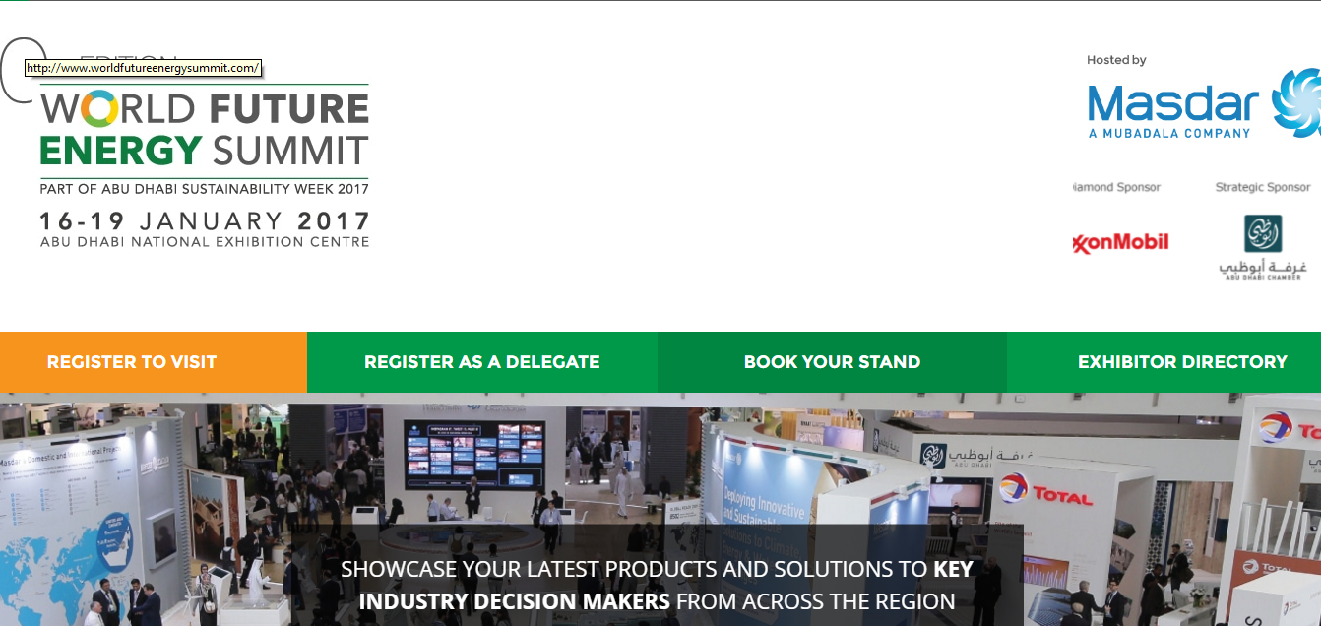
ABOUT
World Future Energy Summit continues to set the agenda for a global discussion on the future of renewable energy, clean technology and sustainability. A platform for governments, corporate decision-makers, investors, entrepreneurs and opinion makers, World Future Energy Summit is an annual meeting place that promotes dialogue, fosters knowledge transfer and accelerates strategic decision making in the pursuit of viable solutions to the world’s growing energy challenges.
LOCATION
Abu Dhabi, UAE
DATE
16-19TH January 2017
DONORS PRESENT:
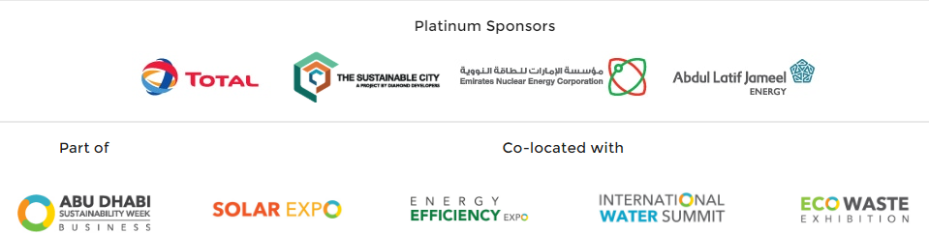
More Information: http://www.worldfutureenergysummit.com/2017-partners#/?_k=6zn3ez

