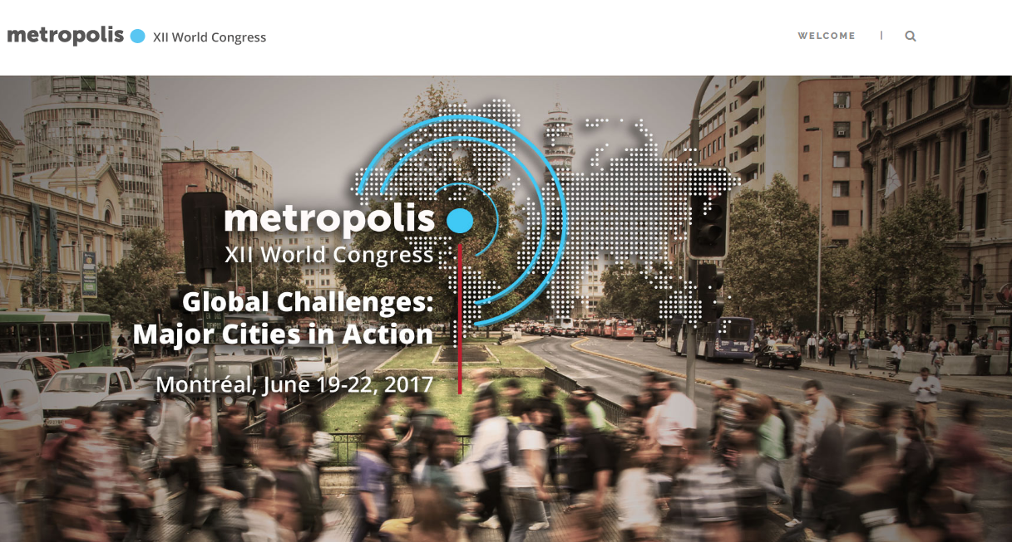
ABOUT
Under the theme”Global Challenges: Major Cities in Action”, the XII Metropolis World Congress will unite decision-makers from major cities around the world as well as public, institutional, academic, private and community stakeholders in order to: Promote key political messages and declarations from the community of mayors worldwide, Showcase and acknowledge good urban practices from across the globe and Discuss and enrich the debate among the various urban management stakeholders.
LOCATION
Montreal
DATE
19- 22 June, 2017
More Information
http://montreal2017.metropolis.org/
Event sourced form Word Urban Campaign website: http://www.worldurbancampaign.org/event-calendar

