ABOUT
The Safe City Event takes place at the World Forum Convention Center The Hague, the international city of peace and justice. Governments, corporates and knowledge institutions will work together on smart solutions for safety and security problems in the city (of the future).
LOCATION
Hague
DATE
7 & 8 June 2017
PATNERS
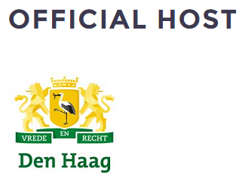
More Information
http://www.smart-circle.org/smartcity/

