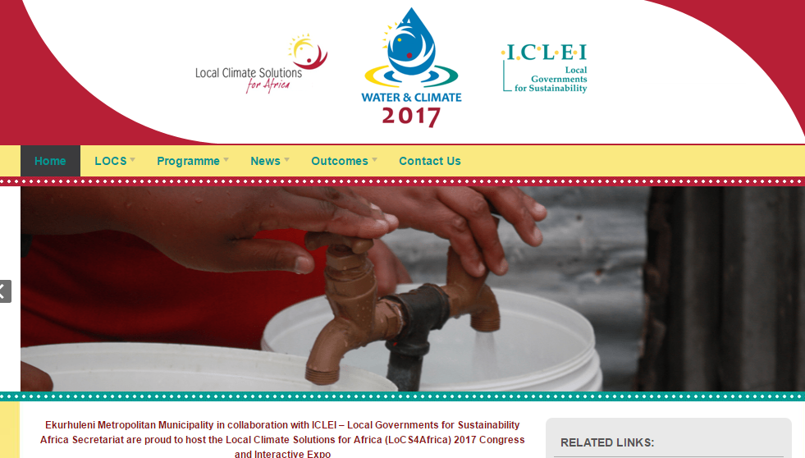
ABOUT
The Local Climate Solutions for Africa (LOCS4Africa) Congress series is Africa’s leading platform on local climate action for cities and other sub-national governments. The congress offers the opportunity for direct engagement and strategic discussions around current local climate solutions and emerging trends relating to urban climate resilience and low carbon development in Africa.
LOCATION
South Africa
DATE
22 – 24 March, 2017
DONORS PRESENT:
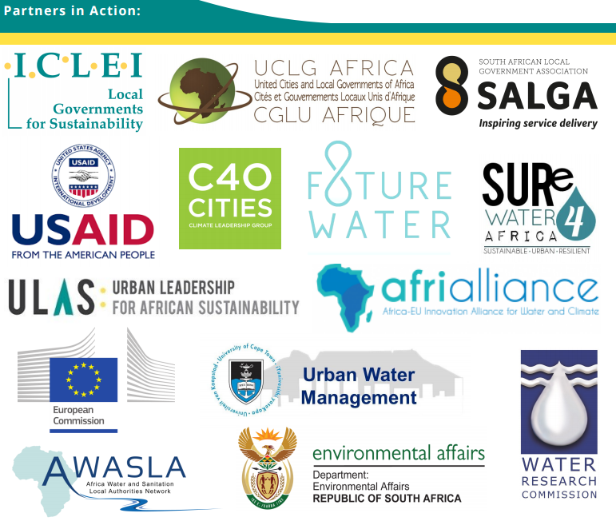
More Information: http://locs4africa.iclei.org/locs2015/locs2017callforabstracts/

