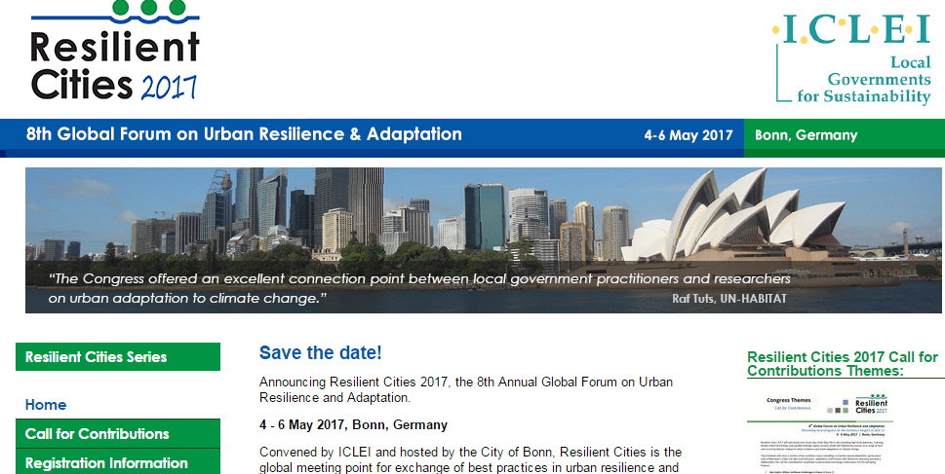
ABOUT
The 8th Global Forum on Urban Resilience and adaptation, Reviews local progress on the resilience targets of SDG 11.
LOCATION
Bonn, Germany
DATE
4-6th May, 2017
DONORS PRESENT:
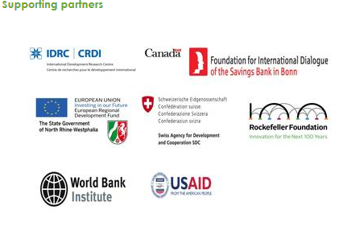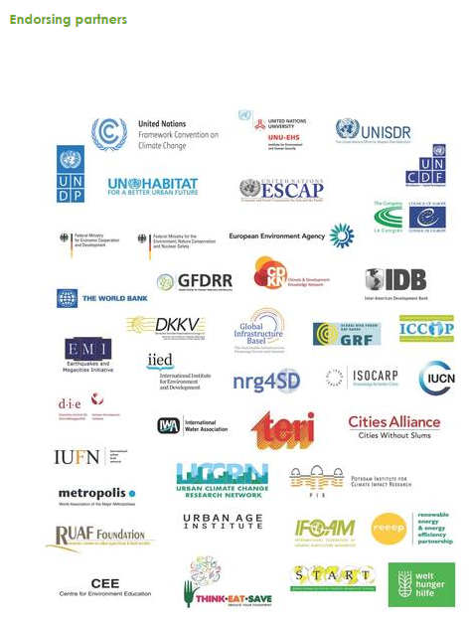
More Information: http://resilient-cities.iclei.org/resilient-cities-hub-site/partners/

