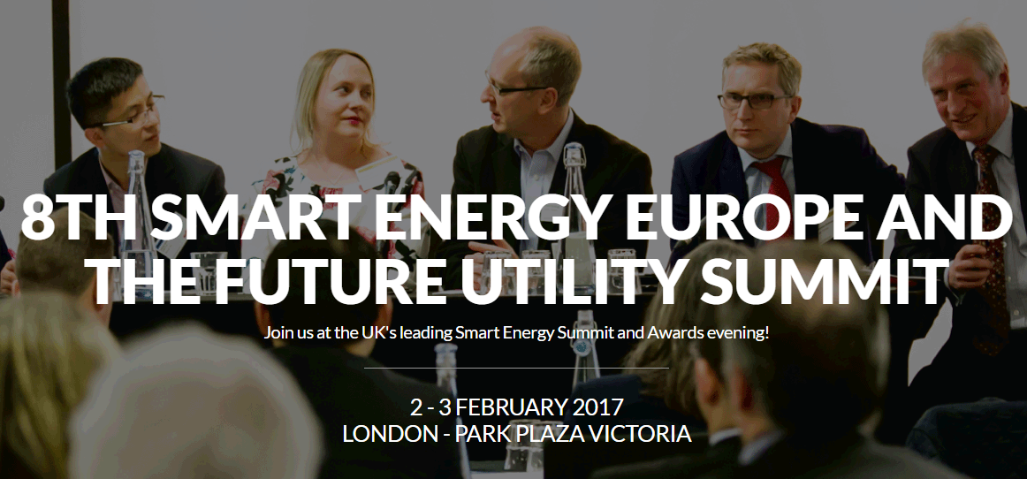
ABOUT
Smart Energy Europe & Future Utility Summit is Europe's leading and most established Smart Energy event.
The Smart Energy Europe & Future Utility Summit is an annual event attended by the Department of Energy and Climate Change, the European Commission, the UK's Big Six utilities, Thames Water and hundreds of European Energy Companies including Endesa, Iberdrola, ENEL, Engie, MVM, Eneco, CEZ, Stakraft, RWE AG, EDF, Fortum, DONG, Smart Energy GB and many additional leading and Independent Energy Companies, TSOs/DSOs, Think Tanks, Energy Market Analysts and more.
LOCATION
London
DATE
2-3 February 2017
DONORS PRESENT: Honeywell, Alpiq, Awesense, Bidgely, First fuel, Holley, EDSO for Smart Grids, Smart Energy Demand Coalition
More Information
http://www.smuksummit.com/

