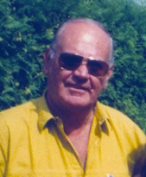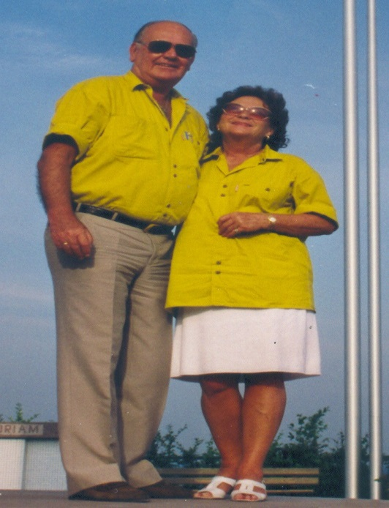
Paul Bouda : Obituary
Habitat’s friends and (retired) colleagues have been saddened by the news that Paul Bouda is no longer with us.
Paul was a founding father of Habitat, one of very few colleagues in the first years of the agency’s existence in the early eighties. He brought with him much needed experience in setting up and implementing operational projects in urban development in the UN system. After field assignments as project manager for UNDP in Congo Brazzaville, Lagos, Haiti and Burundi, he joined the young agency in Nairobi in 1979, and was the first Chief of the Africa and Western Asia Section. The first Executive Director, Arcot Ramachandran, new in the UN system himself, certainly benefitted from Paul Bouda’s professional knowledge and diplomatic talent in dealing with Governments, their ministers and ambassadors to the young Habitat.
Everybody enjoyed Paul’s jovial attitude, roaring laughter and particular sense of humor. He loved Africa and its people, and felt very much at home in Nairobi. Not only on New Year’s eves, he and his wife Trude hosted legendary parties for friends and their families at their home in Lavington. He loved fast cars, and held the speed record in the late eighties in daily driving home for lunch and back to the office in his Peugeot from Gigiri, an amazing performance even in those days. His wife Trude, a retired ballet dancer, made use of her years in Kenya and very much enjoyed enrolling young girls in ballet classes.
Paul Bouda’s professional commitment to urban planning and housing continued well after his retirement to his home country Germany in 1989. At the request of German government institutions, Paul carried out a number of consultancies in China and in Senegal. Already in his seventies, he enrolled for a PhD in his home country, which allowed him to present an academic analysis of his wide experience with human settlement issues, mainly from African countries.
Born in Bratislawa in 1928, Paul succumbed to cancer in late October 2015. Paul and Trude Bouda were happily married for 57 years.

