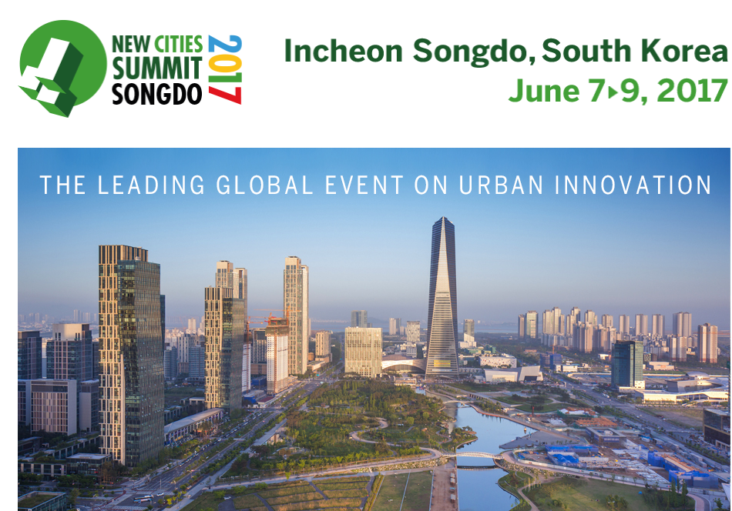
ABOUT
Discussion about the future wellbeing of our cities and those who live in them. Join urban leaders and innovators from over 50 countries Incheon Songdo, the world's most innovative new city as they discuss the theme Thriving Cities: The Building Blocks of Urban Wellbeing.
LOCATION
Inchen Songdo, South Korea
Date
7-9th June 2017
DONORS PRESENT:
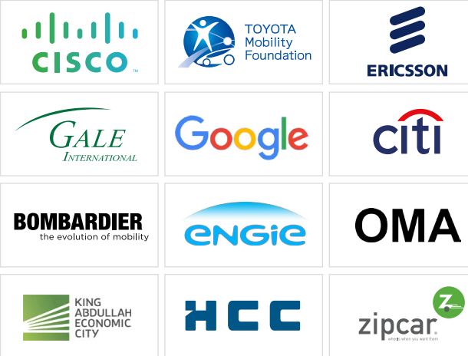
More Information:
http://www.newcitiessummit2017.org/

