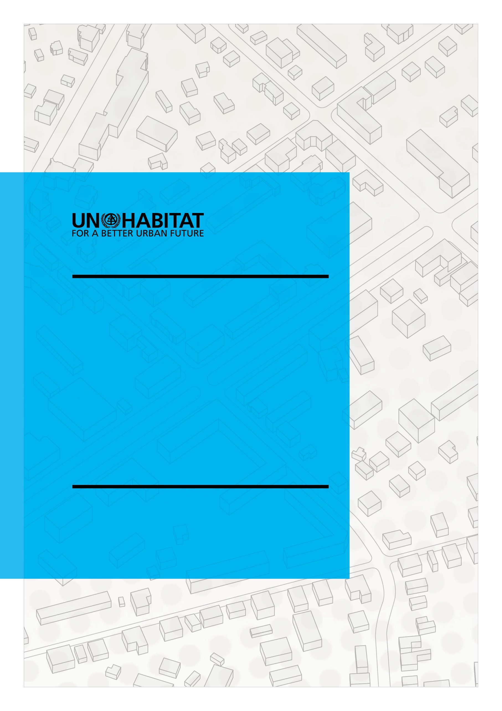

**CONCEPT NOTE:**

**PROJECT/PROGRAMME TITLE**

TABLE OF CONTENTS

1. GENERAL INFORMATION 4

2. PROJECT OVERVIEW 5

Project Description 5

Project Approach 5

Main Expected Accomplishments 5

Proposed Target Group/Population 5

Project Type (pick from drop down list with text box) 5

3. PROJECT RATIONALE 6

Purpose and Justification 6

Theory of Change 6

4. STAKEHOLDERS 7

INTERNAL STAKEHOLDERS 7

Lead Organisational Unit (pick from drop down list) 7

Collaborating Unit (pick from drop down list) 7

Other Internal Stakeholders (pick from drop down list) 7

EXTERNAL STAKEHOLDERS 7

Key External Partners 7

Other External Stakeholders 7

5. THEMATIC INFORMATION 8

Theme (pick from drop down list) 8

Subprogramme (pick from drop down list) 8

Project’s Link to Current Work Programme Expected Accomplishment(s) and Outputs (pick from drop down list with text box) 8

Project’s Link to Sustainable Development Goals and related targets (pick from drop down list with text box) 8

Project’s Link to the New Urban Agenda (pick from drop down list with text box) 8

6. PROJECT RISKS 10

High Level Project/Programme Risks 10

# 1. GENERAL INFORMATION

|  |  |
| --- | --- |
| Project Title |  |
| Project Objective |  |
| Donor (s) (If known) |  |
| Link to Existing Project or Programme  (Indicate predecessor project or programme, if this is a continuation of an existing project or a child of an existing programme) |  |
| Estimated Total Project Budget |  |

Estimated Project Budget Breakdown

|  |  |  |  |
| --- | --- | --- | --- |
| Year 1 | Year 2 | Year 3 | Year 4 |
|  |  |  |  |
|  |  |  |  |

# 2. PROJECT OVERVIEW

## Project Description

(what is the project/programme about? What is the problem and what is the project/programme going to do? This section should be maximum 1 pages)

## Project Approach

(Project/Programme Strategy – define choice of solution that will be used in the project/programme to deliver the expected results. Demonstration of reflection of lessons learned from other projects/programmes and external sources/best practices is required – This section should be maximum 2 pages)

## Main Expected Accomplishments

(What will be the main result of the project/programme; what is the desired outcome?)

## Proposed Target Group/Population

(Beneficiaries – describe the individual, group, institution or organization that will benefit directly and indirectly from the implementation of the project/programme. Include number of target population/beneficiaries, disaggregated into women, men and youth)

## Project Type (pick from drop down list with text box)

(Indicate if project is: Core Normative or Core Operational or Integrated)

**(Where Core Normative is selected; specify what normative product is envisaged and how this will support Operational work.) (Where Core Operational and Integrated are selected; what UN-Habitat or external normative product will be utilized on the project?)**

# 3. PROJECT RATIONALE

## Purpose and Justification

#### (Project/Programme Business Case: why is the project/programme being done? On what basis, can we justify doing the project/programme? The link or alignment of project/programme to Regional, National, Local priorities and any United Nations Framework (such as UNDAF) should be clearly stated. Demonstrate how normative product of the project/programme will link to and support operational work and vice versa; Demonstration of reflection of lessons learned from other projects/programmes and external sources is required) (maximum 2 pages)

## Theory of Change

(Provide a Theory of Change that logically defines the preconditions required to achieve the project/programme goals (expected accomplishment – long term outcome) and explain why these preconditions are necessary and sufficient. Include your basic assumptions about the context. Describe the identified interventions required to create those preconditions. The graphical presentation of the Theory of Change can be attached/uploaded – this is recommended. – Theory of Change is mandatory for all programmes and large projects)

# 4. STAKEHOLDERS

## INTERNAL STAKEHOLDERS

## Lead Organisational Unit (pick from drop down list)

(Indicate the Branch or Region or Other Division that is leading the project/programme implementation)

## Collaborating Unit (pick from drop down list)

(Indicate all collaborating Branch(es), Region(s) or Other Division(s) that will collaborate in the implementation of the project/programme)

## Other Internal Stakeholders (pick from drop down list)

(Indicate other internal stakeholders – groups, branch, division that the project/programme will impact positively or negatively)

## EXTERNAL STAKEHOLDERS

## Key External Partners

(Indicate key external project/programme partners – consortium partner, implementing partner etc.)

## Other External Stakeholders

(Indicate other external stakeholders – groups, government institutions, communities, etc. that the project/programme will impact positively or negatively; people/group who will be affected or who will affect the project and those who will participate)

# 5. THEMATIC INFORMATION

## Theme (pick from drop down list)

(Indicate the key project/programme theme(s) – sub themes of UN-Habitat thematic subprogrammes)

## Subprogramme (pick from drop down list)

(Indicate the key project/programme subprogramme(s)

## Project’s Link to Current Work Programme Expected Accomplishment(s) and Outputs (pick from drop down list with text box)

(Indicate the UN-Habitat’s Current Work Programme Expected Accomplishment(s) (EA) that the project/programme contributes to achieve. Also, indicate the relevant Output(s) of the selected EA(s) that the project/programme will specifically contribute to deliver)

## Project’s Link to Sustainable Development Goals and related targets (pick from drop down list with text box)

(Indicate the SDG(s) that the project/programme contributes to achieve. Also, indicate the relevant target(s) of the selected SDG(s) that the project/programme will specifically contribute to deliver)

## Project’s Link to the New Urban Agenda (pick from drop down list with text box)

(Indicate the key (most related) New Urban Agenda’s Transformative Commitment(s) and the areas of Effective Implementation that the project/programme contributes to achieve. Also, indicate the relevant New Urban Agenda paragraph(s) of the selected Transformative Commitment (s) and areas of Effective Implementation that the project/programme will specifically contribute to deliver – No description of the NUA paragraph is required)

# 6. PROJECT RISKS

## High Level Project/Programme Risks

(Initial identified high level risk –major project/programme risk; potential threats and opportunities for the project/programme)