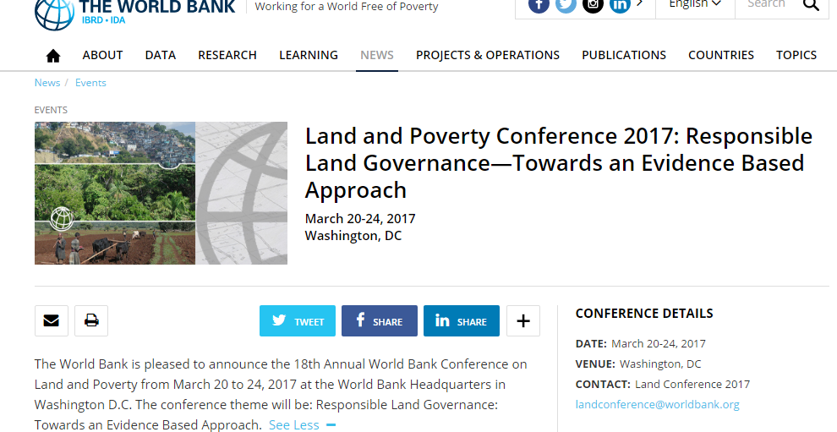
ABOUT
The Annual World Bank Conference on Land and Poverty brings together key stakeholders engaged in strengthening land governance and tenure security for a weeklong event at World Bank Headquarters in Washington DC, USA. The conference program brings you a large number of sessions organized around thematic tracks with oral presentations on latest research, impact evaluations, experiences with new approaches for scaling land administration systems and business models.
The 2017 conference theme will be: Responsible Land Governance: Towards an Evidence Based Approach.
LOCATION
Washington, DC
DATE: 20-24TH March, 2017
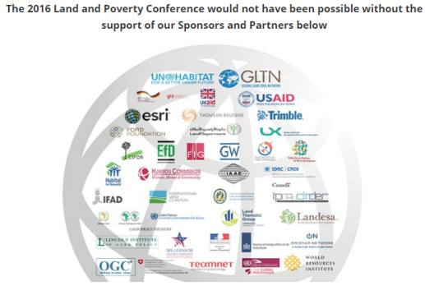
PREVIOUS DONORS:
2016 Sponsors
- UN-Habitat
- GLTN
- USAID
- LANDESEA
- Ford Foundation

More Information:
http://www.worldbank.org/en/events/2016/08/22/land-and-poverty-conference-2017-responsible-land-governance-towards-an-evidence-based-approach

