Dear Colleagues,

I would like to introduce Gary Landes and welcome him to UN-Habitat- he has taken over the position of Chief of what is currently the Management and Operations Division (MOD) effective 1 December 2019.  
  
Gary has a long and distinguished career with the UN Secretariat and has worked in a number of functions in the financial and budgetary administration of the United Nations Secretariat both at HQ and in the field - he was inter alia prominently involved in the roll -out of UMOJA and has also a solid Information Technology background . He will join us from Umoja Project in New York. I trust you will accord him your cooperation and support during this critical period of restructuring and re-orientation of UN-Habitat.  
  
I would also like to take this opportunity to thank Joerg Weich who has been looking after the Management and Operations Division　since 1 November 2018 - he joins the Executive Office where he will in addition to his temporary assignment as Chief of Staff support the restructuring process.

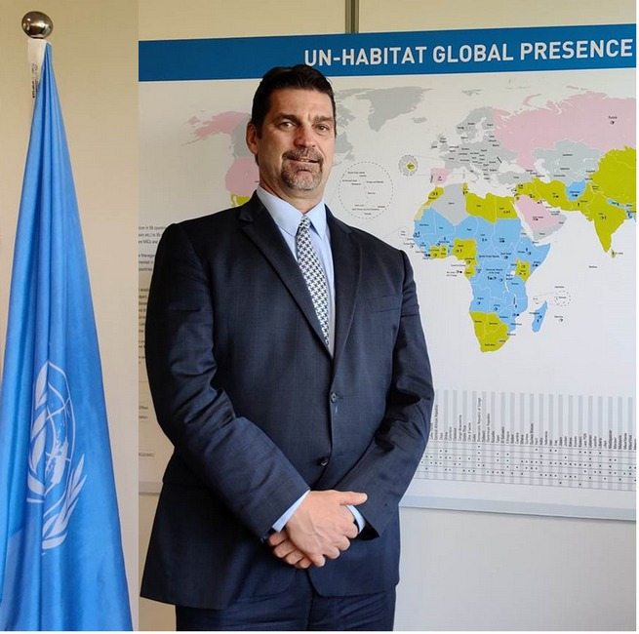

Best regards,

Maimunah Mohd Sharif

Executive Director and Under-Secretary-General

UN-Habitat, Nairobi, Kenya