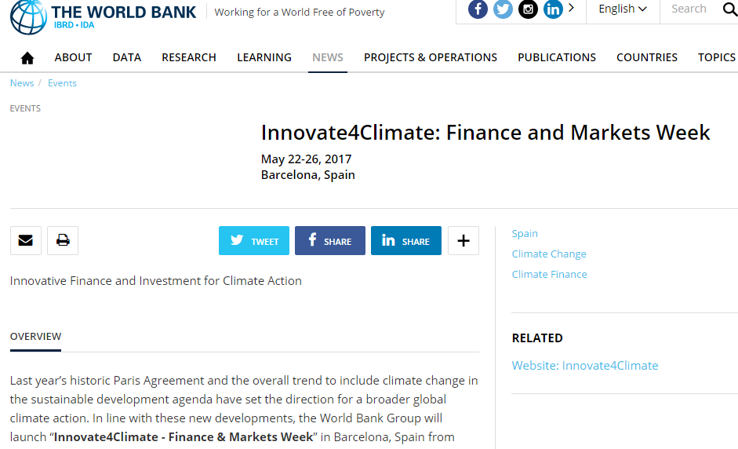
ABOUT
The first edition features a two day forum with high level government representatives, finance and business leaders focused on Unlocking the Trillions in private sector investment needed to scale up national climate plans and to accelerate the global transition to a low-carbon, climate-resilient future.
LOCATION
Barcelona, Spain
DATE:
22-26TH May, 2017

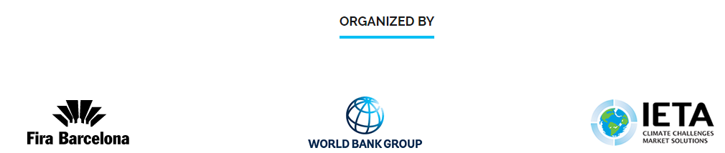

More information: http://www.worldbank.org/en/events/2016/11/16/innovate4climate-finance-and-markets-week

