How to Book / Reserve a room in Lotus Notes
- Click on the UNON Applications Portal icon to access the available applications:
- Click on the UNON Resources icon under ICTS Applications to open the reservations page where you can view existing reservations and/or make new reservations:

- Click on the Quick Reservation Icon at the top of the screen to book a room:
- Fill in the description, reservation date, phone extension, and click on the select room icon to choose a meeting room:

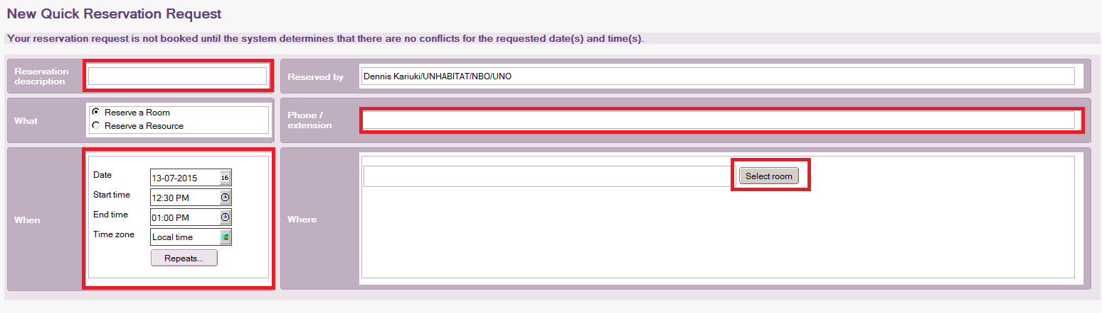
- Click save and close to send the room reservation request to the approver:
- An information dialog will appear showing the approvers of the room. Click on Ok.
- You will receive a confirmation email when the booking is Accepted or Declined by the approver.
NOTE: Kindly send all meeting set-up requests 24 hours before the meeting begins to ensure that all necessary equipment is tested and set-up correctly.

