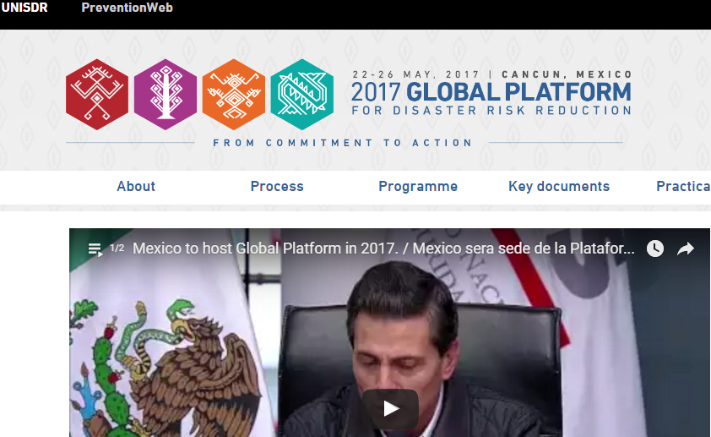
ABOUT
The Global Platform for Disaster Risk Reduction (Global Platform), as recognized by the UN General Assembly, is the main forum at the global level for strategic advice, coordination, partnership development and the review of progress in the implementation of international instruments on disaster risk reduction.
Mexico will host the next global conference on how to reduce loss of life and economic losses from disasters caused by man-made and natural hazards, the most important multilateral forum of its kind.
LOCATION
Mexico
DATE
22-26TH May 2017

More Info: http://www.unisdr.org/conferences/2017/globalplatform/en

