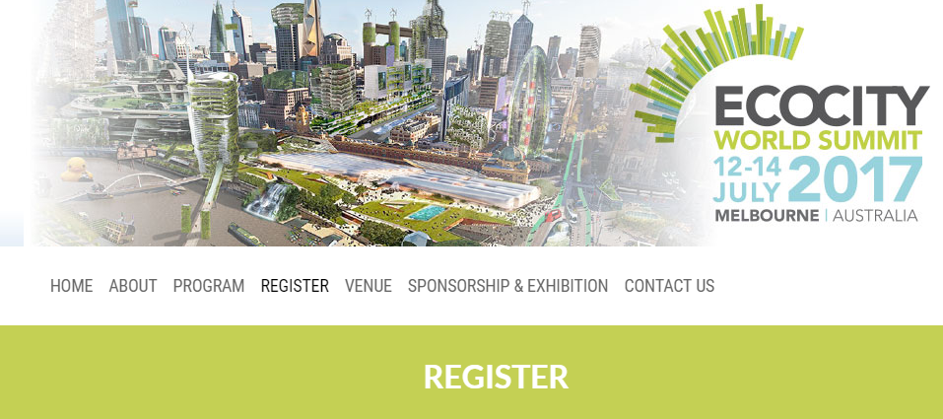
ABOUT
Ecocity 2017: Changing Cities: Resilience and Transformations. The Ecocity Summit series, held every two years since 1990, has developed into one of the most globally significant forums for addressing the complex challenges facing humanity in a rapidly urbanizing world. The 2017 Summit will bring together a diverse mix of researchers, policy makers and citizens with a common focus on identifying and creating pathways to more sustainable, resilient and equitable cities.
LOCATION
Melbourne, Australia
DATE
12 — 14 July 2017
DONORS PRESENT:
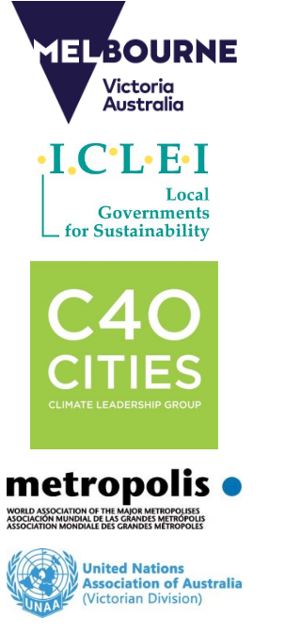
More info: http://www.ecocity2017.com/

