Cisco WebEx Meeting Set-up:
- Go to http://unhabitat.webex.com and click on the Log In Link on the upper right corner;
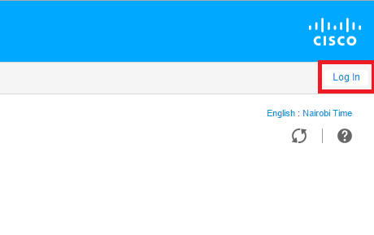
- Use the credentials provided to log into the administration page.
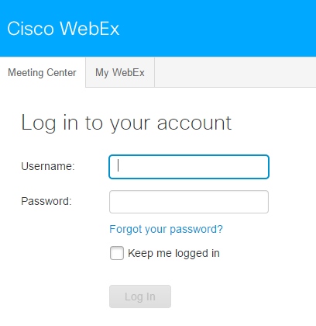

- To schedule a meeting, click on the Schedule a Meeting link on the left menu.
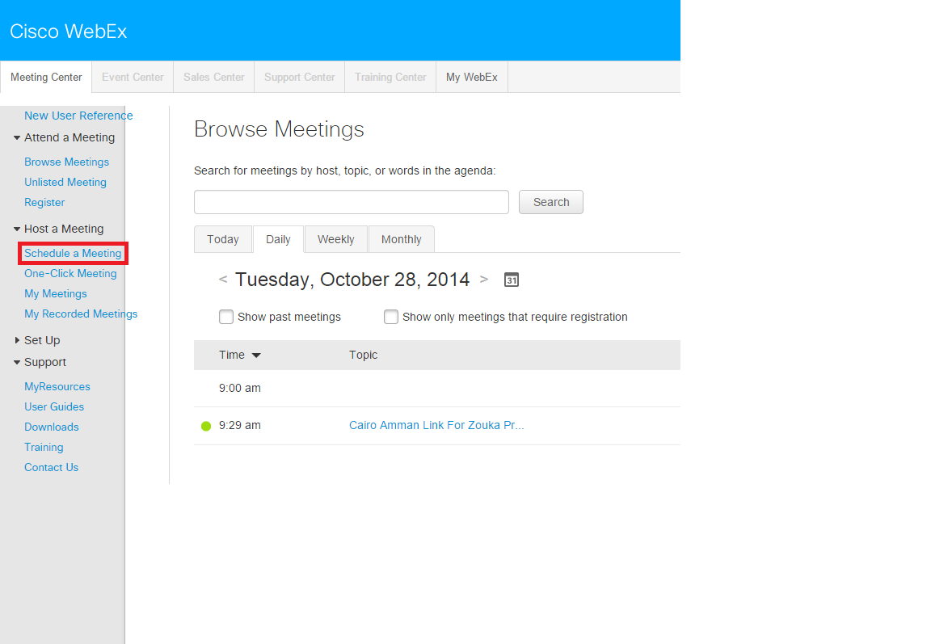

- Enter then required details (Topic, Meeting password and confirmation, date, time, time zone, Attendees emails, send copy) and click on the Schedule Meeting button to schedule the meeting and send out invitations.
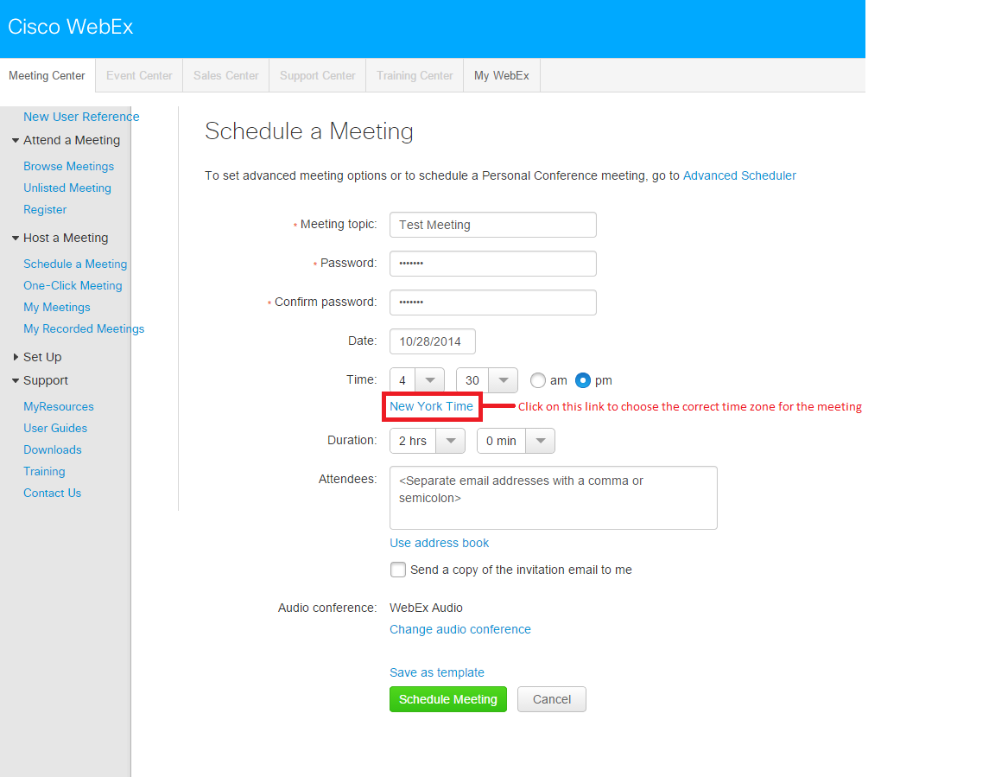

- To edit or delete a scheduled meeting, click on the Browse Meetings link on the left menu. Find the meeting by clicking on the “Today, Daily, Weekly and Monthly” tabs.
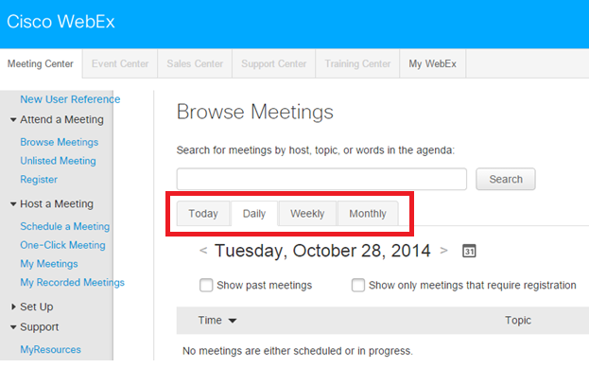

- Click on the meeting link, where you will find the edit and delete buttons.
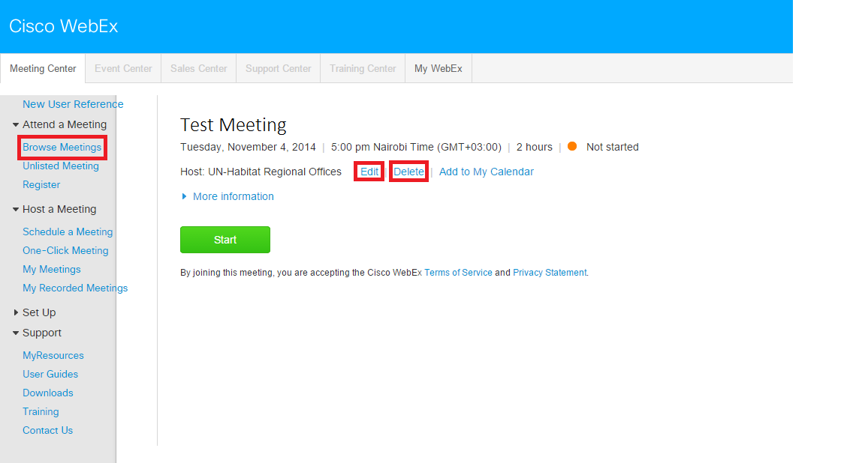
- To start a meeting, find the meeting link and click the meeting’s start button.

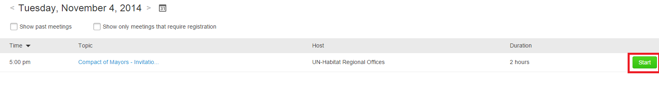

- Install and run the Cisco browser plugin (If not already installed). 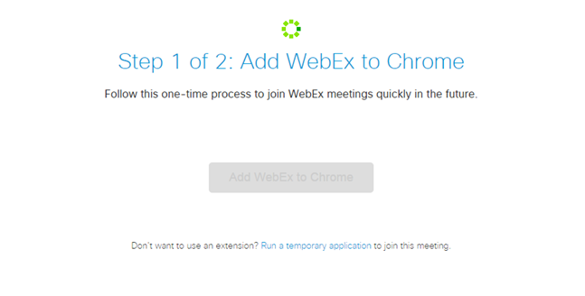
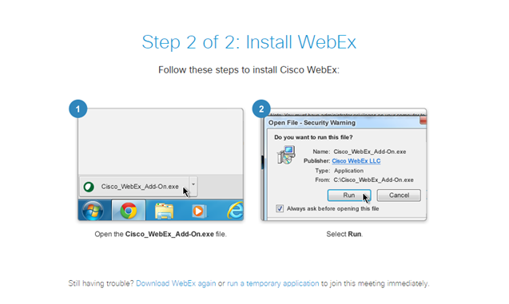
- Ensure pop-ups are not blocked. Wait for the meeting to load.

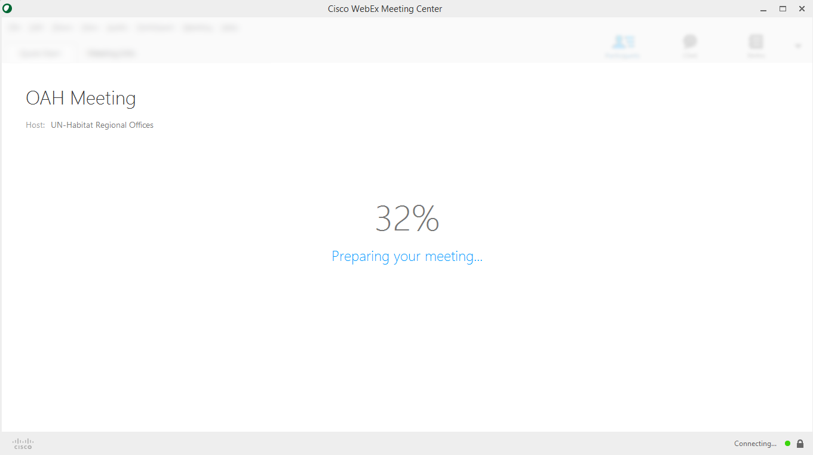

- Click the more button under the call using computer button to connect your audio. Connect your camera by clicking the camera icon

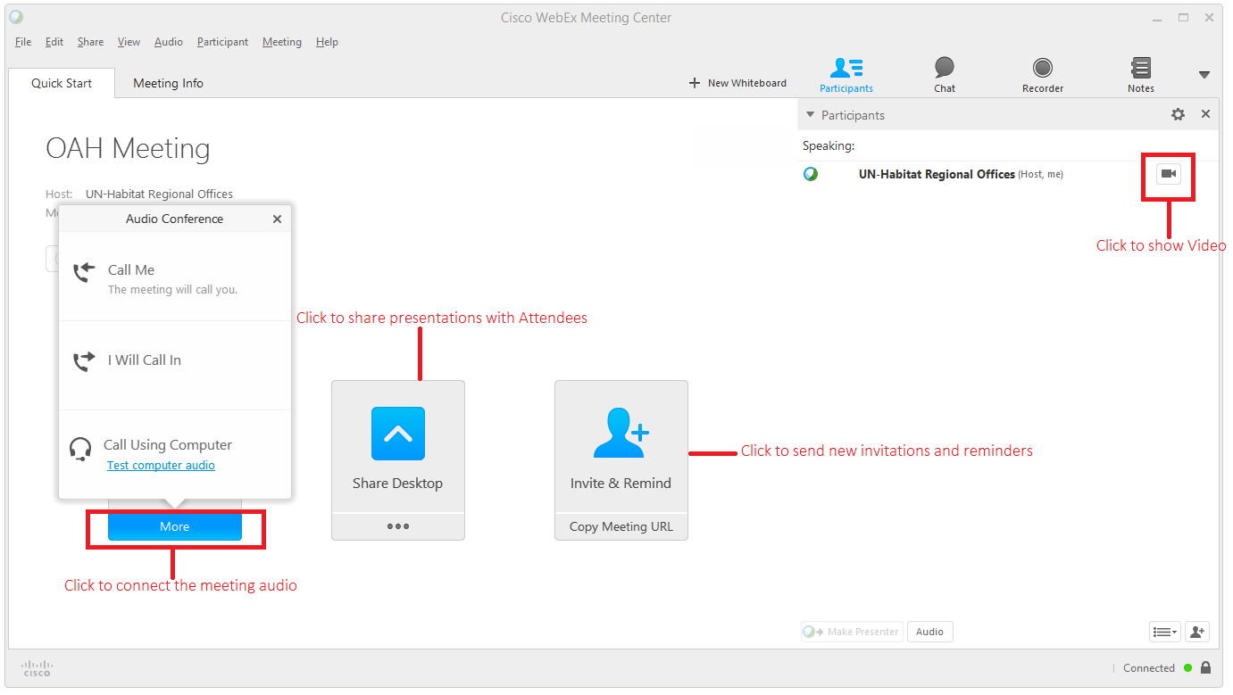

- To end the meeting, Click on the End Meeting Button and confirm.

