ABOUT
The largest and most prominent smart cities summit in Qatar is back for its sixth year. Across two days, the summit will bring together renowned industry leaders from the region and across the globe to lay emphasis on implementing strategic smart city developments and address the challenges faced in the region.
The 2017 Arab Future Cities Summit’s aim is to highlight the building blocks required towards achieving a sustainable and connected city.
LOCATION
The Ritz-Carlton, Doha, Qatar
DATE: 10-11 APRIL 2017
PREVIOUS DONORS:
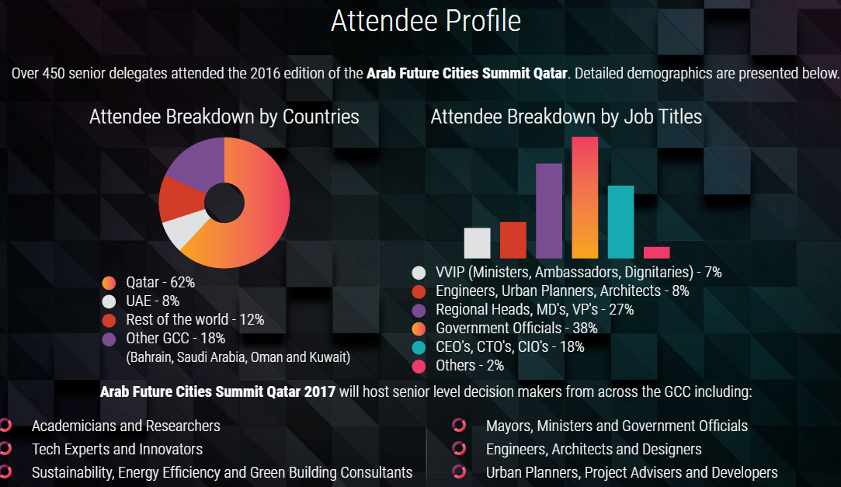
More Information: http://www.arabfuturecities.com/

