Seventy-sixth session
Items 140 and 141 of the preliminary list*

Proposed programme budget for 2022

Programme planning

* A/76/50.
** In keeping with paragraph 11 of resolution 72/266 A, the part consisting of the programme plan and programme performance information is submitted through the Committee for Programme and Coordination for the consideration of the General Assembly.
*** In keeping with paragraph 11 of resolution 72/266 A, the part consisting of the post and non-post resource requirements is submitted through the Advisory Committee on Administrative and Budgetary Questions for the consideration of the General Assembly.

Proposed programme budget for 2022

Part IV

International cooperation for development

Section 15

Human settlements

Programme 12

Human settlements

Contents
 |  |  | Page
Foreword |  |  | 3
- Proposed programme plan for 2022 and programme performance for 2020** |  |  | 4
- Proposed post and non-post resource requirements for 2022*** |  |  | 44
Annexes
- Organizational structure and post distribution for 2022 |  |  | 67
- Summary of follow-up actions taken to implement relevant recommendations of oversight bodies |  |  | 68
- Summary of proposed post changes, by component and subprogramme |  |  | 69

Foreword

The United Nations Human Settlements Programme (UN-Habitat) is entrusted with supporting Member States and other key stakeholders in addressing the many challenges of sustainable urbanization. This includes the achievement of the Sustainable Development Goals and the implementation of the New Urban Agenda to ensure the widest possible participation in the social, economic and environmental benefits brought by sustainable urban development. The coronavirus disease (COVID-19) pandemic has laid bare, and indeed heightened, both the challenges and the opportunities associated with the remarkable growth of cities. More than ever, a rights-based approach is needed to protect people, prosperity and planet.
The present document sets out the programme of work for UN-Habitat for 2022, demonstrating the capacity of the agency to adjust to these evolving conditions and the related economic crisis. The implementation of the strategic plan for the period 2020–2023 continues to reflect our renewed vision, focusing on impact and the achievement of the Sustainable Development Goals.
The 2020 UN-Habitat flagship World Cities Report 2020: The Value of Sustainable Urbanization, clarifies the intrinsic value of cities with regard to generating economic prosperity, mitigating environmental degradation, reducing social inequality and building stronger institutions. This supports the Secretary-General’s policy brief on COVID-19 in an urban world (July 2020). The 2022 programme of work prioritizes strategic support and guidance to countries and cities recovering from the COVID-19 pandemic. It provides evidence-based support to prepare urban development plans and actions for greater institutional coherence and effectiveness, with better coordination mechanisms and appropriate monitoring tools. The programme of work is the road map to respond to the most pressing challenges and allow recipient communities to participate fully and benefit from the social, economic and environmental gains of the sustainable urban agenda.
Based on the first year of implementation of the strategic plan for the period 2020–2023, UN-Habitat has been able to refine its catalytic functions, advance in the creation of innovative urban solutions and ideas, strengthen strategic partnerships and deliver more focused interventions. Owing to having to adapt to COVID-19 and locked down economies, not all targets were reached last year. The programme received less in voluntary resources, partly due to the impact of COVID-19, causing delays in implementation; as a result, some key targets were missed. UN-Habitat has produced publications and technical materials, through its earmarked funding and in line with donor intent, at the country and regional levels. This work will form a good basis for strengthening the global normative work. UN-Habitat has also initiated the implementation of flagship programmes that aim to strengthen the delivery capacity and efficiency of the strategic plan and the current portfolio. These programmes consolidate and refine existing initiatives with targeted interventions and mechanisms to engage with Governments and partners, resulting in effective vehicles to reinforce integration of our normative and operational work for higher efficiency and impact.
The programme of work for 2022 is key to coordinating these actions and achieving the best results. Financial resources commensurate with the ambition and deliverables proposed by this programme are needed to adequately respond to multiple urbanization challenges. It is only in this way that UN-Habitat will fulfil the objective to become a centre of excellence and innovation with the capacity to set the global discourse and agenda on sustainable urban development, generate specialized cutting-edge knowledge, shape technical norms, principles and standards, and propose innovative solutions to build a sustainable future for all.

(Signed) Maimunah Mohd Sharif
Executive Director, United Nations Human Settlements Programme

A. Proposed programme plan for 2022 and programme performance for 2020

Overall orientation

Mandates and background

15.1 The United Nations Human Settlements Programme (UN-Habitat) is responsible for sustainable urbanization and human settlements in the United Nations system. It supports Member States in the development of sustainable cities and human settlements through its normative and operational work at the global, regional, national and local levels. UN-Habitat also leads and coordinates the monitoring of and reporting on global progress in the implementation of the New Urban Agenda and Sustainable Development Goal 11. The mandate derives from priorities established by General Assembly resolutions and decisions, including resolution 3327 (XXIX), by which the Assembly established the United Nations Habitat and Human Settlements Foundation, and resolution 32/162, by which the Assembly established the United Nations Centre for Human Settlements (Habitat). The Assembly, through its resolution 56/206, transformed it to the United Nations Human Settlements Programme (UN-Habitat), effective 1 January 2002. The Assembly, through its resolution 73/239, established a new governance structure for the Programme, consisting of the universal UN-Habitat Assembly, the 36-member Executive Board and the Committee of Permanent Representatives.
15.2 The Programme’s support is aimed at developing the capacity at all levels of government and other key stakeholders to formulate and implement policies, plans and concrete activities for sustainable urban development through the implementation of the regular programme of technical cooperation and United Nations Development Account projects.

Strategy and external factors for 2022

15.3 Globally, 56 per cent of the population lives in cities. This share is expected to rise to 70 per cent by 2050, continuing to make urbanization one of the most significant trends of the twenty-first century. Regional and sociopolitical disparities continue to influence who benefits from urbanization. However, some 90 per cent of urban growth is taking place in less developed regions, where it is largely unplanned and capacities and resources are most constrained, while in other parts of the world many cities are experiencing negative growth and shrinking populations. Unplanned urban growth fuels the expansion of informal settlements and slums, resulting in an increase in urban poverty, inequality and lack of adequate and affordable housing. Globally, more than 1.6 billion people live in inadequate housing and more than 1 billion live in slums and informal settlements. Of significance to the programme of work are the estimated 763 million internal migrants and 224 million international migrants in 2019, most of whom live in urban areas, often under difficult conditions.
15.4 High levels of inequality and exclusion are persistent trends in urban areas; income inequality has increased in urban areas for more than two thirds of the world’s population since 1980. This widening gap means that some 2.9 billion people are living in cities, both in the developed and the developing world, where income inequalities are more pronounced than they were a generation ago. Cities are also hot spots for environmental and energy challenges, accounting for 60 to 80 per cent of global energy consumption, 70 per cent of global carbon emissions and more than 70 per cent of resource use. The urban poor, living in risk-prone and underserviced areas, suffer the worst consequences of climate change-related disasters and natural and human-made crises and conflicts. The coronavirus disease (COVID-19) pandemic has exacerbated the systemic inequalities that exist across territories and urban areas, where the urban poor are disproportionately affected due to crowded and underserviced environments. While urban areas have been the epicentre of the pandemic, this has equally demonstrated that cities are hubs of resilience and innovation. UN-Habitat will prioritize tailored approaches to fight the pandemic and support cities to build back better. Through technical cooperation, cities will be assisted in designing and implementing action plans to protect marginalized communities and strengthen participatory community engagement. Local governments will continue to be supported to accelerate the digital transformation in local governance as part of dedicated COVID-19 responses. Supporting citywide and spatially targeted approaches will contribute to improving living conditions in all settlements and reducing disadvantages in specific locations. Support will be provided to local governments to invest in social, economic, institutional and financial innovations for a sustained socioeconomic recovery. Partnerships will catalyse support for cities in building more resilient budgets and fiscal frameworks in support of local service delivery and local economic development. UN-Habitat will support cities in reshaping urban planning solutions that are more sustainable and integrated, supported by innovation and technology to become healthier and more resilient.
15.5 The strategy of UN-Habitat for delivering the programme plan in 2022 continues to be driven by the strategic plan for the period 2020–2023, which has proven robust in responding to the COVID-19 pandemic. The plan enables the organization to advance its innovative, delivery-focused and partnership-oriented model of operation. Its recently developed organizational structure makes UN-Habitat a dynamic, fit-for-purpose organization for delivering the four interconnected subprogrammes of the strategic plan for the period 2020–2023, which was approved by the UN-Habitat Assembly at its first session, in May 2019.
15.6 In addition, UN-Habitat flagship programmes are proving to be vehicles to fast-track integration between the normative and operational work of UN-Habitat, scaling the impact of the organization. In 2022, UN-Habitat will primarily focus on the following flagship programmes:
(a) “Sustainable Development Goals Cities” (SDG Cities). Supporting Member States in achieving the Sustainable Development Goals is the main goal of all four subprogrammes. This flagship programme is designed to advance the overall implementation of the Goals at the local level by supporting cities in developing and implementing transformative projects designed to maximize the progress of Member States towards achieving the Goals;
(b) “RISE-UP: resilient settlements for the urban poor”. This flagship programme will be implemented mainly by subprogrammes 1 and 3 by leveraging large-scale investment to build urban adaptation and climate resilience in global hotspots of vulnerability and also address issues of spatial inequality;
(c) “Inclusive cities: enhancing the positive impacts of urban migration”. This flagship programme will mainly respond to subprogrammes 1 and 4 by supporting local and national authorities in creating inclusive and non-discriminatory urban environments for all people;
(d) Two other flagship programmes, on “inclusive, vibrant neighbourhoods and communities” and “people-centred smart cities”, will be mainstreamed across the four subprogrammes, strengthening links across the outcomes of the strategic plan. In addition, a normative and capacity-building approach to strengthen the agency-wide operationalization of digital transformation in sustainable urbanization contexts will be implemented.
15.7 In 2022, the programme will continue to streamline social inclusion as a process and outcome to address cross-cutting issues relating to older persons, children, people with disabilities, gender and youth. UN-Habitat will strengthen its programmatic approach to leaving no one behind by focusing on the spatial dimension of exclusion and the self-reinforcing mechanisms of marginalization, thereby assisting Governments in providing basic services, housing and public goods in the most deprived areas of cities. UN-Habitat thematic areas of resilience and urban safety will be cross-cutting in guiding frameworks, tools and capacity-building materials, setting standards, proposing norms and principles, and sharing good practices on social inclusion issues. Global networks such as the Global Land Tool Network, the Global Water Operators’ Partnerships Alliance, the Resilient Cities Network, the Global Network on Safer Cities, the Global Network of Urban Planning and Design Labs and the Global Network of Public Space will be systematically engaged to develop and test these tools.
15.8 To better meet the needs of Member States and to engage a wider audience, UN-Habitat will strengthen capacity-building initiatives, digitization of tools and virtual e-learning programmes. The UN-Habitat capacity-building strategy for the implementation of the Sustainable Development Goals and the New Urban Agenda, adopted by its Executive Board in 2020, provides a clear framework to fill the institutional and operational gap within UN-Habitat for greater coordination, coherence and monitoring of results and to improve the delivery of capacity-building services to Member States and local governments, as well as other key urban stakeholders, for greater impact and resource efficiency. Some of the first results, including an illustrated handbook on the New Urban Agenda, along with an online course, have been launched to expand its implementation.
15.9 UN-Habitat will continue to build on its experience of implementing large-scale programmes and projects at the local, national and regional levels to guide technical cooperation work and ensure that it has a demonstrable impact on the lives of beneficiaries. Over the years, UN-Habitat has developed a wide range of diverse projects, focused in large part on integrated programming for sustainable urbanization, as well as activities ranging from crisis response to post-disaster and post-conflict reconstruction and rehabilitation.
15.10 In its catalytic role as a knowledge hub and partner convenor, UN-Habitat will carry out advocacy, communication and outreach activities across the four subprogramme themes and mobilize public and political support. It will continue to make maximum use of advocacy and knowledge platforms, including its own website, the Urban Agenda Platform and key global meetings such as the World Urban Forum, World Cities Day and World Habitat Day, regional ministerial conferences and the 2022 high-level meeting of the General Assembly on the implementation of the New Urban Agenda.
15.11 As a focal point for sustainable urbanization and human settlements, UN-Habitat will continue to monitor and report on global conditions and trends and provide evidence for policymaking. For 2022, UN-Habitat will prepare the second quadrennial report on the progress made in the implementation of the New Urban Agenda, in close collaboration with other United Nations entities and development partners. The programme will also prepare the second synthesis report for Goal 11 and other urban Sustainable Development Goals, to be presented at the high-level political forum on sustainable development. These reports will be supported by reporting guidelines for Member States and other stakeholders, a dedicated global online Urban Agenda Platform, a new global urban monitoring framework, an agreed operational definition of urban areas, specialized tools for spatial analysis and the re-establishment of the Urban Indicators Programme. Progress will be made in 2022 in the deployment of technologies for data collection and analysis, visualization and management of information. The use of the City Prosperity Index, and its adaptation to a global monitoring framework, will serve in the implementation of the Sustainable Development Goals cities flagship programme to assist in the realization of Sustainable Development Goals in cities and the preparation of voluntary local reviews.
15.12 For 2022, UN-Habitat planned deliverables and activities reflect known and anticipated challenges related to the COVID-19 pandemic that are being faced by Member States. Such planned deliverables and activities include: (a) assisting Governments in supporting increased access to water and sanitation and adequate housing, (b) advocating for the prevention of evictions and (c) measuring and reducing spatial vulnerability and (d) preparing urban planning strategies and local resilience programmes. Specific examples of such planned deliverables and activities are provided under the four subprogrammes. The global database produced by UN-Habitat in partnership with CitiIQ provides data on 1,500 cities, and analyses the initial conditions of the cities, their response capacity and the incidence of infection and death. The spatial vulnerability index for COVID-19 and a global report on the state of cities with dedicated policy recommendations will serve to support technical interventions. These data and knowledge, combined with normative and operational work adjusted to respond to the pandemic from a short- and long-term perspective, provide opportunities for cities and Member States to address structural inequalities and prepare for social and economic recovery. The UN-Habitat programme of work for 2022 will focus all efforts of the different subprogrammes and deploy advisory services, innovative solutions, and knowledge packages to support Member States in the fight against COVID-19 and other pandemics.
15.13 With regard to cooperation with other entities at the global, regional, national and local levels, UN-Habitat will build on its close cooperation with international and regional organizations and other regional actors, such as the Organisation for Economic Co-operation and Development, the World Bank, the European Union and regional development banks.
15.14 With regard to inter-agency coordination and liaison, UN-Habitat will continue to play a key role in supporting efforts by Member States to develop policies, frameworks and actions that enhance the transformative value of urbanization and maximize city responses to the COVID-19 pandemic. This will be done through collaboration with local and regional governments and their associations and city networks, the Department of Economic and Social Affairs, the United Nations regional economic and social commissions, the Cities Alliance and partnerships and coalitions with grass-roots organizations, foundations, international financial institutions, the private sector and academia. UN-Habitat will continue to strengthen its strategic partnerships with other United Nations agencies. To support Member States in developing innovative policies and actions that promote inclusive and sustainable economic growth, employment and decent work for all, particularly women and young people, UN-Habitat will collaborate with the Food and Agriculture Organization of the United Nations, the International Fund for Agricultural Development, the International Labour Organization (ILO), the International Organization for Migration (IOM), the United Nations Industrial Development Organization, the International Telecommunication Union, the United Nations Capital Development Fund, the United Nations Conference on Trade and Development, the United Nations Innovation Network, technology companies, “smart city” associations, innovation hubs, academia and other organizations.
15.15 To mainstream environmental sustainability into urban development, UN-Habitat will collaborate with the United Nations Environment Programme (UNEP), climate funds, the urban climate knowledge and innovation communities and organizations focusing on resilience, such as the United Cities and Local Government and ICLEI-Local Governments for Sustainability initiatives. To implement the Greener Cities Partnership, UN-Habitat will collaborate with the secretariat of the United Nations Framework Convention on Climate Change to develop national climate action plans and with the United Nations Office for Disaster Risk Reduction, the World Bank, the European Union and the United Nations Development Programme (UNDP) to develop frameworks for joint financing mechanisms and to harmonize the implementation of the Sendai Framework for Disaster Risk Reduction 2015–2030. UN-Habitat will collaborate with the Office of the United Nations High Commissioner for Refugees, UNDP, IOM, the United Nations Office for Disaster Risk Reduction, the World Food Programme (WFP), the Mayors Migration Council and the Resilient Cities Network to integrate sustainable urban development into resilience and humanitarian response, and with the United Nations Office on Drugs and Crime (UNODC) to promote safety in public spaces. UN-Habitat will collaborate with the World Health Organization (WHO) and the United Nations Children’s Fund (UNICEF) on the monitoring of water and sanitation and on mainstreaming the New Urban Agenda into UN-Water and UN-Energy. UN-Habitat will also collaborate with the United Nations Entity for Gender Equality and the Empowerment of Women (UN-Women) to promote gender equality and ensure that projects benefit women and girls.
15.16 UN-Habitat will continue to work closely with the Department of Economic and Social Affairs and the regional economic and social commissions to serve as a knowledge platform and the global first port of call for data and knowledge on cities, towns and rural settlements. Given that cities play a vital role in realizing the sustainable urban development agenda, UN-Habitat will reenergize its partnerships with local authorities and their associations and city networks in the context of national policies. Furthermore, the Programme will fully support municipal efforts in the local achievement and monitoring of the Sustainable Development Goals and the implementation of the New Urban Agenda through work on policy, legislation, governance, planning and design, and financing mechanisms. It will also collaborate with the Resident Coordinator system to improve the efficiency and effectiveness of operational activities at the country level, supporting common country assessments and the formulation of the United Nations Sustainable Development Cooperation Framework.
15.17 With regard to external factors, the overall plan for 2022 is based on the following planning assumptions:
(a) Adequate unearmarked extrabudgetary resources are available to implement the planned work and produce the deliverables;
(b) Country make commitments to the New Urban Agenda and the 2030 Agenda for Sustainable Development;
(c) Ongoing requests are received from national and local governments for policy advice and technical support from UN-Habitat in the development and implementation of their urban policies, plans and strategies;
(d) Urban indicators, data and information are used to formulate policies, with adequate mechanisms available for impact monitoring and the assessment of city performance;
(e) Social, political and macroeconomic stability continues in the areas in which UN-Habitat and partners will be implementing programmes and projects.
15.18 With regard to the COVID-19 pandemic, the programme plan is based on the assumption that the proposed deliverables and activities for 2022 will be feasible to implement. However, if the pandemic were to continue to have an impact on the planned deliverables and activities, they would be adjusted during 2022 within the scope of the overall objectives, strategies and mandates. Any such adjustments would be reported as part of the programme performance information.
15.19 UN-Habitat integrates a gender perspective in its operational activities, deliverables and results, as appropriate, with guidance from its Advisory Group on Gender Issues. For example, one of the 2022 planned results for subprogramme 1 demonstrates the aim of UN-Habitat interventions to support Member States with policy, legislation, planning and financing instruments to implement integrated, inclusive and gender-responsive land and housing policies that improve tenure security for all, and continue the work related to strengthened land rights for men and women in the Arab world.
15.20 UN-Habitat integrates disability inclusion in its operational activities, deliverables and results as appropriate. Through the work of its subprogrammes, UN-Habitat is working with its partners to develop a disability inclusion strategy in line with the one released by the Secretary-General in 2019. Following the establishment of agreements with memorandums of understanding with the World Blind Union and World Enabled, UN-Habitat is also developing guidelines for disability inclusion by enhancing the environmental and social safeguards framework that is applied to all projects, to be socially inclusive, including disability inclusion as an integral part of each project presented for approval.

Programme performance in 2020

Impact of COVID-19 on programme delivery

15.21 During 2020, the COVID-19 pandemic had an impact on the planned deliverables and activities of UN-Habitat. The impact included adjusting support to national and local authorities, as well as local communities, by shifting from face-to-face meetings and technical advisory missions to virtual and/or hybrid meetings. UN-Habitat progressively moved towards alternative forms of gatherings and consultations, using virtual meeting platforms, and remote technical support, combining local consultants with remote virtual advisory services. Specific activities related to technical cooperation projects were delayed or postponed due to severe international travel restrictions as a result of the COVID-19 pandemic. Specific examples of the impact are provided under all four subprogrammes. The change in approach of planned deliverables and activities also had an impact on the expected results for 2020, as described in the programme performance under subprogrammes 1, 2 and 3.
15.22 At the same time, however, some planned deliverables and activities were modified, and new activities were identified during 2020, within the overall scope of the objectives of the subprogrammes, in order to support Member States on issues related to the COVID-19 pandemic. Those included modifications and new activities at the normative level: contributions to the policy brief by the Secretary-General on COVID-19 in an urban world and to “A United Nations framework for the immediate socio-economic response to COVID-19”, the preparation of the Cities and Pandemics: Towards a More Just, Green and Healthy Future report and several technical guidelines to support the response to COVID-19 under the UN-Habitat COVID-19 response plan. At the operational level, UN-Habitat adjusted its programming to help respond to the pandemic through its COVID-19 response plan and partnered with United Cities and Local Government to facilitate a series of live learning sessions, facilitating north-south and south-south exchange on COVID-19 response. Specific examples of the modified and new activities are provided under all four subprogrammes. The modified and new deliverables and activities contributed to results in 2020, as described in the programme performance under subprogrammes 1, 2 and 3.
15.23 Reflecting the importance of continuous improvement and responding to the evolving needs of Member States, the programme will mainstream lessons learned and best practices related to the adjustments to and adaptation of its programme owing to the COVID-19 pandemic. Specific examples of lessons learned include the continuation of virtual meeting modalities where possible for expert group meetings, which allows for broader participation, and complementing the existing tools of UN-Habitat with online digital learning companions to expand its outreach.

Legislative mandates

15.24 The list below provides all mandates entrusted to the programme.

General Assembly resolutions

3327 (XXIX) | Establishment of the United Nations Habitat and Human Settlements Foundation
34/114 | Global report on human settlements and periodic reports on international cooperation and assistance on human settlements
53/242 | Report of the Secretary-General on environment and human settlements
55/2 | United Nations Millennium Declaration
S-25/2 | Declaration on Cities and Other Human Settlements in the New Millennium
56/206 | Strengthening the mandate and status of the Commission on Human Settlements and the status, role and functions of the United Nations Centre for Human Settlements (Habitat)
70/1 | Transforming our world: the 2030 Agenda for Sustainable Development
71/256 | New Urban Agenda
72/146 | Policies and programmes involving youth
72/234 | Women in development
75/212 | United Nations Conference on the Midterm Comprehensive Review of the Implementation of the Objectives of the International Decade for Action, “Water for Sustainable Development”, 2018–2028
75/221 | Ensuring access to affordable, reliable, sustainable and modern energy for all
75/224 | Implementation of the outcomes of the United Nations Conferences on Human Settlements and on Housing and Sustainable Urban Development and strengthening of the United Nations Human Settlements Programme (UN-Habitat)

UN-Habitat Assembly resolutions and decisions

1/1 | United Nations Human Settlements Programme strategic plan for the period 2020–2023
1/2 | United Nations System-Wide Guidelines on Safer Cities and Human Settlements
1/3 | Enhancing capacity-building for the implementation of the New Urban Agenda and the urban dimension of the 2030 Agenda for Sustainable Development
1/4 | Achieving gender equality through the work of the United Nations Human Settlements Programme to support inclusive, safe, resilient and sustainable cities and human settlements
1/5 | Enhancing urban-rural linkages for sustainable urbanization and human settlements
Decision 1/3 | Arrangements for the transition towards the new governance structure of the United Nations Human Settlements Programme

Executive Board decisions

2019/1 | Implementation of the strategic plan for the period 2014–2019 and the strategic plan for the period 2020–2023, and approval of the work programme and budget for 2020
2019/2 | Financial, budgetary and administrative matters of the United Nations Human Settlements Programme
2019/3 | Implementation of normative and operational activities of the United Nations Human Settlements Programme, including the resolutions and decisions of the United Nations Human Settlements Assembly
2020/3 | Implementation of the strategic plan for the period 2014–2019, the strategic plan for the period 2020–2023, approval of the draft work programme and draft budget for 2021, implementation by the United Nations Human Settlements Programme of the reform of the development system and management of the United Nations, and alignment of the planning cycles of the Programme with the quadrennial comprehensive policy review process
2020/4 | Financial, budgetary and administrative matters of the United Nations Human Settlements Programme
2020/5 | Implementation of normative and operational activities of the United Nations Human Settlements Programme, including resolutions and decisions of the United Nations Habitat Assembly, and reporting on the programmatic activities of the Programme in 2020 and the implementation of subprogrammes, flagship programmes and technical cooperation activities

Governing Council resolutions

19/4 | Cooperation between the United Nations Human Settlements Programme and the United Nations Environment Programme
19/11 | Strengthening the United Nations Habitat and Human Settlements Foundation
20/6 | Best practices, good policies and enabling legislation in support of sustainable urbanization and the attainment of internationally agreed development goals
20/16 | Enhancing the involvement of civil society in local governance
21/3 | Guidelines on decentralization and strengthening of local authorities
21/7 | Sustainable public-private partnership incentives for attracting large-scale private-sector investment in low-income housing
22/9 | South-South cooperation in human settlements
23/3 | Support for pro-poor housing
23/10 | Future activities by the United Nations Human Settlements Programme in urban economy and financial mechanisms for urban upgrading, housing and basic services for the urban poor
24/5 | Pursuing sustainable development through national urban policies
24/7 | Making slums history: a worldwide challenge
24/11 | Promoting sustainable urban development by creating improved economic opportunities for all, with special reference to youth and gender
24/13 | Country activities by the United Nations Human Settlements Programme
25/1 | Contribution of the United Nations Human Settlements Programme to the post-2015 development agenda in order to promote sustainable urban development and human settlements
25/2 | Strengthening national ownership and operational capacity
25/6 | International guidelines on urban and territorial planning
25/7 | United Nations Human Settlements Programme governance reform
26/4 | Promoting safety in cities and human settlements
26/5 | Regional technical support on sustainable housing and urban development by regional consultative structures
26/6 | World Urban Forum
26/9 | Human settlements development in the Occupied Palestinian Territory

Economic and Social Council resolutions

2003/62 | Coordinated implementation of the Habitat Agenda
2017/24 | Human settlements
2020/7 | Affordable housing and social protection systems for all to address homelessness
2020/9 | Mainstreaming a gender perspective into all policies and programmes in the United Nations system

Deliverables

15.25 Table 15.1 lists all cross-cutting deliverables, by category and subcategory, for the period 2020–2022.

Table 15.1

Cross-cutting deliverables for the period 2020–2022, by category and subcategory

Category and subcategory | 2020 planned | 2020 actual | 2021 planned | 2022 planned
A. Facilitation of the intergovernmental process and expert bodies
Parliamentary documentation (number of documents) | – | – | 2 | 2
1. UN-Habitat inputs to reports of the Secretary-General and other United Nations system-wide documents | – | – | 1 | 1
2. Implementation of the outcome of the United Nations Conference on Housing and Sustainable Urban Development (Habitat III) and strengthening of the United Nations Human Settlements Programme (UN-Habitat): report of the Secretary-General | – | – | 1 | 1
Substantive services for meetings (number of three-hour meetings) | 6 | 12 | 7 | 17
3. Meetings of the governing bodies (UN-Habitat Assembly, Executive Board and Committee of Permanent Representatives) | 3 | 9 | 4 | 12
4. Meeting of the Committee for Programme and Coordination | 1 | 1 | 1 | 1
5. Meeting of the Advisory Committee on Administrative and Budgetary Questions | 1 | 1 | 1 | 1
6. Meeting of the Fifth Committee | 1 | 1 | 1 | 1
7. General Assembly high-level meeting on the review of the implementation of the New Urban Agenda | – | – | – | 2
B. Generation and transfer of knowledge
Publications (number of publications) | 5 | 2 | 6 | 5
8. UN-Habitat flagship reports | 4 | 1 | 5 | 2
9. World Cities Report | 1 | 1 | 2 | 1
10. Second quadrennial report on the implementation of the New Urban Agenda | – | – | – | 1
11. UN-Habitat annual report | 1 | 1 | 1 | 1

ª The 2022 planned deliverables, to be funded from the foundation non-earmarked fund, have been adjusted downward, taking into account the resources approved by the Executive Board of $10.0 million for 2021 and a budget ceiling figure of $12.0 million in 2022, as shown in table 15.14.

Evaluation activities

15.26 The following self-evaluations completed in 2020 have guided the proposed programme plan for 2022:
(a) Impact evaluation of the UN-Habitat housing approach on adequate, affordable housing and poverty reduction;
(b) Final evaluation of the implementation of UN-Habitat strategic plan for the period 2014–2019;
(c) Midterm evaluation of the municipal governance support programme, 2015–2021;
(d) Midterm evaluation of the Accelerating climate action through the promotion of Urban Low Emission Development Strategies (Urban-LEDS II) project;
(e) End-of-project evaluation of the Fostering the tenure and resilience of Palestinian communities through spatial economic planning intervention in area C project;
(f) End-of-project evaluation of the making cities sustainable and resilient project (2016–2020).
15.27 The findings, lessons and recommendation of the self-evaluations referenced above have been taken into account for the programme plan for 2022 and informed the implementation of the strategic plan for the period 2020–2023. For example, on the basis of recommendations from the final evaluation of the strategic plan for the period 2014–2019, an inventory of normative tools is in development to facilitate the costing of methods used and strengthen linkages between normative and operational programming and learning within the organization. This is supported by the Umoja integrated planning, management and reporting tool, which is to be rolled out in 2021 and will contribute to strengthening processes and systems for integrated outcome-focused design, monitoring and reporting by tracking project outputs and outcomes, tools and linkages to the strategic plan. Further, UN-Habitat has built a network of focal points at the country level to strengthen its engagement in the common country analysis process in 15 selected countries and promote sustainable urbanization in relation to the United Nations reform process.
15.28 Based on recommendations stemming from the impact evaluation of the housing approach of UN-Habitat, concerted efforts were made to advance the role of housing in the UN-Habitat portfolio. For example, housing was a theme of the Urban October 2020 Housing for All Campaign (#Housing4All), strengthening linkages with other UN-Habitat programmes and national and international partners. Moving forward, UN-Habitat is reviewing the operationalization of the right to adequate housing, including by developing a monitoring and reporting framework, and revising the position of UN-Habitat on and methods related to the governance and management of adequate housing. This has become all the more important in the light of the COVID-19 pandemic.
15.29 The following self-evaluations are planned for 2022:
(a) Evaluation of the impact and outcomes of the eleventh session of the World Urban Forum;
(b) Evaluation of two country programmes;
(c) Six evaluations of projects that close in 2022;
(d) Two thematic self-evaluations.

Programme of work

Subprogramme 1

Reduced spatial inequality and poverty in communities across the urban-rural continuum

Objective

15.30 The objective, to which this subprogramme contributes, is to reduce inequality between and within communities, and to reduce poverty in communities across the urban-rural continuum through increased and equal access to basic services, sustainable mobility, accessible and safe public space, increased and secure access to land, adequate and affordable housing and effective human settlements growth and regeneration.

Strategy

15.31 To contribute to the objective, the subprogramme will develop and disseminate toolkits, standards and technical guidelines to Member States, and engage partner cities in policy dialogues, peer-to-peer support, the sharing of best practices, training sessions and other capacity-building initiatives to strengthen institutional and managerial capacity towards improved access to and the efficiency, quality, reliability and sustainability of basic services, such as water, sanitation and energy, and the provision of sustainable mobility and public space in order to mitigate and adapt to climate change and reduce environmental impacts, such as air and water pollution. In the area of waste management, the subprogramme will continue to expand its Waste Wise Cities campaign, which focuses on mobilizing national and local governments to commit to improving their waste management practices and resource efficiency through rethinking, reducing, reusing and recycling materials and waste before and after consumption, UN-Habitat will also support national and local authorities in building capacity to use frontier technologies to improve the provision and management of basic services for all. This work helps Member States make progress towards achieving the Sustainable Development Goals, in particular Goals 1, 6, 7, 11, 12 and 14.
15.32 The subprogramme will provide Member States with policy, legislation, planning and financing instruments to implement integrated and inclusive and gender-responsive land and housing policies that improve tenure security for all, provide adequate, affordable housing and prevent unlawful forced evictions. The subprogramme will advocate for the implementation of sustainable building codes, regulations and sustainability certification tools for the housing sector while contributing to an urban energy transition. This work helps Member States make progress towards achieving Goals 1, 2, 5, 11 and 15.
15.33 The subprogramme will also provide technical assistance to national and local governments to develop specific integrated plans, policies, technical guidelines and toolkits in line with the International Guidelines on Urban and Territorial Planning and principles of sustainable urbanization. The subprogramme will provide technical assistance to national and local governments and cities seeking to develop specific bankable, catalytic and pilot urban interventions. It will support partner cities in institutionalizing different approaches on urban regeneration through the development of specific plans, policies, technical guidelines and toolkits. The subprogramme will provide guidance on how planning for urban expansion and regeneration can contribute to climate mitigation and adaptation and make urban growth more inclusive. This work helps Member States make progress towards achieving Goal 11.
15.34 The subprogramme will continue to support Member States on issues related to COVID-19 by supporting national and local governments on recovering from COVID-19 in cities and human settlements by disseminating toolkits, best practices and technical guidelines for addressing the structural inequalities exposed by the pandemic. The subprogramme will scale up access to basic and social services, sustainable mobility and safe public space, in particular in urban slums and informal settlements and for people in vulnerable situations, focus more on the need for adequate and affordable housing and the prevention of unlawful evictions and develop more integrated and inclusive urban development programming, integrating, for instance, health in urban and territorial planning and ensuring proximity to jobs and basic services and infrastructure.
15.35 The above-mentioned work is expected to result in:
(a) Improved quality, accessibility, inclusion and safety of public spaces for all in urban areas;
(b) An increased number of people living in adequate and affordable housing and strengthened capacities of policymakers to implement sustainable land governance systems;
(c) The transformation and regeneration of dilapidated urban areas into social and economically inclusive areas that offer improved quality of life to inhabitants.

Programme performance in 2020

15.36 Programme performance in 2020 includes the below result that emerged during 2020, as well as programme performance presented under results 1 and 2 below.

Transformed cities and communities through safe, inclusive and accessible public spaces

15.37 Public space represents a vital element of urban efficiency, mobility and social interaction. Public spaces are diminishing and are unequally distributed due to unplanned development, inadequate street networks, overcrowding, encroachment, poor maintenance and privatization. These factors contribute to public spaces often being inaccessible to large sections of society. The challenge of inadequate public spaces compounds spatial inequalities and specifically harms the urban poor and marginalized communities. Cities and towns struggle to identify relevant, locally based approaches to co-create and implement public space interventions at different scales and to maintain those spaces. The COVID-19 crisis has also highlighted how public spaces represent a key lifeline for marginalized populations and an important asset for deploying emergency measures, facilitating the delivery of essential services and hosting well-spaced activities to enable recreation. Active in 88 cities, the subprogramme provided advice and technical support to cities and local governments worldwide on all dimensions of public space enhancement, from assessment to creation and management. For example, the subprogramme has developed tools and partnerships to undertake citywide public space assessments, implemented site-specific assessments in over 41 cities in 2020 and worked on both individual sites (26 in 2020) and citywide strategies (11 in 2020). The subprogramme encourages, women, children, youth, older persons and persons with disabilities to participate in the public space design processes by using tailored tools to reimagine and co-create their surroundings. In India, the United Arab Emirates and South Africa, the subprogramme engaged persons with disabilities to design public spaces to improve their accessibility and provide disability-friendly spaces while ensuring safety through providing spaces for all genders, supporting multifunctionality and amenities such as lighting. Through this process, the subprogramme engaged 6,750 citizens in participatory planning and 470 citizens in digital workshops, and trained 560 people on public space assessments.
15.38 The subprogramme also supported 10 cities in their COVID-19 recovery through capitalizing on public spaces as opportune places to restore livelihoods, increase accessibility to essential services and improve the well-being of those in vulnerable situations. These projects addressed a variety of challenges, such as decongestion and digitization of local markets, increasing hygiene and sanitation in slums, creating livelihood opportunities and raising awareness through culture and art. The project engaged 6,230 people in 88 workshops. The implementation of these small interventions enabled cities to slowly reopen and allowed communities to regain confidence in being out in the public realm and using public spaces safely for economic and social purposes. Furthermore, the subprogramme enabled local and national governments to embrace the potential of public spaces as flexible and resilient spaces during emergencies and crisis and understood the need to adopt policies and regulations and invest in scaling up interventions at the city level.

Progress towards the attainment of the objective, and performance measure

15.39 The above-mentioned work contributed to the objective, as demonstrated by 972,787 people in 88 cities who have access to safe and inclusive public spaces through public space interventions (see figure 15.I).

Figure 15.I

Performance measure: total number of beneficiaries in 88 cities with access to safe and inclusive public spaces through public space interventions (cumulative)

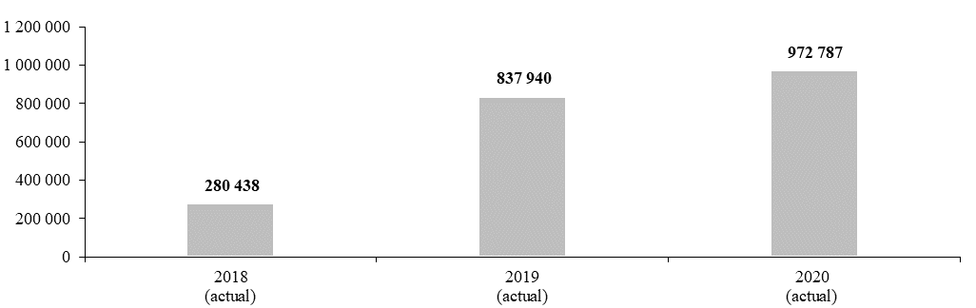

Impact of COVID-19 on subprogramme delivery

15.40 Owing to the impact of COVID-19 during 2020, the subprogramme cancelled planned in-person events, including seminars, training sessions, workshops and conferences as of the second quarter of 2020. On some occasions, these events were postponed until further notice or conducted remotely, utilizing the application of online conferencing tools. Considerable progress in the utilization of information and communications technology tools for the organization of urban planning sessions with stakeholder engagement processes was achieved. The adjustment to new working modalities had an impact on the programme performance in 2020, as specified in result 3 below.
15.41 At the same time, however, the subprogramme identified new and modified activities to support Member States on issues related to the COVID-19 pandemic, within the overall scope of objectives and within the margins of projects funded from extrabudgetary resources, namely, technical advisory services and infrastructure solutions in order to enhance access to hygiene facilities, including access to safe drinking water and the extension of water supply to the most vulnerable communities, particularly in urban slums and informal areas. A particular emphasis was placed on expanding livelihood opportunities, particularly for households headed by women, and introducing sustainable management modalities for newly created infrastructure and service provision. In particular, the subprogramme supported the mainstreaming of housing and basic urban services as interventions highlighted in national-level socioeconomic impact assessments and recovery strategies at the country and city levels, as well as advised ongoing programme activities in this regard to adapt to COVID-19 response and recovery. Moreover, the subprogramme supported the development of an implementation tool for local authorities on leading local adaptation to COVID-19 in informal settlements. The modified deliverables contributed to results in 2020, as specified in the emerging result above.

Planned results for 2022

15.42 The planned results for 2022 include results 1 and 2, which are updates of results presented in the preceding proposed programme plans and therefore show both the programme performance in 2020 and the proposed programme plan for 2022. Result 3 is a new planned result.

Result 1: Strengthened land rights for men and women in the Arab world

Programme performance in 2020

15.43 The subprogramme has continued to support the work done by partners and other land actors in the Arab region by establishing partnerships and formalizing collaboration with eight organizations in the region. The subprogramme also held one partnership-building event with champions based in the region. Furthermore, the subprogramme conducted two capacity development events, on monitoring land governance and land tenure security in the Arab region (Middle East subregion) and on the role of civil society organizations in land governance in the Arab region.
15.44 The above-mentioned work contributed to eight institutions involved in land administration in the Arab States implementing inclusive and gender-appropriate normative products on land as tools to develop their research and curricula with support from UN-Habitat, which exceeded the planned target of six institutions reflected in the proposed programme budget for 2020.

Proposed programme plan for 2022

15.45 The subprogramme will continue the work related to the planned result, in line with its mandate. To contribute to further progress towards the objective, the subprogramme will continue the capacity development, as well as the knowledge- and partnership-building, in the region. The expected progress is presented in the updated performance measure below (see table 15.2).

Table 15.2

Performance measure

2018 (actual) | 2019 (actual) | 2020 (actual) | 2021 (planned)ª | 2022 (planned)
Two institutions involved in land administration in the Arab States implementing inclusive and gender-appropriate land tools and approaches | Four institutions involved in land administration in the Arab States implementing inclusive and gender-appropriate land tools and approaches | Eight institutions involved in land administration in the Arab States implementing inclusive and gender-appropriate land tools and approaches | Eight institutions involved in land administration in the Arab States implementing inclusive and gender-appropriate land tools and approaches | Both men and women in eight cities benefit from more comprehensive institutional support from land sector organizations, leading to the acquisition of stronger tenure security

ª To maintain accountability for initial programme plans, the 2021 target is carried forward from the programme budget for 2021 and reflects best estimates at that point in time before the COVID-19 pandemic. Programme performance for 2021 will be reported in the proposed programme budget for 2023.

Result 2: inclusive, vibrant neighbourhoods and communities

Programme performance in 2020

15.46 The subprogramme created new partnerships, established legal agreements and mobilized resources to start the development of comprehensive guidelines and tools to support Member States in the areas of spatial inequality reduction, urban regeneration, participatory planning and socioeconomic recovery. Furthermore, the subprogramme acted as an umbrella programme to provide technical assistance to ongoing urban regeneration and socioeconomic projects in Asia, Africa, the Arab States and Latin America and the Caribbean.
15.47 The above-mentioned work contributed to the adoption of urban regeneration policies by 8 cities, which did not meet the planned target of 15 cities reflected in the proposed programme budget for 2021. Several more cities seeking support could not be assisted. The reprioritization of local governments in their efforts to respond to the COVID-19 pandemic caused a delay in the roll-out of activities and the establishment of partnerships of the subprogramme. Also, the lack of specific extrabudgetary funding for the subprogramme made the implementation dependent on successful resource mobilization from national and local governments on a case-by-case basis.

Proposed programme plan for 2022

15.48 The subprogramme will continue the work related to the planned result, in line with its mandate. To contribute to further progress towards the objective, the subprogramme will expand the number of governments and cities supported as part of this result, develop normative outputs related to urban regeneration and socioeconomic recovery and mobilize additional resources from a larger pool of stakeholders to develop concrete urban regeneration projects based on the normative knowledge and lessons developed from the expertise of UN-Habitat. It is expected that socioeconomic recovery after the COVID-19 pandemic could result in an increased uptake of urban regeneration activities to increase local resilience and improve overall local socioeconomic conditions. The expected progress is presented in the performance measure below (see figure 15.II).

Figure 15.II

Performance measure: total number of cities adopting urban regeneration policies with support from the United Nations Human Settlements Programme (cumulative)

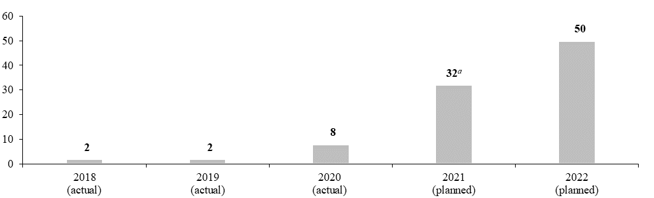

ª To maintain accountability for initial programme plans, the 2021 target is carried forward from the proposed programme budget for 2021 and reflects best estimates at that point in time before the COVID-19 pandemic. Programme performance for 2021 will be reported in the proposed programme budget for 2023.

Result 3: increased access to basic services, sustainable mobility and slum upgrading programmes to strengthen community resilience to pandemics such as COVID-19 in slums and informal settlements

Proposed programme plan for 2022

15.49 Increasing access to water, sanitation, mobility, waste management and energy services for the 700 million urban dwellers currently unserved will play a key role in making cities and human settlements inclusive, safe, resilient and sustainable, as envisioned in Sustainable Development Goal 11. The COVID-19 pandemic highlighted the essential role of basic services in strengthening community preparedness, response and recovery in slums and informal settlements, where the lack of such services makes simple public health interventions such as the regular washing of hands extremely difficult. By 2020, the subprogramme had supported Member States in increasing access for 2.7 million people in slums and informal settlements in 39 countries, strengthening community resilience to pandemics such as COVID-19.

Lessons learned and planned change

15.50 The lesson for the subprogramme was the need to focus more on the development, field testing and dissemination of slum upgrading and urban basic services-related tools and technical guidelines that may be used by various actors and players to implement slum upgrading and basic services programmes. There was also a need for continuous monitoring, learning and documentation of the subprogramme outcomes and impacts. In applying the lesson, the subprogramme will strengthen global advocacy, networking and preparation of tools and technical guidelines on slum upgrading and urban basic services. In 2022, the subprogramme plans to support slum upgrading and urban basic services projects to promote a healthy living environment. Assessments will be undertaken in selected cities to highlight inequities in access to water and sanitation, energy, mobility and solid waste management services. Importance will be given to extending adequate water, sanitation, clean energy, public transport and waste management services in slums and informal settlements. The focus of the work will be on those left behind, including the needs of women, youth and other persons in vulnerable situations, such as the elderly and people with disabilities, highlighting for example, the principles of inclusive design to ensure access to basic services. Focus will also be on strengthening governance and building the capacity of local governments and service providers for effective delivery of urban basic services.

Expected progress towards the attainment of the objective, and performance measure

15.51 This work is expected to contribute to the objective, as demonstrated by 3.1 million people in slums and informal settlements in 45 countries having access to basic services, strengthening community resilience to pandemics such as COVID-19 (see figure 15.III).

Figure 15.III

Performance measure: total number of people in slums and informal settlements in 45 countries with access to basic services (cumulative)

(Millions)

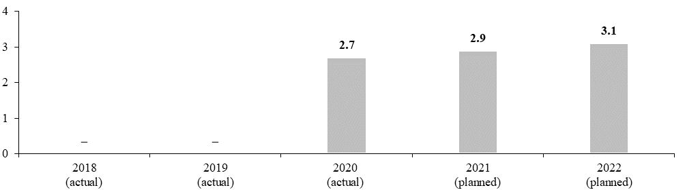

Legislative mandates

15.52 The list below provides all mandates entrusted to the subprogramme.

General Assembly resolutions

42/146 | Realization of the right to adequate housing
67/291 | Sanitation for All
69/213 | Role of transport and transit corridors in ensuring international cooperation for sustainable development
74/299 | Improving global road safety
74/141 | The human rights to safe drinking water and sanitation
74/237 | Eradicating rural poverty to implement the 2030 Agenda for Sustainable Development

Governing Council resolutions

21/8 | Africa fund/financing mechanism on slum prevention and upgrading
21/9 | Women’s land and property rights and access to finance
21/10 | Strengthening the Habitat and Human Settlements Foundation: experimental financial mechanisms for pro-poor housing and infrastructure
23/4 | Sustainable urban development through access to quality urban public spaces
23/8 | Third United Nations conference on housing and sustainable urban development
23/17 | Sustainable urban development through expanding equitable access to land, housing, basic services and infrastructure
24/2 | Strengthening the work of the United Nations Human Settlements Programme on urban basic services
24/9 | Inclusive national and local housing strategies to achieve the Global Housing Strategy paradigm shift

Deliverables

15.53 Table 15.3 lists all deliverables, by category and subcategory, for the period 2020–2022 that contributed and are expected to contribute to the attainment of the objective stated above.

Table 15.3
Subprogramme 1: deliverables for the period 2020–2022, by category and subcategory

Category and subcategory | 2020 planned | 2020 actual | 2021 planned | 2022 plannedª
B. Generation and transfer of knowledge
Field and technical cooperation projects (number of projects) | 32 | 22 | 50 | 36
1. Projects on urban basic services: mobility, water and sanitation, energy and solid waste management and safe, inclusive and accessible public space | 13 | 9 | 15 | 12
2. Project on development of national and local policies on urban heritage, historical landscape and culture | 1 | 1 | 1 | 1
3. Pilot projects on housing, slum upgrading, innovative financing for housing and land readjustment and on integrated urban and territorial renewal and regeneration | 9 | 6 | 12 | 8
4. Projects on land tenure security, land-based financing and implementation of the Secretary-General’s guidance note on land and conflict | – | – | 10 | 7
5. Projects for integrated urban and territorial planning and on developing and implementing effective planning laws | 6 | 4 | 9 | 6
6. Projects supporting urban monitoring, evidence-based policies for crime prevention and on community safety and social cohesion in cities and human settlements | 3 | 2 | 3 | 2
Seminars, workshops and training events (number of days) | 51 | 37 | 79 | 49
7. Workshops and training sessions on urban basic services: mobility, water and sanitation, energy and solid waste management | 21 | 15 | 29 | 20
8. Workshops and training sessions on slum upgrading, housing, heritage in urban development, regeneration and urban growth, urban design governance, public space, Global Network of Urban Planning and Design Labs and crime prevention and urban safety | 13 | 9 | 20 | 12
9. Global and regional training workshops on land, housing, slum upgrading, housing studios and practitioner labs | 5 | 4 | 7 | 5
10. Technical workshops on monitoring the Sustainable Development Goals and the New Urban Agenda | 4 | 3 | 2 | 1
11. Training sessions on policy, planning and design, governance, legislation and finance and data collection | 8 | 6 | 14 | 8
12. Training sessions on land and conflict and on land tenure, governance and financing; and expert group meetings on urban land governance in the Arab States region | – | – | 7 | 3
Publications (number of publications) | 2 | 2 | 3 | 3
13. Publication on low emission options for sustainable mobility | 1 | 1 | – | –
14. Global report: Transforming One Billion Lives – Improved Living Conditions and Sustainable Urbanization – The Challenge of Slums and Informal Settlements in 2020 (follow-up to publication from 2003) | 1 | 1 | – | –
15. Land tenure and land degradation | – | – | 1 | 1
16. Global report on land governance | – | – | 1 | 1
17. Publication on affordable and sustainable housing | – | – | 1 | 1
Technical materials (number of materials) | – | 8 | 19 | 11
18. Innovative finance mechanisms for rental, cooperative, incremental housing and land readjustment schemes to reduce urban poverty | – | 2 | – | –
19. Compendium of policies, plans, good practices and experiences on city planning, urban regeneration, heritage conservation and extension | – | 2 | 2 | 1
20. Best practices, guides, standards and case studies on increased and equal access to basic services, sustainable mobility and public space | – | 2 | 2 | 2
21. Report on policies, plans and legislation for improved safety, particularly for urban youth, women and children | – | 1 | – | –
22. Guide for land management and spatial plans for poverty reduction and spatial equality | – | – | 2 | 1
23. Guidelines on the right to adequate housing and prevention of homelessness among those in vulnerable situations, including migrants | – | 1 | 2 | 1
24. Guide series for innovative land, legal and financial mechanisms in relation to conservation and regeneration | – | – | 1 | 1
25. Toolkits, housing profiles and technical guides for city leaders on planning, on managing and implementing affordable and sustainable housing and on slum upgrading programmes | – | – | 4 | 2
26. Series of guides and tools to improve land management and tenure security | – | – | 2 | 1
27. Guidelines and handbooks on slum upgrading solutions | – | – | 3 | 2
28. Neighbourhood planning guidelines on participation and inclusive regeneration | – | – | 1 | –
C. Substantive deliverables
Consultation, advice and advocacy: technical advice to all requesting Member States on reporting, monitoring and implementation of the New Urban Agenda and the Sustainable Development Goals, including advisory services on Goal reporting, data collection, analysis and monitoring of indicators, namely on Goal targets and indicators 11.1, 11.3.1, 11.3.2 and 11.7.1, leveraging the New Urban Agenda online platform and incorporating best practices; advisory services to 22 Member States on the right to adequate housing and tenure security for those in vulnerable situations, housing policies, urban law reform and compliance for regeneration and urban growth as well as effective regeneration and growth management through: inclusive territorial and urban planning and design, inclusive and participatory governance, public space design and management, design labs, planned city extensions, city infill and heritage preservation; technical advice on urban regeneration and heritage conservation, urban land administration and management to different stakeholders (United Nations agencies, national and local governments, non‑governmental organizations, grassroots organizations); activities to strengthen partnerships and existing networks.
Databases and substantive digital materials: Upon request, data collection on land-related global commitments along the rural-urban nexus and online solutions to tackle issues on urban basic services, sustainable mobility, energy, water and sanitation, solid waste management, housing, urban air quality and climate change mitigation; integrated and open digital platforms on urban safety, heritage, regeneration, urban growth; awareness-raising materials and information databases on cultural heritage and identity for urban dwellers, the Global Urban Indicators database and UrbanLex – Urban Law database; the New Urban Agenda online platform.
D. Communication deliverables
Outreach programmes, special events and information materials: advocacy materials, brochures, leaflets and profiles featuring the work of the subprogramme; networks to disseminate information, including the Global Network of Public Space with some 100 members; in partnership with the municipality of Dubai, United Arab Emirates, sponsorship of Best Practices Award in Urban Regeneration and Public Spaces (case studies published/articles); social media advocacy provided on women’s empowerment, youth empowerment and disability-friendly cities, especially with regard to urban regeneration and public space; communication materials on urban land governance and management; partnerships and cross-learning activities (the Global Land Tool Network) for achieving sustainable urbanization.
External and media relations: media kits, press releases, web stories and social media updates and, upon request, events with 500 participants, 20 non-governmental organizations and 50 cities on slum upgrading, urban renewal, public space and affordable and adequate housing, urban land governance and management, partnerships and cross-learning activities with partner organizations.
Digital platforms and multimedia content: maintenance of social media accounts to enhance information on urban basic services, public space, sustainable mobility, land, slum upgrading, housing and regeneration; multimedia content, including video documentaries, infographics, presentations and webinars; start-up version of a global database of urban plans.

ª The 2022 planned deliverables, to be funded from the foundation non-earmarked fund, have been adjusted downward, taking into account the resources approved by the Executive Board of $10.0 million for 2021 and a budget ceiling figure of $12.0 million in 2022, as shown in table 15.14.

Subprogramme 2

Enhanced shared prosperity of cities and regions

Objective

15.54 The objective, to which this subprogramme contributes, is to enhance the shared prosperity of cities and regions through improved spatial connectivity and productivity, increased and equitably distributed locally generated revenue and expanded deployment of frontier technologies and innovation.

Strategy

15.55 To contribute to the objective, the subprogramme will support Member States and other partners in enhancing the contribution made by urbanization to productivity and inclusive economic development through the formulation of national urban policies and related legal, financial and implementation frameworks integrated into whole-of-government planning, policy and financing frameworks; knowledge transfer; capacity-building; and the development of tools on urban and rural territorial planning and design. This work helps Member States make progress towards achieving the Sustainable Development Goals, in particular Goal 1 and Goal 11.
15.56 The subprogramme will also provide technical assistance and capacity-building and advisory services to cities with regard to developing participatory budgeting approaches and optimizing local revenue systems through data collection and the development of municipal databases, sharing case studies on revenue optimization and participatory approaches and developing guidelines on local revenue generation. In addition, it will explore and realize additional opportunities to leverage private sources of capital to achieve sustainable urban development. Emphasis will be placed on using frontier technology to increase the efficiency of urban management and digitizing revenue systems and performance monitoring. This work will help Member States make progress towards achieving Sustainable Development Goal 8 on decent work and economic growth.
15.57 Furthermore, the subprogramme will strengthen the capacity of national and local governments to effectively procure, test and implement frontier technologies and innovations such as sensor networks, machine-to-machine communication, artificial intelligence, virtual and augmented reality, geographic information systems, remote sensing and big data processing and visualization, while supporting their digital transition. This work will support Member States in making progress towards achieving Sustainable Development Goal 9 on industry, innovation and infrastructure.
15.58 The subprogramme plans to support Member States on issues related to COVID-19 by providing a territorial framework for socioeconomic recovery from COVID-19, climate action and safeguarding the environment and biodiversity; ensuring that economic recovery measures support green urban recovery that helps drive climate action and progress towards the achievement of the Sustainable Development Goals; and placing a stronger focus on the recovery of locally generated revenue (including land-based financing) as a way to help alleviate the socioeconomic impact of COVID-19.
15.59 The above-mentioned work is expected to result in:
(a) Balanced territorial development and better-connected human settlements, while contributing to improved social inclusivity, poverty reduction and climate action;
(b) The enactment by local authorities of institutional and legal reforms conducive to the generation of additional financial resources, including through public-private partnerships and land-based revenue and financing tools;
(c) Strengthened capacity of cities to address inequalities and bridge social, spatial and digital divides.
15.60 The planned support on issues related to COVID-19 is expected to result in improved data on urban COVID-19 hotspots and local responses and improved living standards for the most vulnerable through the provision of clean water supplies, handwashing stations, education and communication materials and protective equipment.

Programme performance in 2020

15.61 Programme performance in 2020 includes the below result that emerged during 2020, as well as programme performance presented in results 1 and 2 below.

National urban policies as a driver for sustainable urban development

15.62 As the world continues to urbanize rapidly, harness urbanization, mitigate its negative externalities and promote an urban paradigm shift, there is a need for a coordinated approach and clear policy direction. National urban policies have been identified as one of the key tools for Governments in promoting sustainable development that cuts across urban, peri-urban and rural areas and support the achievement of the New Urban Agenda and the Sustainable Development Goals. National urban policies were adopted by the Statistical Commission as an indicator for target 11.a of the Sustainable Development Goals in 2020.
15.63 The subprogramme has also been developing normative tools to accompany urban policy development to better address issues including urban-rural linkages, climate change, sustainable mobility, migration, public spaces, green and smart cities and housing. These tools include the following technical materials: Mainstreaming Urban-Rural Linkages in National Urban Policies; Monitoring and Evaluating National Urban Policy: A Guide; National Urban Policies: Driving Public Space Led Urban Development; Developing National Urban Policies: Ways Forward to Green Smart Cities.

Progress towards the attainment of the objective, and performance measure

15.64 The above-mentioned work contributed to the objective, as demonstrated by the fact that 55 countries developed national urban policies (see figure 15.IV).

Figure 15.IV

Performance measure: total number of countries developing national urban policies (cumulative)

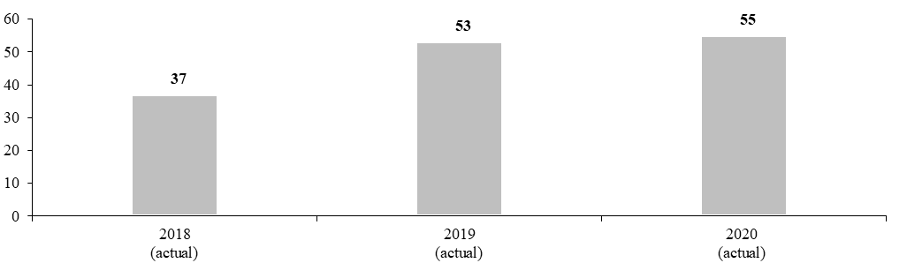

Impact of COVID-19 on subprogramme delivery

15.65 Owing to the impact of COVID-19 during 2020, the subprogramme cancelled several planned in-person events, including seminars, training sessions, workshops and conferences, and in some cases held them remotely. These changes had an impact on programme performance in 2020, as specified in result 1 below.
15.66 At the same time, however, the subprogramme identified new and modified activities to support Member States on issues related to COVID-19, within the overall scope of its objectives, including deploying its Data and Analytics Unit, previously focused on the implementation of the City Prosperity Initiative, to develop a methodology for rapid mapping of COVID-19 vulnerability, impact and responses in cities and implementing it in over 1,500 cities for the UN-Habitat COVID-19 response; and tailoring its national urban policy demonstration projects to COVID-19 response and recovery.

Planned results for 2022

15.67 The planned results for 2022 include results 1 and 2, which are updates of results presented in the preceding proposed programme plans and therefore show both the programme performance in 2020 and the proposed programme plan for 2022. Result 3 is a new planned result.

Result 1: innovation driving city transformation and sustainable development: the City Prosperity Initiative

Programme performance in 2020

15.68 The subprogramme has utilized the capacity of the City Prosperity Initiative to guide decision-making in 550 cities by establishing linkages between data, knowledge and policy actions. The subprogramme also worked with 60 United Nations and development partners to develop a global United Nations system-wide Urban Monitoring Framework to track changes concerning the urban Sustainable Development Goals and support voluntary local reporting, for adoption by the Statistical Commission and the Inter-Agency and Expert Group on Sustainable Development Goal Indicators. Furthermore, the subprogramme adapted the initiative to provide rapid spatial analysis of urban vulnerability and city responses to COVID-19, having developed a methodology to integrate intra-urban inequality analysis in pandemic tracking.
15.69 The above-mentioned work contributed to 550 cities using the City Prosperity Initiative, which did not meet the planned target of 700 cities reflected in the proposed programme budget for 2020, since team capacity was deployed to respond to the newly emerging COVID-19 crisis. However, the subprogramme tracked the development of voluntary local reviews and carried out spatial analyses of COVID-19 vulnerability and responses in over 1,500 cities.

Proposed programme plan for 2022

15.70 The subprogramme will continue the work related to the planned result, in line with its mandate. To contribute to further progress towards the objective and in response to recent developments, the subprogramme’s work will evolve to include the implementation of the Urban Monitoring Framework in the context of the Sustainable Development Goal Cities initiative and to support voluntary local reviews. The expected progress is presented in the updated performance measure below (see figure 15.V).

Figure 15.V

Performance measure: total number of cities using the City Prosperity Initiative and the Urban Monitoring Framework (cumulative)

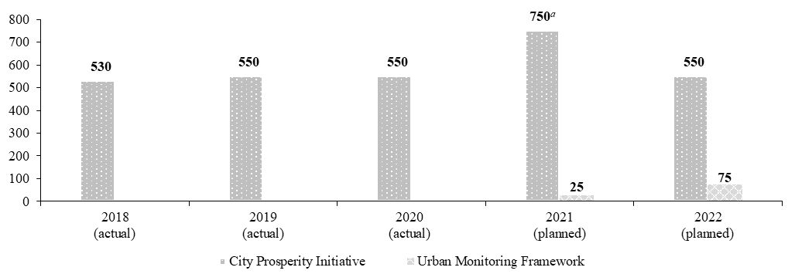

ª To maintain accountability for initial programme plans, the 2021 target is carried forward from the proposed programme budget for 2021 and reflects best estimates at that point in time before the COVID-19 pandemic. Programme performance for 2021 will be reported in the proposed programme budget for 2023.

Result 2: strengthened capacities of cities to accelerate the implementation of the Sustainable Development Goals by linking evidence-based policies to investments

Programme performance in 2020

15.71 The subprogramme launched the Sustainable Development Goal Cities global flagship programmes during the World Urban Forum in 2020. The subprogramme also mobilized collaboration with international local government institutions, academic institutions, private entities and investors committed to the implementation of the Goals. Furthermore, the subprogramme developed approaches and digitalized tools that enable large-scale participation of cities in the flagship programmes; the digital toolkit will include data and strategic planning tools, local capacity diagnostic tools, e-learning tools and a city investment portal. These will support cities in relation to connecting data, planning, Sustainable Development Goal project preparation and related financing.
15.72 The above-mentioned work contributed to 425 cities using the Sustainable Development Goal Cities initiative urban indicator and monitoring platform, which met the planned target reflected in the programme budget for 2021.

Proposed programme plan for 2022

15.73 The subprogramme will continue the work related to the planned result, in line with its mandate. To contribute to further progress towards the objective, the subprogramme will continue to develop digitalized data, develop capacity diagnostic and training tools and build a Cities Investment Portal and advisory service, as key components of a systematized backbone for large-scale implementation; advance partnerships with key global stakeholders; implement far-reaching communications and advocacy efforts; and onboard national groupings of cities. The expected progress is presented in the performance measure below (see figure 15.VI).

Figure 15.VI

Performance measure: total number of cities using the Sustainable Development Goal Cities initiative urban indicator and monitoring platform (cumulative)

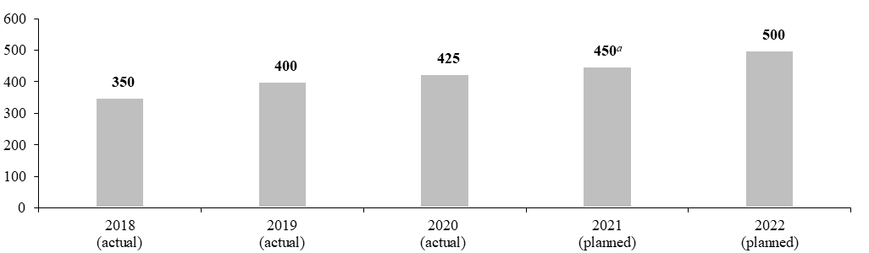

ª To maintain accountability for initial programme plans, the 2021 target is carried forward from the proposed programme budget for 2021 and reflects best estimates at that point in time before the COVID-19 pandemic. Programme performance for 2021 will be reported in the proposed programme budget for 2023.

Result 3: a people-centred approach to urban innovation, digital technologies, smart cities and urbanization processes adopted by cities

Proposed programme plan for 2022

15.74 Cities are hubs for open technological and social innovation. Smart cities play an increasing role in urban development (see World Cities Report 2020), which was recognized in the ministerial declaration of the UN-Habitat Assembly entitled “Innovation for better quality of life in cities and communities: accelerated implementation of the New Urban Agenda towards the achievement of the Sustainable Development Goals”, adopted in 2019. In order to use smart technologies to accelerate the achievement of the urban-related Sustainable Development Goals and a better quality of life for all, cities need to shift from a supply-driven to a needs-based approach to smart technologies and innovation and strengthen digital rights and inclusion in order to leave no one behind. The subprogramme has supported the development of people-centred smart cities strategies, starting in Kigali, and carried out research into the potential for challenge-driven innovation to make cities healthy, thriving and climate-neutral. The subprogramme launched the Climate Smart Cities Challenge, an open call to city governments and agencies around the world to join an open competition aimed at stimulating and scaling up innovative means of reducing greenhouse gas emissions in cities while creating other social benefits. It also established the United Nations Innovative Technology Accelerator for Cities in Hamburg, with the support of the Government of Germany, to demonstrate the power of digital technologies to solve urban challenges. The subprogramme will continue advancing a people-centred approach to urban innovation and digital transformation for resilient, safe, inclusive and sustainable urbanization processes.

Lessons learned and planned change

15.75 The lesson for the subprogramme was that it needed to better support the strategic and proactive role of local and national governments in harnessing innovation, digital technologies and smart cities to advance sustainable urban development. In applying the lesson, the subprogramme will support cities in developing people-centred smart city strategies aligned with efforts to implement the New Urban Agenda and achieve the Sustainable Development Goals. This will include establishing appropriate multi-level governance frameworks and ensuring that technologies and innovation directly contribute to improved urban environments and raise the quality of life, including in marginalized communities. Additionally, the subprogramme will build on the Climate Smart Cities Challenge and support challenge-driven innovation to generate innovative solutions to new and pre-existing challenges faced in urban areas, including in the context of COVID-19 recovery and pandemic preparedness.

Expected progress towards the attainment of the objective, and performance measure

15.76 This work is expected to contribute to the objective, as demonstrated by the implementation of digital transformation, smart city strategies and innovations that address the digital divide by 20 local authorities (see table 15.4).

Table 15.4

Performance measure

2018 (actual) | 2019 (actual) | 2020 (actual) | 2021 (planned) | 2022 (planned)
Rwanda implements a smart cities masterplan | Member States at the UN-Habitat Assembly note the potential of frontier technologies and innovation for sustainable urban development | 10 cities benefit from a flagship programme on people-centred smart cities | 10 local governments adopt people-centred digital transformation and smart city strategies that address the digital divide  10 countries implement urban innovation challenges | 20 local authorities implement digital transformation and smart city strategies and benefit from innovations addressing the digital divide

Legislative mandates

15.77 The list below provides all mandates entrusted to the subprogramme.

General Assembly resolutions

71/327 | The United Nations in global economic governance
75/176 | The right to privacy in the digital age

Governing Council resolutions

19/4 | Cooperation between the United Nations Human Settlements Programme and the United Nations Environment Programme
24/3 | Inclusive and sustainable urban planning and elaboration of international guidelines on urban and territorial planning

UN-Habitat Assembly resolution

1/5 | Enhancing urban-rural linkages for sustainable urbanization and human settlements

Deliverables

15.78 Table 15.5 lists all deliverables, by category and subcategory, for the period 2020–2022 that contributed and are expected to contribute to the attainment of the objective stated above.

Table 15.5

Subprogramme 2: deliverables for the period 2020–2022, by category and subcategory

Category and subcategory | 2020 planned | 2020 actual | 2021 planned | 2022 plannedª
B. Generation and transfer of knowledge
Field and technical cooperation projects (number of projects) | 37 | 28 | 50 | 29
1. National, urban, regional and interregional projects on spatial connectivity, urban policies and spatial frameworks, urban planning and design, urban-rural linkages and integrated territorial development, city planning, extension and design | 10 | 10 | 15 | 14
2. National, urban, regional and interregional projects on spatial productivity, local economic development, urban and municipal finance, financing urban basic services and infrastructure | 11 | 9 | 15 | 7
3. National, urban, regional and interregional projects on best practices, centres of excellence, university partnerships, prosperity indices, frontier technologies and legal and governance frameworks for sustainable, inclusive and innovative development of cities and regions | 16 | 9 | 20 | 8
Seminars, workshops and training events (number of days) | 74 | 50 | 66 | 39
4. Policy dialogues, seminars, workshops and training events on spatial connectivity, urban planning and design, metropolitan planning, urban and rural linkages, action planning, urban and territorial planning and national urban policies | 41 | 41 | 44 | 25
5. Training events and workshops on use of information and communications technology, innovation, frontier technologies, best practices, legal and governance frameworks and prosperity indices for sustainable urban development and implementation of the New Urban Agenda and the Sustainable Development Goals | 21 | 3 | 21 | 6
6. Training events and workshops on urban productivity, local economic development, urban and municipal finance, public financial management and local governance | 12 | 6 | 1 | 8
Publications (number of publications) | 2 | 2 | 4 | 3
7. National cities report | 1 | 1 | 2 | 2
Technical materials (number of materials) | 21 | 22 | 30 | 11
8. Technical materials on spatial connectivity, urban planning and design, metropolitan planning, urban and rural linkages, action planning, urban and territorial planning and national urban policies | 7 | 9 | 10 | 5
9. Technical materials on spatial productivity, local economic development, urban and municipal finance, financing urban basic services and infrastructure | 7 | 7 | 10 | 3
10. Technical materials on frontier technologies and innovation, best practices, legal and governance frameworks and prosperity indices for sustainable urban development and implementation of the New Urban Agenda and the Sustainable Development Goals | 7 | 6 | 10 | 3
C. Substantive deliverables
Consultation, advice and advocacy: advisory services and technical assistance to 20 Member States on national urban policy, territorial development, urban-rural linkages, metropolitan development, preparation of local economic development plans and strategies and on improving local revenue generation; use of frontier technologies, innovations and development of solutions; urban law reform, compliance and community contracting, urban prosperity, including the use of the Urban Monitoring Framework, and monitoring of the Sustainable Development Goals.
Databases and substantive digital materials: national urban policy database, compendium of urban-rural linkages case studies and global municipal database.
D. Communication deliverables
Outreach programmes, special events and information materials: www.urbanpolicyplatform.org; content for social media coverage, brochures, leaflets and profiles on national urban policy, urban-rural linkages, metropolitan development, territorial development, urban monitoring and reporting, basic services, mobility and public space; fourth International Conference on National Urban Policy, second International Forum on Urban-Rural Linkages; private-sector focused engagement frameworks reaching an audience of 2,000.

ª The 2022 planned deliverables, to be funded from the Foundation non-earmarked fund, have been adjusted downward, taking into account the resources approved by the Executive Board of $10.0 million for 2021 and a budget ceiling figure of $12.0 million in 2022, as shown in table 15.14.

Subprogramme 3

Strengthened climate action and improved urban environment

Objective

15.79 The objective, to which this subprogramme contributes, is strengthened climate action and improved urban environments through reducing greenhouse gas emissions and improving air quality, improving resource efficiency and protecting ecological assets, and the effective adaptation of communities and infrastructure to climate change.

Strategy

15.80 To contribute to the objective, the subprogramme will provide technical support for the development of low-emission city development that addresses emerging climate risks, adaptation investments, and basic service provision and the integration of low-emission development and air quality strategies into urban mobility, public space and urban development strategies. The subprogramme will provide assistance to selected Member States through knowledge transfer, capacity-building, policy advice and peer-to-peer engagement in regional initiatives on sustainable approaches to urban climate action. The subprogramme plans to broaden its engagement with Member States to scale up the urban dimension of nationally determined contributions and national adaptation plans, while strengthening the evidence base. This work helps Member States make progress towards achieving Sustainable Development Goals 1, 11 and 13.
15.81 The subprogramme will promote nature-based solutions to climate action for urban and peri-urban environmental protection, restoration and green public spaces. The subprogramme will also strengthen resource efficiency by promoting integrated solid waste management and by addressing marine plastic litter reduction. The subprogramme will also promote the development of energy- and resource-efficient standards for buildings and the integration of energy and resource efficiency principles into country-specific building and planning codes. This work helps Member States make progress towards achieving Sustainable Development Goals 6, 7, 8, 11, 12, 13, 14 and 15.
15.82 The subprogramme will also provide assistance with regard to the formulation of policy and legislation, urban planning and design, multilevel governance and financing instruments through its flagship programme entitled “RISE-UP: resilient settlements for the urban poor”, which focuses on mobilizing investments to address climate resilience issues affecting the poor and marginalized communities in cities. It will further support the implementation of global adaptation initiatives aimed at improving the enabling environment for adaptation investments in urban infrastructure and communities, such as the National Adaptation Plan Global Support Programme, the Nationally Determined Contributions Partnership, which is at the core of the Paris Agreement on climate agreement and in which countries specify their emissions reduction and adaptation targets for the period up to 2030, and the Least Developed Countries Expert Group. This work helps Member States make progress towards achieving Sustainable Development Goals 9, 11 and 13.
15.83 The subprogramme plans to support Member States on issues related to COVID-19 by highlighting technologies, processes and investment opportunities, as part of its normative work, which will support green COVID-19 recovery opportunities and an integrated approach to climate and health resilience. The subprogramme will also integrate such guidance in its technical advisory services.
15.84 The above-mentioned work is expected to result in:
(a) Strengthened capacities of partner cities and Member States to plan for, invest in and monitor city-level climate action;
(b) Multidimensional climate action and urban environment planning by partner cities that preserves, regenerates and restores urban biodiversity and reduces air and water pollution;
(c) The mobilization of investments for adaptation to climate change at the national and sub-national levels.
15.85 The planned support on issues related to COVID-19 is expected to result in:
(a) Increased capacities of partner cities and Member States to develop green COVID-19 recovery plans that can attract funding;
(b) More climate- and pandemic-resilient cities, human settlements and communities.

Programme performance in 2020

15.86 Programme performance in 2020 includes the below result that emerged during 2020, as well as programme performance presented in results 1 and 2 below.

Integrated climate and COVID-19 response plans

15.87 Cities and local governments are at the forefront of the COVID-19 response, while for many local governments, climate change remains the most pressing long-term challenge. In line with the policy brief by the Secretary General on COVID-19 in an urban world, cities have started to develop integrated climate change and COVID-19 response plans.
15.88 The subprogramme supported five cities in the Philippines in updating their climate change action plans to align climate change mitigation measures with green recovery opportunities and climate resilience actions with a COVID-19 response that ensures that community members in vulnerable situations are supported. Furthermore, the subprogramme disseminated early results through an investment forum, to attract funding for the initiatives, and through a series of webinars attended by officials from nearly 100 local governments.

Progress towards the attainment of the objective, and performance measure

15.89 The above-mentioned work contributed to the objective, as demonstrated by the integration of the COVID-19 response into the plans and selected climate projects of five cities in the Philippines (see table 15.6).

Table 15.6

Performance measure

2018 (actual) | 2019 (actual) | 2020 (actual)
Development of city-wide climate change action plans in five cities | Prioritized climate projects developed and prepared for finance | COVID-19 response integrated into the plans and selected climate projects of five cities in the Philippines

Impact of COVID-19 on subprogramme delivery

15.90 Owing to the impact of COVID-19 during 2020, the implementation of numerous large-scale climate change programmes started up to six months late, and the rate of implementation was slower as a result of lockdowns or other movement restrictions; examples include projects in the Comoros, the Lao People’s Democratic Republic, Madagascar, Malawi and Mozambique. In countries with very severe international travel restrictions, project implementation all but halted; for example, project advisers have not been allowed to travel to Solomon Islands since March 2020 and some project components could not be implemented with local capacities only. These changes had an impact on the programme performance in 2020, as specified in results 1 and 2 below.
15.91 At the same time, however, the subprogramme identified new activities to support Member States on issues related to COVID-19, within the overall scope of its objectives, namely supporting green recovery and addressing socioeconomic vulnerabilities affected by climate change and COVID-19. This included contributing to socioeconomic response plans at the city and national levels by leveraging climate change analyses as well as organizing seminars and workshops with mayors and local government officials. The modified deliverables contributed to results in 2020, as specified in the emerging result for 2020 above.

Planned results for 2022

15.92 The planned results for 2022 include results 1 and 2, which are updates of results presented in the preceding proposed programme plans and therefore show both the programme performance in 2020 and the proposed programme plan for 2022. Result 3 is a new planned result.

Result 1: Strengthened adaptation to climate change and other shocks: Solomon Islands

Programme performance in 2020

15.93 The subprogramme has continued to support the Government of Solomon Islands, the Honiara City Council and communities in five informal settlement areas in the development and implementation of community climate change action plans. The subprogramme also supported the national and local governments in the analysis of the socioeconomic impact of COVID-19 on these five communities. Furthermore, the subprogramme supported the national Government in its spatial and institutional analysis of COVID-19 and the compounded impacts of climate change.
15.94 The work above did not contribute to any additional informal settlement implementing community-level resilience action, which did not meet the planned target of five settlements reflected in the proposed programme budget for 2020. The planned target for 2020 could not be fully met as infrastructure projects have not yet commenced owing to the complete closure of the border as a result of COVID-19.

Proposed programme plan for 2022

15.95 The subprogramme will continue the work related to the planned result, in line with its mandate. To contribute to further progress towards the objective, the subprogramme will accelerate implementation once the COVID-19 situation allows and, in the meantime, will work more closely with increased national expertise that will be built through virtual support. In 2022, the subprogramme will implement community resilience initiatives such as activities related to community infrastructure and sustainable and resilient livelihoods. The expected progress is presented in the performance measure below (see figure 15.VII).

Figure 15.VII

Performance measure: number of informal settlements that have implemented community-level resilience action (annual)

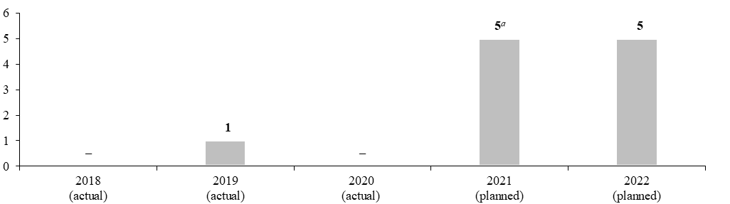

ª To maintain accountability for initial programme plans, the 2021 target is carried forward from the proposed programme budget for 2021 and reflects best estimates at that point in time before the COVID-19 pandemic. Programme performance for 2021 will be reported in the proposed programme budget for 2023.

Result 2: accelerated climate action in 16 cities and eight countries around the world

Programme performance in 2020

15.96 The subprogramme has supported 16 cities in Bangladesh, Brazil, Colombia, Indonesia, India, the Lao People’s Democratic Republic, Rwanda and South Africa in progressing through the steps of their city climate action planning, including through the development of 15 new or updated greenhouse gas inventories and 13 new or updated climate risk and vulnerability assessments. The subprogramme also supported capacity-building and training efforts, including peer-to-peer exchange between cities in Rwanda and South Africa and between cities in Indonesia and the Lao People’s Democratic Republic. Furthermore, the subprogramme supported the vertical integration and enhanced the multilevel governance of these local efforts through the release of a guide entitled “Enhancing nationally determined contributions through urban climate action”, as well as country-level advisory services for improved multilevel governance.
15.97 The above-mentioned work contributed to eight cities enacting legal frameworks for low-emission development strategies that are partially in draft form and have not yet been adopted by local governments, which did not meet the target of 10 cities enacting such frameworks reflected in the proposed programme budget for 2020. The frameworks are comprehensive in nature and cover sectoral low-emission development strategies in building and construction, energy systems, transport and land use. COVID-19 lockdowns disrupted the participatory process for drafting the climate strategies and action plans. A project extension agreed by the donor reflects this reality and allows for the draft legal frameworks to be completed before September 2021.

Proposed programme plan for 2022

15.98 The subprogramme will continue the work related to the planned result, in line with its mandate. To contribute to further progress towards the objective, the subprogramme will continue to support the Lao People’s Democratic Republic in the implementation of policies and plans with an emphasis on green and resilient recovery. It also plans to identify a new set of cities in Mexico where policy support will be provided. Other opportunities to deliver city-level climate action support will be explored. The expected progress is presented in the performance measure below (see figure 15.VIII).

Figure 15.VIII

Performance measure: total number of cities enacting legal frameworks for low-emission development strategies with support from the United Nations Human Settlements Programme (cumulative)
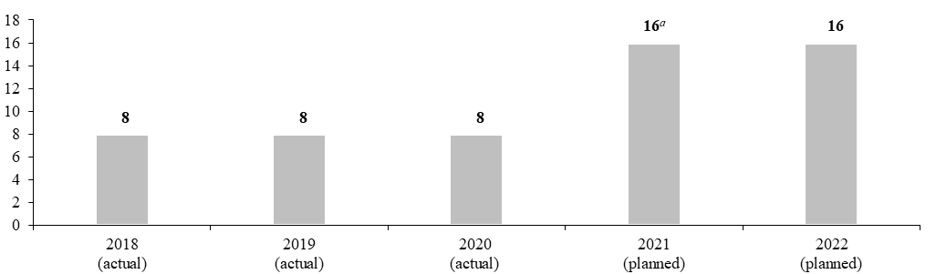

ª To maintain accountability for initial programme plans, the 2021 target is carried forward from the proposed programme budget for 2021 and reflects best estimates at that point in time before the COVID-19 pandemic. Programme performance for 2021 will be reported in the proposed programme budget for 2023.

Result 3: participatory urban resilience action in Southern Africa

Proposed programme plan for 2022

15.99 In sub-Saharan Africa, the critical situation arising from multiple increasingly extreme weather-related hazards caused by climate change, combined with extraordinarily rapid urbanization, a lack of adequate infrastructure and the risks associated with health emergencies, including pandemics, requires an urgent response. The hazards and vulnerabilities faced by urban areas transcend national boundaries and are shared by cities in multiple countries. Capacity-building activities were carried out to promote cooperation and sustainable and resilient urbanization in Southern, East and West Africa. Participatory urban resilience planning using the city resilience action planning tool (CityRAP) methodology was implemented in 10 cities across seven countries (Comoros, Ethiopia, Malawi, Mozambique, South Africa, Zambia and Zimbabwe). With regard to normative work, a regional assessment on urban vulnerability and resilience was conducted in the 16 States members of the Southern African Development Community (SADC). The subprogramme has been supporting the affected urban settlements in the region through efforts at different levels of government to foster better community-led participatory climate-related resilience planning, coordination, response, preparedness and adaptation. The subprogramme facilitated the regional and subregional exchange of knowledge among national and local authorities and academic institutions from different SADC countries.

Lessons learned and planned change

15.100 The lesson for the subprogramme was that it needed to better support multi-country coordination to strengthen the links between the regional, national and city levels. In addition, smaller secondary cities in Southern Africa hold the key to building urban resilience in the region, given their rapid urban growth and limited resources. In applying the lesson, the subprogramme will take a dual approach, improving regional coordination for an effective trickle-down effect of policies and regulations and promoting a bottom-up approach in which participatory resilience and climate adaptation planning in secondary cities inform planning at the national and regional levels through cross-fertilization and the exchange of best practices, including with regard to the design and implementation of resilient infrastructure. In 2022, the subprogramme will expand its support to Member States in relation to the implementation of climate and pandemic resilience plans in two additional cities and will further support regional efforts across the 16 SADC countries to build capacity on local-level disaster risk reduction and climate change adaptation policies.

Expected progress towards the attainment of the objective, and performance measure

15.101 This work is expected to contribute to the objective, as demonstrated by 18 distinct resilience action frameworks developed in sub-Saharan Africa (see figure 15.IX).

Figure 15.IX

Performance measure: total number of distinct resilience action frameworks developed in sub-Saharan Africa (cumulative)

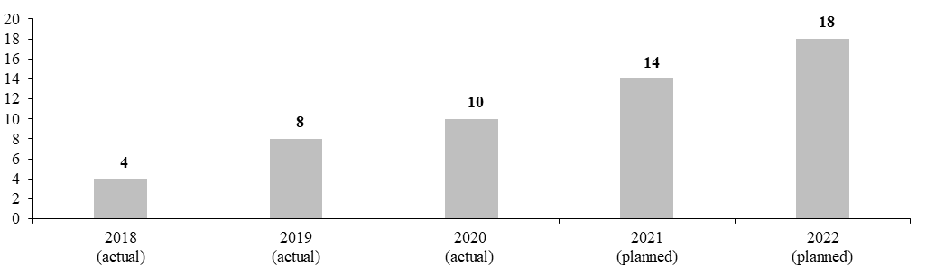

Legislative mandates

15.102 The list below provides all mandates entrusted to the subprogramme.

General Assembly resolutions

63/217 | Natural disasters and vulnerability
67/263 | Reliable and stable transit of energy and its role in ensuring sustainable development and international cooperation
69/225 | Promotion of new and renewable sources of energy
73/228 | Follow-up to and implementation of the SIDS Accelerated Modalities of Action (SAMOA) Pathway and the Mauritius Strategy for the Further Implementation of the Programme of Action for the Sustainable Development of Small Island Developing States
74/219 | Protection of global climate for present and future generations of humankind
75/216 | Disaster risk reduction
75/218 | Implementation of the United Nations Convention to Combat Desertification in Those Countries Experiencing Serious Drought and/or Desertification, Particularly in Africa
75/219 | Implementation of the Convention on Biological Diversity and its contribution to sustainable development

Governing Council resolutions

19/4 | Cooperation between the United Nations Human Settlements Programme and the United Nations Environment Programme
22/3 | Cities and climate change

Deliverables

15.103 Table 15.7 lists all deliverables, by category and subcategory, for the period 2020–2022 that contributed and are expected to contribute to the attainment of the objective stated.

Table 15.7

Subprogramme 3: deliverables for the period 2020–2022, by category and subcategory

Category and subcategory | 2020 planned | 2020 actual | 2021 planned | 2022 plannedª
B. Generation and transfer of knowledge
Field and technical cooperation projects (number of projects) | 28 | 24 | 32 | 15
1. Demonstration projects on improving urban air quality, the urban environment, climate change mitigation, and increased access to low-carbon basic services, greener infrastructure and buildings | 4 | 4 | 4 | 2
2. Improved policies, legal instruments, plans and strategies for better urban air quality, the urban environment, climate change mitigation and low-carbon basic services and greener infrastructure and buildings | 2 | 2 | 3 | 1
3. Demonstration projects on resilience-building and adaptation of communities and infrastructure to climate change, and disaster risk reduction | 10 | 10 | 11 | 6
4. Improved policies, legal instruments, plans and strategies for effective adaptation of communities and infrastructure to climate change, informed by participatory processes, assessments of local vulnerabilities and innovative data collection (i.e., remote sensing) and processing | 5 | 5 | 6 | 3
5. Demonstration projects on urban environmental management and restoration, biodiversity protection, circular economy and ecosystem services | 4 | 2 | 4 | 1
6. National, regional and local policies, plans and strategies for improved urban resource management and efficiency, including circular economy, efficient use of urban land, service provision and sustainable water and waste management, and promotion of renewable energy and energy efficiency | 3 | 1 | 4 | 2
Seminars, workshops and training events (number of days) | 93 | 57 | 100 | 38
7. Seminars, workshops and training events leading to enhanced awareness and capacity of partners and those in vulnerable situations (e.g., in informal settlements) to plan for, manage and act on climate change mitigation, air quality and low-carbon basic services | 30 | 16 | 35 | 10
8. Seminars, workshops and training events leading to strengthened capacities of UN-Habitat partners to plan for, manage and act on effective adaptation of communities and infrastructure to climate change | 55 | 33 | 55 | 25
9. Seminars, workshops and training events leading to enhanced understanding of green city models and their application, green infrastructure and green-blue urban planning | 4 | 4 | 5 | –
10. Training on environment and climate dimensions (air quality, water, sanitation, waste management) and Sustainable Development Goal monitoring in urban areas | 4 | 4 | 5 | 3
Publications (number of publications) | 2 | 2 | 3 | 3
11. Publication on climate change mitigation and air quality | 1 | 1 | 1 | 1
12. Publication on effective adaptation of communities of slums and other marginalized communities in urban neighbourhoods, and infrastructure, to climate change | 1 | 1 | 1 | 1
13. Publication on improved low-carbon urban services and resource efficiency (e.g., focusing on technological innovation) | – | – | 1 | 1
Technical materials (number of materials) | 9 | 9 | 12 | 5
14. Series or set of technical materials on improved resource efficiency and protection of ecological assets, including sectoral materials | 2 | 2 | 2 | 1
15. Series of technical materials on climate change mitigation and air quality | 2 | 2 | 3 | 1
16. Series or set of non-recurrent case studies on climate action, basic services or environment in human settlements | 2 | 2 | 3 | 1
17. Series of non-recurrent compilations of national, regional and local guidelines, plans, coordination mechanisms and strategies on climate action, the urban environment, ecosystems and biodiversity, blue-green networks, ecological assets and ecosystem services | 1 | 1 | 2 | 1
18. Series of technical materials on improved low-carbon urban services, resource efficiency and (electric) mobility solutions and infrastructure (including monitoring) | 2 | 2 | 2 | 1
C. Substantive deliverables
Consultation, advice and advocacy: advisory services to 16 Member States on reducing urban greenhouse gas emissions to achieve climate change mitigation and adaptation, improving air quality and low-carbon urban services, improving resource efficiency and protecting ecological assets.
Databases and substantive digital materials: databases on urban climate- or environment-relevant subjects, and substantive digital materials (i.e., simulations) on reduced greenhouse gas emissions and improved air quality; improved resource efficiency and protection of ecological assets, effective adaptation of communities and infrastructure to climate change.
D. Communication deliverables
Outreach programmes, special events and information materials: on reduced greenhouse gas emissions and improved air quality; improved resource efficiency and protection of ecological assets; effective adaptation of communities and infrastructure to climate change with the aim of reaching an audience of 6 million.
External and media relations: articles on reduced greenhouse gas emissions and improved air quality, improved resource efficiency and protection of ecological assets and effective adaptation of communities and infrastructure to climate change.
Digital platforms and multimedia content: websites and social media and multimedia content on reduced greenhouse gas emissions and improved air quality, improved resource efficiency and protection of ecological assets and effective adaptation of communities and infrastructure to climate change.

ª The 2022 planned deliverables, to be funded from the Foundation non-earmarked fund, have been adjusted downward, taking into account the resources approved by the Executive Board of $10.0 million for 2021 and a budget ceiling figure of $12.0 million in 2022, as shown in table 15.14.

Subprogramme 4

Effective urban crisis prevention and response

Objective

15.104 The objective, to which this subprogramme contributes, is to enhance urban crisis prevention and response. This is done through promoting social integration and inclusive communities as well as improved living standards and the inclusion of migrants, refugees, internally displaced persons and returnees, and enhancing resilience of the built environment and infrastructure.

Strategy

15.105 To contribute to the objective, the subprogramme will support Member States in implementing strategies and actions to increase social integration and safety in public spaces through in-country comprehensive, participatory and inclusive operational programmes responding to crises affecting all members of the community, including those in vulnerable situations; and implement fit-for-purpose land administration towards the achievement of tenure security for all in crisis-affected areas. The subprogramme also plans to support implementation by Member States of inclusive, evidence-based, sustainable recovery approaches, such as the Programme’s “People’s Process”, a community-based planning and management process that fosters social integration, inclusiveness and transition to sustainable development, in line with the principle of “leaving no one behind” and the aim of building back better. The focus will be on elements that have a catalytic impact when integrated into broader efforts of the United Nations community in relation to promoting stability and sustaining peace, strengthening social cohesion and building resilient cities and communities, which will help Member States to make progress towards achieving target 11.b of the Sustainable Development Goals The subprogramme will continue to focus on supporting local actors as key players in increasing social cohesion between communities, reducing discrimination and xenophobia and advancing rights-based approaches in urban crisis situations. In addition, the subprogramme will complement efforts made under subprogramme 2 to increase local revenue by improving tenure security and ensuring that increased local revenue is managed locally and in a way that strengthens social integration and inclusive communities. This work helps Member States make progress towards achieving Sustainable Development Goals 9, 11 and 16.
15.106 The subprogramme also plans to prioritize improved living standards and the inclusion of migrants, refugees, internally displaced persons and returnees. The subprogramme will provide urban crisis-response expertise and support integrated urban development strategies that address the needs of both host communities and the displaced, seeking to overcome both chronic and acute vulnerabilities. It will also provide expertise regarding the planning of camps as future urban extensions, in prioritized crises, and incorporate adequate urban planning standards and tenure arrangements that are suitable for the eventual transformation of camps into neighbourhoods. It will increase the focus of UN-Habitat on overcoming land-related challenges that are drivers of conflict, including by providing support in relation to housing, land and property rights in humanitarian and development contexts and advancing fit-for-purpose land administration towards the achievement of tenure security for all in crisis-affected areas. This will be done through further mobilizing United Nations efforts as set out by the Secretary-General’s guidance note on land and conflict. The subprogramme will also tailor the Programme’s normative guidance and operational support in urban displacement contexts, within the framework of the flagship programme “Inclusive cities: enhancing the positive impacts of urban migration”, in coordination and close cooperation with United Nations agencies and other key actors, and advance synergies between the humanitarian, development and peace pillars. This work helps Member States make progress towards achieving Sustainable Development Goals 1, 5, 8, 10 and 11.
15.107 The subprogramme will continue to develop evidence-based local disaster risk reduction and resilience strategies in line with the Sendai Framework for Disaster Risk Reduction and implement disaster risk reduction and resilience strategies. The subprogramme will further develop and improve urban profiling and urban-specific recovery frameworks, tools and approaches, supporting local implementation and mobilizing networks of urban stakeholders and complementing work led by the World Bank, the European Union and UNDP at the national level. This work helps Member States make progress towards achieving Sustainable Development Goals 9, 11, 13 and 16.
15.108 The subprogramme plans to support Member States on issues related to COVID-19 by working with cities and informal settlements within cities, through both normative and operational activities, to increase their resilience to a broad range of threats, including health emergencies, and by working towards the inclusion of urban recovery in national COVID-19 recovery strategies.
15.109 The above-mentioned work is expected to result in:
(a) An increased proportion of the population in crisis-affected communities engaging in local decision-making with regard to reconstruction projects and improved social inclusion, strengthened land tenure and improved access to adequate housing and basic services in fragile situations;
(b) An increased number of cities where refugees, migrants, internally displaced persons, returnees and host communities have access to secure tenure, sustainable basic services and social services, adequate housing, safety and security;
(c) The reduction of multidimensional risks and increased protection for those in vulnerable situations in cities.
15.110 The planned support on issues related to COVID-19 is expected to result in strengthened systems for analysis and decision-making concerning resilient infrastructure at the city level, particularly in crisis settings.

Programme performance in 2020

15.111 Programme performance in 2020 includes the below result that emerged during 2020, as well as programme performance presented in results 1 and 2 below.

Strengthened urban response to COVID-19

15.112 COVID-19 has presented a global existential threat, which has proven to be most complex in densely populated urban areas. Density in and of itself is not the problem or the cause of this threat; rather, the threat results from a wide range of historic and current socioeconomic deprivations and a basic lack of appropriate access to urban services. The subprogramme’s response was aligned with and contributed to the three pillars of the health response of the United Nation system. In coordination with WHO, and based on experience gained from the Ebola crisis in West Africa, the subprogramme shared its expertise on data analysis, urban analysis and health guidance in urban settings. For the global humanitarian response, the subprogramme actively participated in the Inter-Agency Standing Committee mechanisms, making a particular effort to raise the visibility of urban COVID-19 threats and response priorities. The subprogramme also participated in the coordinated inter-agency Global Humanitarian Response Plan for COVID-19 and provided country-level contributions in relation to shaping the global narrative on the impact of the pandemic in urban areas. The subprogramme also contributed actively to the United Nations framework for the immediate socioeconomic response to COVID-19 by co-leading on pillar 5 (social cohesion and community resilience). In addition, UN-Habitat took a lead role in contributing to the Secretary-General’s policy brief on COVID-19 in an urban world, in collaboration with UNDP, the Department of Economic and Social Affairs, UNEP, UNICEF, UNODC, ILO, WHO, the Office of the United Nations High Commissioner for Human Rights and the regional commissions.
15.113 The subprogramme also developed a policy and programming framework to define the thematic scope of the COVID-19 response. This framework was used by Headquarters and regional offices to ensure the strategic alignment and complementarity of urban response programmes and projects. From rapid response to longer-term recovery, the subprogramme has supported the overall response in 37 countries and more than 250 cities, benefiting 6.8 million people. The subprogramme’s important work in slums and informal settlements was a vital component of the response to COVID-19. Furthermore, the subprogramme prepared a response plan to support 64 countries through over 100 projects and raised or reprogrammed $25 million, mainly for informal settlements. For example, in “Somaliland”, the subprogramme facilitated access to water for vulnerable communities to prevent the spread of COVID-19, supplying clean water to internally displaced persons in two settlements on the outskirts of Hargeysa. In relation to the national urban policy programme of Myanmar, the subprogramme developed an emergency response project to combat COVID-19 in an informal settlements project in Yangon. In the Philippines, the subprogramme opened two satellite markets and several mobile stores around Marawi City to improve access to food, engage communities in small business and inform communities about recovery strategies.

Progress towards the attainment of the objective, and performance measure

15.114 This above-mentioned work contributed to the objective, as demonstrated by the development and adaptation of projects and programmes to address COVID-19 in urban environments and informal settlements in 262 beneficiary cities in 37 countries. It reached 6.8 million individual beneficiaries through 71 projects involving more than 250 partners (see table 15.8).

Table 15.8

Performance measure

2018 (actual) | 2019 (actual) | 2020 (actual)
– | – | 71 projects with a focus on mitigating the impact of COVID-19 in 262 beneficiary cities in 37 countries, reaching 6.8 million individual beneficiaries

Impact of COVID-19 on subprogramme delivery

15.115 Owing to the impact of COVID-19 during 2020, the subprogramme changed its approach to capacity-building and training activities for local communities, as well as to its engagement with national and local authorities, by moving from face-to-face to virtual or hybrid meetings. Global travel restrictions effectively stopped all planned capacity development missions, field trips and fact-finding, as well as the deployment of staff to duty stations.
15.116 At the same time, however, the subprogramme identified new activities to support Member States on issues related to COVID-19, within the overall scope of its objectives, namely contributing its urban expertise in the context of the development of the Global Humanitarian Response Plan, the United Nations framework for the immediate socioeconomic response to COVID-19 and the Secretary General’s policy brief on COVID-19 in an urban world. Further, UN-Habitat developed its COVID-19 policy and programme framework, identifying global, regional and country-level action plans, focusing on support for local governments, urban profiling and data mapping, improvements to water and sanitation in informal settlements, and awareness-raising with regard to the COVID-19 threat. The Programme’s internal emergency funds of $1.3 million supported projects benefiting 5 million people in 145 cities in 13 countries, including Brazil, Ghana, Iraq, Kenya, Lebanon, Mexico, Mozambique, Myanmar, the Philippines and the Syrian Arab Republic. In Mosul, Iraq, in collaboration with WHO, UN-Habitat developed guidelines for managing COVID-19 risks at construction sites in order to facilitate return-to-work policies for reconstruction projects. The guidelines were disseminated to contractors and partners, and the resumption of the Programme’s activities in Mosul resulted in the provision of shelter and livelihood opportunities for disadvantaged communities. The new deliverables contributed to results in 2020, as specified in the emerging result for 2020 above.

Planned results for 2022

15.117 The planned results for 2022 include results 1 and 2, which are updates of results presented in the preceding proposed programme plans and therefore show both the programme performance in 2020 and the proposed programme plan for 2022. Result 3 is a new planned result.

Result 1: rehabilitation and shelter recovery for vulnerable families in Mosul, Iraq

Programme performance in 2020

15.118 The subprogramme addressed the urban crisis in Iraq by scaling up its housing rehabilitation efforts in three liberated governorates and, in particular, in the city of Mosul. Shelter interventions contributed to the sustainable return of some 2,500 Mosul residents who had been displaced and affected by the conflict with Islamic State in Iraq and the Levant. The subprogramme also embarked on the participatory redesign and rehabilitation of Yarmuk Park, the largest public open space in western Mosul, as an integral component of its ongoing area-based urban recovery programming. Furthermore, the subprogramme has been promoting a “build back better” approach that embraces the adoption of greener technologies, including renewable energy, passive design, recycling of debris and the use of materials sourced and produced in Iraq.
15.119 The above-mentioned work contributed to the rehabilitation of 356 war-damaged houses in the target neighbourhoods of Shifa’, Sikak, Matahin and Maghrib, in parallel to the upgrading of water, sanitation and hygiene infrastructure in Shifa’, and the creation of sport facilities and greening in Yarmuk Park, which met the planned target reflected in the proposed programme budget for 2020. The newly built multipurpose sports grounds provide a powerful tool for strengthening social ties and networks, overcoming mistrust and reaching across political divides and ethnic and religious differences, particularly among disenfranchised young people that have grown up in an environment of intolerance and conflict.

Proposed programme plan for 2022

15.120 The subprogramme will continue the work related to the planned result, in line with its mandate. To contribute to further progress towards the objective, the subprogramme will lead the drafting of a participatory recovery plan for the Old City of Mosul, in partnership with the United Nations Educational, Scientific and Cultural Organization (UNESCO). The expected progress is presented in the performance measure below (see table 15.9).

Table 15.9

Performance measure

2018 (actual) | 2019 (actual) | 2020 (actual) | 2021 (planned)ª | 2022 (planned)
Absence of nationally owned coordination mechanism and lack of large humanitarian response for the reconstruction of Mosul in order to guide recovery and rehabilitation work of beneficiary returnees for the 600 rehabilitated houses | Establishment of nationally owned coordination mechanism for the reconstruction of Mosul in order to guide recovery and rehabilitation work; rehabilitation of damaged houses and construction of new homes undertaken simultaneously | Return of 356 families to rehabilitated war-damaged houses in the neighbourhoods of Shifa’, Sikak, Matahin and Maghrib, following rehabilitation  Sport facilities and green spaces for local neighbourhoods at Yarmuk Park | Improved access to adequate housing and basic services by returnees and vulnerable community members; long-term development and peacebuilding challenges are addressed through measures such as protection of housing, land and property rights and facilitation of mediation to resolve disputes among community members | Progress on the rehabilitation of the Old City of Mosul following the launch of a participatory recovery plan in partnership with UNESCO

ª To maintain accountability for initial programme plans, the 2021 target is carried forward from the proposed programme budget for 2021 and reflects best estimates at that point in time before the COVID-19 pandemic. Programme performance for 2021 will be reported in the proposed programme budget for 2023.

Result 2: inclusive cities: enhancing the positive impacts of urban migration

Programme performance in 2020

15.121 Migrants and displaced persons (including internally displaced persons) are increasingly residing in and moving towards urban areas. The rapid influx of additional inhabitants to cities due to human-made or natural hazards puts stress on urban systems and affects service provision as well as the availability of adequate housing, infrastructure and livelihood opportunities. The subprogramme has worked in multiple regions to support Member States facing major migration or displacement-related challenges. In 2020, this included the development of urban spatial profiles in Latin America, the Arab States/Middle East and North Africa region, Africa and Asia; workshops to build local capacity in using participatory planning to increase social cohesion; the drafting of recommendations and guidance documents; and the provision of technical advisory services to advance area-based, cross-sectoral, multi-stakeholder, multilevel governance approaches to migrant inclusion in cities. The subprogramme contributed to strengthening the synergies between the humanitarian, development, and peace pillars, as the subprogramme’s objective is to improve the lives of urban refugees, migrants and internally displaced persons, while also supporting host communities, through the promotion of area-based, whole-of-government and whole-of-society approaches. Furthermore, the subprogramme’s work in urban crisis contexts ranged from spatial and participatory data collection (urban profiling) for evidence-based decision-making to policy recommendations, capacity-building and pilot project implementation. Building upon experiences from countries such as Iraq, Lebanon and Somalia, teams in different countries developed master plans and regeneration projects, including planned city extensions and the upgrading of underserviced neighbourhoods inhabited by the urban poor and other persons in vulnerable situations.
15.122 The above-mentioned work contributed to supporting 96 cities in applying participatory planning methodologies through participatory data collection and consultations with all relevant stakeholders and to fostering increased social cohesion between migrant, displaced and host communities, which met the planned target reflected in the proposed programme budget for 2021. Interventions aimed at improving the standard of living of all people in cities and communities, for example, through increased access to basic, social and urban services, land tenure security and housing, were based on participatory processes and verifiable urban data.

Proposed programme plan for 2022

15.123 The subprogramme will continue the work related to the planned result, in line with its mandate. To contribute to further progress towards the objective, the subprogramme will continue to work to support governments at all levels in advancing rights-based approaches for the inclusion of migrants and displaced people in cities. Work will be undertaken to focus its activities on developing integrated and inclusive projects (including research, spatial data collection and analysis, review and recommendations for policy environments, training, guidance and advisory services and advocacy at the global level) that support the improvement of the living conditions of people in vulnerable situations. The expected progress is presented in the performance measure below (see figure 15.X).

Figure 15.X

Performance measure: total number of cities applying participatory planning methodologies (cumulative)

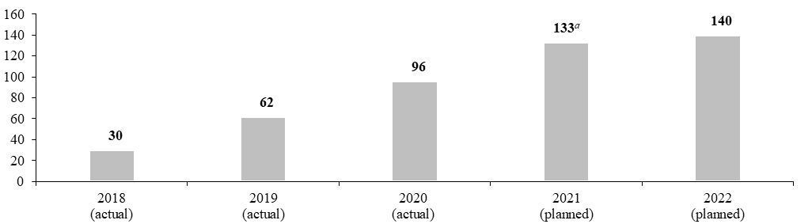

ª To maintain accountability for initial programme plans, the 2021 target is carried forward from the proposed programme budget for 2021 and reflects best estimates at that point in time before the COVID-19 pandemic. Programme performance for 2021 will be reported in the proposed programme budget for 2023.

Result 3: a new approach to strengthen city resilience

Proposed programme plan for 2022

15.124 With more than 50 per cent of the world’s population living in urban areas, and a projected increase to 70 per cent by 2050, challenges in cities are increasing daily. These include internal stresses, such as the limited capacity of service providers to provide basic services such as water to the inhabitants of a city, as well as external shocks such as natural disasters that could potentially disrupt the functioning of a city. The subprogramme’s City Resilience Global Programme works through a multi-hazard, multi-stakeholder and multisectoral approach to building resilient cities, taking into consideration the complexities of urban systems. A recent example of the success of this approach has been the response of cities to the COVID-19 pandemic, for which the subprogramme provided mayors with support in relation to evidence-based decision-making on the basis of city-based data collection, analysis and diagnosis and the development by municipality personnel of technically actionable recommendations, using City Resilience Global Programme approaches, tools and indicators. The City Resilience Global Programme methodology has been calibrated in a broad range of completely different city settings in order to make sure that it is adaptable to different contextual and cultural realities, where resources and capacities may vary greatly.

Lessons learned and planned change

15.125 The lesson for the subprogramme was that regardless of the context and diversity of challenges in any given city, the main urban systems, elements and basic infrastructure needed are similar. Therefore, the need for a flexible conceptual framework such as the City Resilience Global Programme that maps out challenges, shocks and stresses and includes relevant actors across the urban landscape is of critical importance. In applying the lesson, the subprogramme will support cities in automating urban systems data while contextualizing that data to take into account different stakeholders and specific challenges or shocks. The subprogramme will also respond to increasing requests from cities to build their resilience to potential shocks.

Expected progress towards the attainment of the objective, and performance measure

15.126 This work is expected to contribute to the objective, as demonstrated by the growing number of cities adopting and investing in the City Resilience Global Programme methodology. This will increase by two cities in the programme period, and the subprogramme will develop tools in parallel that will provide increased upscaling capacity and support the production of policies and guidelines for national and local authorities (see figure 15.XI).

Figure 15.XI

Performance measure: total number of cities implementing the City Resilience Global Programme (cumulative)

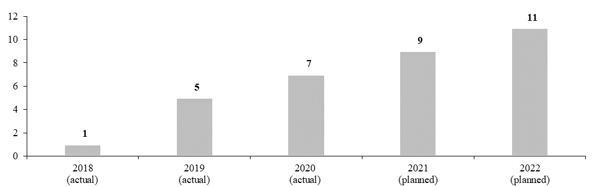

Legislative mandates

15.127 The list below provides all mandates entrusted to the subprogramme.

General Assembly resolutions

64/292 | The human right to water and sanitation
67/291 | Sanitation for All
69/280 | Strengthening emergency relief, rehabilitation and reconstruction in response to the devastating effects of the earthquake in Nepal
69/283 | Sendai Framework for Disaster Risk Reduction 2015–2030
73/139; 74/118 | Strengthening of the coordination of emergency humanitarian assistance of the United Nations
73/150 | Assistance to refugees, returnees and displaced persons in Africa
73/230 | Effective global response to address the impacts of the El Niño phenomenon
74/115 | International cooperation on humanitarian assistance in the field of natural disasters, from relief to development
74/160 | Protection of and assistance to internally displaced persons

Governing Council resolutions

20/17 | Post-conflict, natural and human-made disaster assessment and reconstruction
23/18 | Natural disaster risk reduction, preparedness, prevention and mitigation as a contribution to sustainable urban development
26/2 | Enhancing the role of UN-Habitat in urban crisis response

Deliverables

15.128 Table 15.10 lists all deliverables, by category and subcategory, for the period 2020–2022 that are expected to contribute to the attainment of the objective stated above.

Table 15.10

Subprogramme 4: deliverables for the period 2020–2022, by category and subcategory

Category and subcategory | 2020 planned | 2020 actual | 2021 planned | 2022 plannedª
B. Generation and transfer of knowledge
Field and technical cooperation projects (number of projects) | 28 | 23 | 31 | 19
1. Projects on enhanced social integration and cohesive communities | 10 | 8 | 10 | 8
2. Projects on improved living standards and inclusion of migrants, refugees and internally displaced persons | 10 | 8 | 11 | 5
3. Projects on enhanced resilience of the built environment and infrastructure | 8 | 7 | 10 | 6
Seminars, workshops and training events (number of days) | 42 | 27 | 45 | 31
4. Seminars, workshops and training events on enhanced social integration and cohesive communities | 16 | 10 | 18 | 12
5. Seminars, workshops and training events on improved living standards and inclusion of migrants, refugees and internally displaced persons | 13 | 9 | 13 | 8
6. Seminars, workshops and training events on enhanced resilience of the built environment and infrastructure | 13 | 8 | 14 | 11
Publications (number of publications) | 2 | 1 | 2 | 2
7. Publication on improved living standards and inclusion of migrants, refugees and internally displaced persons | 1 | 1 | 1 | 1
8. Publication on enhanced resilience of the built environment and infrastructure | 1 | – | 1 | 1
Technical materials (number of materials) | 9 | 6 | 9 | 6
9. Technical materials on enhanced social integration and cohesive communities | 3 | 2 | 3 | 2
10. Technical materials on improved living standards and inclusion of migrants, refugees and internally displaced persons | 3 | 2 | 3 | 2
11. Technical materials on enhanced resilience of the built environment and infrastructure | 3 | 2 | 3 | 2
C. Substantive deliverables
Consultation, advice, and advocacy: advisory services to 15 Member States on urban crisis mitigation and response and on enhancing urban resilience to multi-hazard threats, including crises related to migration and displacement.
D. Communication deliverables
Outreach programmes, special events and information materials: brochures, campaigns and events on inclusion in cities, social cohesion, resilience-building, access to adequate housing, land tenure security, basic urban services and economic opportunities for all in urban crisis contexts.
Digital platforms and multimedia content: providing content for and maintaining social media accounts (Twitter, Facebook, Instagram, Trello, LinkedIn, YouTube or similar), blogs and websites will advance the subprogramme’s messaging and communication with regard to the social and economic inclusion of migrants, refugees, internally displaced persons and returnees in urban crisis contexts; messages and multimedia content will be shared through six partners, including Cities Alliance, the Centre for Mediterranean Integration, the global networks for the implementation of the global compact for refugees and the Global Compact for Safe, Orderly and Regular Migration, and the Global Knowledge Partnership on Migration and Development.

ª The 2022 planned deliverables, to be funded from the Foundation non-earmarked fund, have been adjusted downward, taking into account the resources approved by the Executive Board of $10.0 million for 2021 and a budget ceiling figure of $12.0 million in 2022, as shown in table 15.14.

B. Proposed post and non-post resource requirements for 2022

Overview

Note: The following abbreviations are used in tables and figures: GS (OL), General Service (Other level); (LL), Local level; USG, Under-Secretary-General.
15.129 The proposed regular budget resources for 2022, including the breakdown of resource changes, as applicable, are reflected in tables 15.11 to 15.13.

Table 15.11

Overall: evolution of financial resources by object of expenditure
(Thousands of United States dollars)

 |  |  | Changes |  |  |  |  | 2022 estimate (before recosting)
Object of expenditure | 2020 expenditure | 2021 appropriation | Technical adjustments | New/  expanded mandates | Other | Total | Percentage
Post | 10 999.0 | 11 285.5 | 196.2 | – | – | 196.2 | 1.7 | 11 481.7
Other staff costs | 180.4 | 288.5 | – | 230.0 | 5.0 | 235.0 | 81.5 | 523.5
Hospitality | – | 3.1 | – | – | (0.1) | (0.1) | (3.2) | 3.0
Consultants | 182.9 | 106.4 | – | 120.0 | (1.8) | 118.2 | 111.1 | 224.6
Experts | – | 54.0 | – | 30.0 | – | 30.0 | 55.6 | 84.0
Travel of representatives | – | – | – | 39.9 | – | 39.9 | – | 39.9
Travel of staff | 12.8 | 94.3 | – | 10.1 | 0.5 | 10.6 | 11.2 | 104.9
Contractual services | 251.4 | 252.3 | – | 117.0 | 151.8 | 268.8 | 106.5 | 521.1
General operating expenses | 354.6 | 350.4 | – | – | (161.2) | (161.2) | (46.0) | 189.2
Supplies and materials | 33.8 | 32.7 | – | – | (15.2) | (15.2) | (46.5) | 17.5
Furniture and equipment | 152.7 | 28.6 | – | – | 21.0 | 21.0 | 73.4 | 49.6
Grants and contributions | – | – | – | 50.0 | – | 50.0 | – | 50.0
Other | (0.3) | – | – | – | – | – | – | –
Total | 12 167.3 | 12 495.8 | 196.2 | 597.0 | – | 793.2 | 6.3 | 13 289.0

Table 15.12

Overall: proposed posts and post changes for 2022ª

(Number of posts)

 | Number | Details
Approved for 2021 | 75 | 1 USG, 1 D-2, 4 D-1, 9 P-5, 17 P-4, 14 P-3, 5 P-2/1, 2 GS (OL), 22 LL
Redeployment | – | 1 P-3 from subprogramme 2 to subprogramme 4  1 P-3 from subprogramme 3 to subprogramme 4
Proposed for 2022 | 75 | 1 USG, 1 D-2, 4 D-1, 9 P-5, 17 P-4, 14 P-3, 5 P-2/1, 2 GS (OL), 22 LL

ª More information on post changes is reflected in annex III.

Table 15.13

Overall: proposed posts by category and grade

(Number of posts)

 |  | Changes
Category and grade | 2021 approved | Technical adjustments | New/expanded mandates | Other | Total | 2022 proposed
Professional and higher
USG | 1 | – | – | – | – | 1
D-2 | 1 | – | – | – | – | 1
D-1 | 4 | – | – | – | – | 4
P-5 | 9 | – | – | – | – | 9
P-4 | 17 | – | – | – | – | 17
P-3 | 14 | – | – | – | – | 14
P-2/1 | 5 | – | – | – | – | 5
Subtotal | 51 | – | – | – | – | 51
General Service and related
GS (OL) | 2 | – | – | – | – | 2
LL | 22 | – | – | – | – | 22
Subtotal | 24 | – | – | – | – | 24
Total | 75 | – | – | – | – | 75

15.130 Additional details on the distribution of the proposed resources for 2022 are reflected in tables 15.14 to 15.16 and figure 15.XII.
15.131 As reflected in tables 15.14 (1) and 15.15 (1), the overall resources proposed for 2022 amount to $13,289,000 before recosting, reflecting a net increase of $793,200 (or 6.3 per cent) compared with the appropriation for 2021. Resource changes result from three factors, namely: (a) technical adjustments; (b) new and expanded mandates; and (c) other changes. The proposed level of resources provides for the full, efficient and effective implementation of mandates.

Table 15.14

Overall: evolution of financial resources by source of funding, component and subprogramme
(Thousands of United States dollars)

(1) Regular budget

 |  |  | Changes |  |  |  |  | 2022 estimate (before recosting)
Component/subprogramme | 2020 expenditure | 2021 appropriation | Technical adjustments | New/ expanded mandates | Other | Total | Percentage
A. Policymaking organs | 609.3 | 590.2 | – | – | – | – | – | 590.2
B. Executive direction and management | 1 537.2 | 1 640.8 | – | – | (125.1) | (125.1) | (7.6) | 1 515.7
C. Programme of work
1. Reduced spatial inequality and poverty in communities across the urban-rural continuum | 2 928.4 | 2 248.5 | – | 145.0 | 43.8 | 188.8 | 8.4 | 2 437.3
2. Enhanced shared prosperity of cities and regions | 1 707.8 | 2 622.3 | 98.1 | 151.4 | (173.4) | 76.1 | 2.9 | 2 698.4
3. Strengthened climate action and improved urban environment | 2 327.7 | 2 349.2 | 98.1 | 150.5 | (173.1) | 75.5 | 3.2 | 2 424.7
4. Effective urban crisis prevention and response | 1 664.3 | 1 922.8 | – | 150.1 | 427.8 | 577.9 | 30.1 | 2 500.7
Subtotal, C | 8 628.2 | 9 142.8 | 196.2 | 597.0 | 125.1 | 918.3 | 10.0 | 10 061.1
D. Programme support | 1 392.6 | 1 122.0 | – | – | – | – | – | 1 122.0
Subtotal, 1 | 12 167.3 | 12 495.8 | 196.2 | 597.0 | – | 793.2 | 6.3 | 13 289.0

(2) Extrabudgetary

Component/subprogramme | 2020 expenditure | 2021  estimate |  |  |  | Change | Percentage | 2022  estimate
A. Policymaking organs | 1 457.9 | 1 504.2 |  |  |  | (601.5) | (40.0) | 902.7
B. Executive direction and management | 6 515.9 | 3 523.5 |  |  |  | 2 020.1 | 57.3 | 5 543.6
C. Programme of work
1. Reduced spatial inequality and poverty in communities across the urban-rural continuum | 32 594.4 | 60 977.2 |  |  |  | (584.5) | (1.0) | 60 392.7
2. Enhanced shared prosperity of cities and regions | 6 077.9 | 46 531.3 |  |  |  | (8 525.1) | (18.3) | 38 006.2
3. Strengthened climate action and improved urban environment | 8 378.0 | 37 562.4 |  |  |  | 31 961.9 | 85.1 | 69 524.3
4. Effective urban crisis prevention and response | 81 896.3 | 59 269.5 |  |  |  | 484.0 | 0.8 | 59 753.5
Subtotal, C | 128 946.6 | 204 340.4 |  |  |  | 23 336.3 | 11.4 | 227 676.7
D. Programme support | 10 072.5 | 6 314.6 |  |  |  | 1 737.0 | 27.5 | 8 051.6
Subtotal, 2 | 146 992.9 | 215 682.7 |  |  |  | 26 491.9 | 12.3 | 242 174.6
Total | 159 160.4 | 228 178.5 |  |  |  | 27 285.1 | 12.0 | 255 463.6

Table 15.15

Overall: proposed posts for 2022 by source of funding, component and subprogramme

(Number of posts)

(1) Regular budget

 |  | Changes |  |  |  | 2022 proposed
Component/subprogramme | 2021  approved | Technical adjustments | New/expanded mandates | Other | Total
A. Policymaking organs | 5 | – | – | – | – | 5
B. Executive direction and management | 7 | – | – | – | – | 7
C. Programme of work
5. Reduced spatial inequality and poverty in communities across the urban-rural continuum | 13 | – | – | – | – | 13
6. Enhanced shared prosperity of cities and regions | 17 | – | – | (1) | (1) | 16
7. Strengthened climate action and improved urban environment | 14 | – | – | (1) | (1) | 13
8. Effective urban crisis prevention and response | 12 | – | – | 2 | 2 | 14
Subtotal, C | 56 | – | – | – | – | 56
D. Programme support | 7 | – | – | – | – | 7
Subtotal, 1 | 75 | – | – | – | – | 75

(2) Extrabudgetary

Component/subprogramme | 2021 estimate |  |  | Change |  | 2022 estimate
A. Policymaking organs | 1 |  |  | – |  | 1
B. Executive direction and management | 21 |  |  | 7 |  | 28
C. Programme of work
1. Reduced spatial inequality and poverty in communities across the urban-rural continuum | 14 |  |  | (2) |  | 12
2. Enhanced shared prosperity of cities and regions | 13 |  |  | (1) |  | 12
3. Strengthened climate action and improved urban environment | 15 |  |  | 4 |  | 19
4. Effective urban crisis prevention and response | 13 |  |  | 8 |  | 21
Subtotal, C | 55 |  |  | 9 |  | 64
D. Programme support | 31 |  |  | 6 |  | 37
Subtotal, 2 | 108 |  |  | 22 |  | 130
Total | 183 |  |  | 22 |  | 205

Table 15.16

Overall: evolution of financial and post resources

(Thousands of United States dollars/number of posts)

 |  |  | Changes |  |  |  |  | 2022  estimate (before recosting)
 | 2020 expenditure | 2021 appropriation | Technical adjustments | New/  expanded mandates | Other | Total | Percentage
Financial resources by main category of expenditure
Post | 10 999.0 | 11 285.5 | 196.2 | – | – | 196.2 | 1.7 | 11 481.7
Non-post | 1 168.3 | 1 210.3 | – | 597.0 | – | 597.0 | 49.3 | 1 807.3
Total | 12 167.3 | 12 495.8 | 196.2 | 597.0 | – | 793.2 | 6.3 | 13 289.0
Post resources by category
Professional and higher |  | 51 | – | – | – | – | – | 51
General Service and related |  | 24 | – | – | – | – | – | 24
Total |  | 75 | – | – | – | – | – | 75

Figure 15.XII

Distribution of proposed resources for 2022 (before recosting)

(Number of posts/thousands of United States dollars)

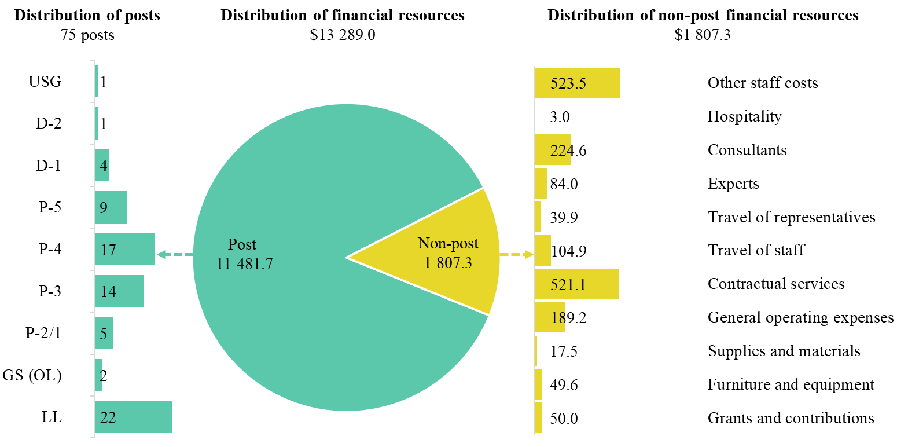

Explanation of variances by factor, component and subprogramme

Overall resource changes

Technical adjustments

15.132 As reflected in table 15.14 (1), resource changes reflect a net increase of $196,200, as follows:
Subprogramme 2, Enhanced shared prosperity of cities and regions (increase of $98,100) and Subprogramme 3, Strengthened climate action and improved urban environment (increase of $98,100). These increases are related to the delayed impact of two Programme Management Officer (P-4) posts approved pursuant to General Assembly resolution 75/252, which were subject to a 50 per cent vacancy rate in accordance with the established practice for new posts.

New and expanded mandates

15.133 As reflected in table 15.14 (1), resource changes reflect an increase of $597,000, related to the inclusion of non-recurrent requirements for the production of the quadrennial report on progress in the implementation of the New Urban Agenda, in accordance with General Assembly resolution 71/235. The resources would be utilized to collect and process qualitative, quantitative and spatial data, and to support the synthesis of national reports based on the guidelines for reporting on the implementation of the New Urban Agenda (other staff costs); to provide technical support for data production and expert group sessions on reporting across regions, and to support the organization of various forums at the subnational, national, regional and global levels in order to discuss findings and support the preparation of regional reports on the implementation of the New Urban Agenda (consultants); to review progress in the implementation of the New Urban Agenda and support expert review sessions and the dissemination of the quadrennial report (experts, travel of representatives, travel of staff); to support the production of information, including the production and implementation of awareness-raising activities related to the quadrennial report (contractual services); and to support the collection of non-traditional data through a variety of platforms and sources, including civil society, academia and online platforms, and to support regional institutions in their efforts to collect qualitative data on the implementation of the New Urban Agenda (grants and contributions). The distribution across the subprogrammes is as follows:
(a) Subprogramme 1, Reduced spatial inequality and poverty in communities across the urban-rural continuum. An increase of $145,000 ($57,500 under other staff costs, $30,000 under consultants, $7,500 under experts, $8,300 under travel of representatives, $29,200 under contractual services and $12,500 under grants and contributions).
(b) Subprogramme 2, Enhanced shared prosperity of cities and regions. An increase of $151,400 ($57,500 under other staff costs, $30,000 under consultants, $7,500 under experts, $11,500 under travel of representatives, $3,100 under travel of staff, $29,300 under contractual services and $12,500 under grants and contributions).
(c) Subprogramme 3, Strengthened climate action and improved urban environment. An increase of $150,500 ($57,500 under other staff costs, $30,000 under consultants, $7,500 under experts, $10,300 under travel of representatives, $3,500 under travel of staff, $29,200 under contractual services and $12,500 under grants and contributions).
(d) Subprogramme 4, Effective urban crisis prevention and response. An increase of $150,100 ($57,500 under other staff costs, $30,000 under consultants, $7,500 under experts, $9,800 under travel of representatives, $3,500 under travel of staff, $29,300 under contractual services and $12,500 under grants and contributions).

Other changes

15.134 As reflected in table 15.14 (1), the net effect of the proposed changes is cost-neutral; those changes, which mainly affect the operational requirements projected for 2022, reflect practices aimed at building back better. The breakdown of changes is as follows:
(a) Executive direction and management. The net decrease of $125,100 reflects the net effect of:
(i) Outward redeployment of non-post resources in the amount of $125,100 to subprogrammes 1 and 4, following the transfer of external relations functions to the programme of work component, in line with the strategic direction endorsed by Executive Board, which is intended to shift the focus from management to programme activities. This resulted in decreases under other staff costs ($82,200), consultants ($13,300) and general operating expenses ($29,600);
(ii) Additional travel resources ($1,900) to attend the Inter-Agency Standing Committee meeting scheduled to take place in Geneva in 2022;
(iii) Decreased rental of furniture, other office equipment and mobile telephony (resulting in a decrease of $4,100 under general operating expenses), and an anticipated reduction in the consumption of office supplies owing to the increased use of flexible work arrangements (resulting in a decrease of $2,000 under stationery and office supplies);
(iv) Redeployment of $11,700 from general operating expenses to contractual services, following changes in the charging modalities under the service level agreement with the United Nations Office at Nairobi;
(v) Increased requirements for the replacement of office automation equipment in 2022 (resulting in an increase of $4,200 under furniture and equipment).
(b) Subprogramme 1, Reduced spatial inequality and poverty in communities across the urban-rural continuum. The net increase of $43,800 mainly relates to:
(i) Transfer of external relations functions from the executive direction and management component to the subprogramme, in order to increase the focus on programmatic activities. This resulted in increases of $4,900 under other staff costs, $9,300 under consultants, $25,600 under contractual services and $4,000 under furniture and equipment;
(ii) Planned attendance at the high-level meeting of the General Assembly on sustainable urbanization, to be held in New York in 2022, resulting in an increase of $6,900 under travel of staff;
(iii) Higher public information requirements for the production and external printing of flagship reports, including the World Cities Report, which is a cross-cutting report that benefits from the contribution of all subprogrammes. This resulted in an increase of $15,600 under contractual services;
(iv) Reduced provisions for miscellaneous services under the service level agreement with the United Nations Office at Nairobi, resulting in a decrease of $19,600 under general operating expenses;
(v) Anticipated reduction in the consumption of office supplies owing to the more extensive use of flexible work arrangements, resulting in a decrease of $3,600 under supplies and materials.
(c) Subprogramme 2, Enhanced shared prosperity of cities and regions. The net decrease of $173,400 mainly relates to:
(i) Proposed outward redeployment of one Programme Management Officer (P-3) post to subprogramme 4, in line with the placement of external relations functions under subprogramme 4. The proposed redeployment to subprogramme 4 is primarily attributable to the recent increase in demand for external relations support for crisis prevention and response, in part owing to the recent developments associated with COVID-19. This redeployment resulted in a decrease of $172,900 under posts;
(ii) Additional requirements for the development of specialized normative tools to deliver global solutions in the areas of policy, legislation and governance, resulting in an increase of $8,300 under consultants and of $100 under experts;
(iii) Reduction of $500 in the requirements under travel of staff. which the Programme plans to achieve through the increased utilization of information and communications technology (ICT) in lieu of travel, including the use of virtual teleconferencing facilities to promote remote participation wherever possible;
(iv) Higher public information requirements for the production and external printing of flagship reports, including the World Cities Report, which is a cross-cutting report that benefits from the contribution of all subprogrammes. This resulted in an increase of $4,900 under contractual services;
(v) Reduced provisions for miscellaneous expenses under the service level agreement with the United Nations Office at Nairobi, resulting in a decrease of $13,400 under general operating expenses;
(vi) Higher stock levels of consumable supplies accumulated in 2020, in line with the lower consumption levels during the pandemic. This change resulted in a decrease of $2,200 in the provision for supplies and materials;
(vii) Additional requirements for the replacement of office automation equipment in 2022, resulting in an increase of $2,200 under furniture and equipment.
(d) Subprogramme 3, Strengthened climate action and improved urban environment. The net decrease of $173,100 mainly relates to the net effect of:
(i) Proposed outward redeployment of one Programme Management Officer (P-3) post to subprogramme 4, in line with the placement of external relations functions under subprogramme 4. The proposed redeployment to subprogramme 4 is primarily attributable to the recent increase in demand for external relations support for crisis prevention and response, in part owing to the recent developments associated with COVID-19. This redeployment resulted in a decrease of $172,900 under posts;
(ii) Reduced requirements for travel to be achieved through the increased utilization of ICT in lieu of travel, including the use of virtual teleconferencing facilities to promote remote participation wherever possible. This change resulted in a decrease under consultants ($2,300) and travel of staff ($3,700);
(iii) Higher public information requirements for the production and external printing of flagship reports, including the World Cities Report, which is a cross-cutting report that benefits from the contribution of all subprogrammes. This resulted in an increase of $2,800 under contractual services;
(iv) Redeployment of $41,000 from general operating expenses to contractual services following changes in the charging modalities under the service level agreement with the United Nations Office at Nairobi;
(v) Higher stock levels of consumable supplies accumulated in 2020, in line with the lower consumption levels during the pandemic. This change resulted in a decrease of $3,400 in the provision for supplies and materials;
(vi) Additional requirements for the replacement of office automation equipment in 2022, resulting in an increase of $6,300 under furniture and equipment.
(e) Subprogramme 4, Effective urban crisis prevention and response. The net increase of $427,800 mainly relates to the net effect of:
(i) Proposed inward redeployment of two Programme Management Officer (P-3) posts from subprogrammes 2 and 3, in line with the placement of external relations functions under subprogramme 4, primarily attributable to the recent increase in demand for external relations support for crisis prevention and response, in part owing to the recent developments associated with COVID-19. This redeployment resulted in an increase of $345,800 under posts. This change is in line with the strategic direction endorsed by the Executive Board and is intended to maximize the effectiveness and progress towards the objectives of all subprogrammes of UN-Habitat. In addition, the consolidation of functions entailed a redeployment from the executive direction and management component to increase the focus on programmatic activities. This change resulted in an increase of $81,300 under other staff costs;
(ii) Reduced requirements for travel to be achieved through the increased utilization of ICT in lieu of travel, including the use of virtual teleconferencing facilities to promote remote participation wherever possible. This change resulted in a decrease under consultants ($2,700) and travel of staff ($4,100);
(iii) Higher public information requirements for the production and external printing of flagship reports, including the World Cities Report, which is a cross-cutting report that benefits from the contribution of all subprogrammes. This resulted in an increase of $6,500 under contractual services;
(iv) Redeployment of $42,300 from general operating expenses to contractual services following changes in the charging modalities under the service level agreement with the United Nations Office at Nairobi;
(v) Higher stock levels of consumable supplies accumulated in 2020, in line with the lower consumption levels during the pandemic. This change resulted in a decrease of $2,100 in the provision for supplies and materials;
(vi) Additional requirements for the replacement of office automation equipment in 2022, resulting in an increase of $2,500 under furniture and equipment.
(f) Programme support. The cost neutral changes reflect:
(i) Reduced requirements for travel to be achieved through the increased utilization of ICT in lieu of travel, including the use of virtual teleconferencing facilities to promote remote participation wherever possible. This change resulted in a decrease under consultants ($1,800);
(ii) Redeployment of $1,900 from supplies and materials to contractual services ($1,400) and general operating expenses ($500) following changes in the service level agreement with the United Nations Office at Nairobi. The change in the service level agreement is proposed to reflect the increased stock levels of consumable supplies accumulated in 2020, in line with the lower consumption levels during the pandemic, and the anticipated increase in demand for public information services, including external printing;
(iii) Additional requirements for the replacement of office automation equipment in 2022, resulting in an increase of $1,800 under furniture and equipment.

Extrabudgetary resources

15.135 As reflected in tables 15.14 (2) and 15.15 (2), UN-Habitat expects to continue to receive both cash and in-kind contributions, which would complement regular budget resources. In 2022, extrabudgetary resources are estimated at $242,174,600 and would provide for 130 posts, as presented in table 15.15 (2).
15.136 The resources would be used mainly to carry out technical cooperation projects, at the request of Member States. Examples of such projects include, under subprogramme 1, technical cooperation to be provided for inclusive urban development that benefits all, through the implementation of digital divide assessments in at least four cities and regions in order to devise digital transformation strategies for inclusive urban and regional development and provide on-the-job capacity development and training for local government officials in order to better manage inclusive urban development following the new challenges to basic service provision for all posed by the COVID-19 pandemic. Under subprogramme 2, technical cooperation projects funded from extrabudgetary resources are anticipated in order to facilitate the implementation of the United Nations Innovation Technology Accelerator for Cities, a partnership with the Government of Germany (the city of Hamburg) which will provide innovative solutions to tackle key urban challenges (addressing the digital divide, reducing greenhouse gas emissions in cities and ensuring that no one is left behind in decision-making processes in cities), and to prepare strategies for the development of people-centred smart cities in order to reduce the digital divide and improve the quality of life of urban dwellers. Under subprogramme 3, extrabudgetary resources would be used to implement technical cooperation projects with requesting countries in support of increased ambitions to combat climate change at the national and local levels. For example, climate-resilient water supply systems in two districts of the Lao People’s Democratic Republic would provide safe water to almost 60,000 people. Finally, under subprogramme 4, extrabudgetary resources would be used to carry out technical cooperation projects; an example is the ongoing area-based programme aimed at supporting recovery and stability in Iraq through local development (2019–2022), which is being implemented in five cities in partnership with UNDP. The main objective of the programme, which is expected to benefit 700,000 people, is to support the sustainable return of internally displaced persons through the provision of basic services and the improvement of living conditions, with a focus on vocational training and job creation. The demand for technical cooperation projects is estimated to continue to increase, as exemplified by the increase in demand for programmes related to strengthened climate action and improved urban environment, which explains the significant increase under subprogramme 3 ($31,961,900, or 85.1 per cent). The consolidated budget for 2022 for UN-Habitat will be submitted to the Advisory Committee on Administrative and Budgetary Questions for its consideration in June 2021 and to the Executive Board for approval at its September 2021 session. Extrabudgetary resources represent 94.8 per cent of the total resources for UN-Habitat.
15.137 The extrabudgetary resources under this section are subject to the oversight of the Executive Board, which has delegated authority from the UN-Habitat Assembly.

Policymaking organs

15.138 The resources proposed under this component would provide for requirements relating to the Executive Board and the Committee of Permanent Representatives. In December 2018, the General Assembly adopted resolution 73/239, by which it established a new governance structure for UN-Habitat, consisting of the universal UN-Habitat Assembly, a 36-member Executive Board and a Committee of Permanent Representatives. Table 15.17 provides information on the standing intergovernmental organs and related resource requirements under the regular budget.

Table 15.17

Policymaking organs
(Thousands of United States dollars)

Policymaking organ | Description | Additional info | 2021 appropriation | 2022 estimate (before recosting)
UN-Habitat Assembly | Provides policy guidance on human settlements and sustainable urbanization and strategic oversight of UN-Habitat. It approves the UN-Habitat four-year strategic plan. It reports every four years on its work to the General Assembly through the Economic and Social Council at its substantive session. It meets every four years for five days. Its first session was held in May 2019; the next will be held in June 2023. | Mandate: General Assembly resolution 73/239 and note by the Secretary-General (A/73/726) | 590.2 | 590.2
 |  | UN-Habitat Assembly rules of procedure
 |  | Membership: 193 government officials
 |  | Number of sessions in 2022: none
Committee of Permanent Representatives | Permanent intersessional subsidiary body of the UN-Habitat Assembly. It is responsible for a high-level midterm review of the implementation of UN-Habitat Assembly decisions and resolutions and of the UN-Habitat strategic plan, and for preparing for the next session of the UN-Habitat Assembly. It meets twice every four years: once prior to the UN-Habitat Assembly session, in preparation for that session, and a second time for a high-level midterm review. The first high-level midterm review will be held from 29 June to 1 July 2021. | Mandate: General Assembly resolutions 73/239 and 56/206 and note by the Secretary-General (A/73/726) | – | –
 |  | UN-Habitat Assembly rules of procedure
 |  | Membership: 193 government officials
 |  | Number of sessions in 2022: none
Executive Board | Permanent intersessional subsidiary body of the UN-Habitat Assembly. It is responsible for strengthening the oversight of UN-Habitat operations and enhancing the accountability, transparency, efficiency and effectiveness of UN-Habitat. It oversees the preparation of the draft strategic plan before its approval by the UN-Habitat Assembly and is responsible for the review and approval of the annual programme of work and budget and the resource mobilization strategy, in accordance with the strategic plans and political guidelines provided by the UN-Habitat Assembly. The Executive Board meets two to three times in a year and held its first session of 2021 on 7 and 8 April 2021. | Mandate: General Assembly resolution 73/239; note by the Secretary-General (A/73/726) | – | –
 |  | UN-Habitat Assembly resolution 1/1, adopted by the Assembly at its first session in May 2019
 |  | UN-Habitat Assembly rules of procedure
 |  | Membership: 36
 |  | Number of sessions in 2022: 3
Total |  |  | 590.2 | 590.2

15.139 The proposed regular budget resources for 2022 amount to $590,200 and reflect no change in the resource level compared with the appropriation for 2021. Additional details on the distribution of the proposed resources for 2022 are reflected in table 15.18 and figure 15.XIII.

Table 15.18

Policymaking organs: evolution of financial resources
(Thousands of United States dollars/number of posts)

 |  |  | Changes |  |  |  |  | 2022 estimate (before recosting)
 | 2020 expenditure | 2021 appropriation | Technical adjustments | New/ expanded mandates | Other | Total | Percentage
Financial resources by main category of expenditure
Post | 574.8 | 558.5 | – | – | – | – | – | 558.5
Non-post | 34.5 | 31.7 | – | – | – | – | – | 31.7
Total | 609.3 | 590.2 | – | – | – | – | – | 590.2
Post resources by category
Professional and higher |  | 2 | – | – | – | – | – | 2
General Service and related |  | 3 | – | – | – | – | – | 3
Total |  | 5 | – | – | – | – | – | 5

Figure 15.XIII

Policymaking organs: distribution of proposed resources for 2022 (before recosting)
(Number of posts/thousands of United States dollars)

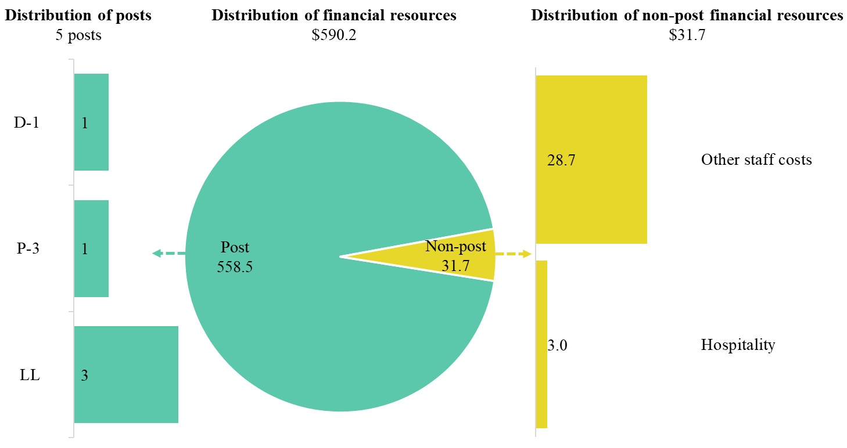

15.140 Extrabudgetary resources for policymaking organs are estimated at $902,700 and would provide for one post (1 P-3), as well as non-post resources. The resources would be used mainly to provide support to the policymaking organs of UN-Habitat. These resources would complement the regular budget resources and enhance the capacity of the Governing Bodies Secretariat to support the new governance structure of UN-Habitat, including the co-financing meetings of the Executive Board. The decrease of $601,500 is attributable mainly to the lesser projected contributions under the foundation for non-earmarked funds in 2022.

Executive direction and management

15.141 The executive direction and management component comprises the Office of the Executive Director, the Office of the Deputy Executive Director, the Office of the Chief of Staff, liaison offices in New York, Brussels, Bangkok and Geneva, the Governing Bodies Secretariat, the Legal Unit and the Independent Evaluation Unit. The Executive Director is also supported by the Office of the Principal Adviser, which undertakes special assignments.
15.142 The overall responsibilities of the executive direction and management component include the following functions:
(a) To provide overall direction, translating the vision of the Executive Director and the guidance from the Executive Board into the Programme’s work priorities;
(b) To foster relationships with Member States and keep abreast of the needs of the Executive Board, the Committee of Permanent Representatives, the UN-Habitat Assembly and stakeholders affiliated with the Economic and Social Council;
(c) To coordinate the planning and ensure the implementation of the UN-Habitat strategic plan by ensuring the overall effectiveness of the Programme’s organizational structure. It provides direction and alignment through the Executive Committee, which is chaired by the Executive Director, whom it assists in providing policy direction in order to ensure the effectiveness of the Programme;
(d) To contribute, in close cooperation with other United Nations agencies, to discussions on, and the implementation of, United Nations reforms, in particular in relation to improving system-wide coherence in United Nations development work, with a special focus on sustainable urbanization;
(e) To foster the mainstreaming of gender and disability inclusion into the four subprogrammes of UN-Habitat.
15.143 The Executive Director has the overall responsibility to provide policy guidance and leadership for the Programme. The Executive Director is supported by the Deputy Executive Director and an Executive Committee, which comprises all division directors and coordinates with them in setting the work priorities for the Programme. This includes establishing policies, providing strategic direction with regard to the programme of work and relations with Member States, coordinating with the United Nations Secretariat, reporting to the General Assembly and the Economic and Social Council and overseeing and developing relations with other United Nations entities and with non-United Nations organizations, the private sector, civil society and non-governmental organizations.
15.144 The Office of the Deputy Executive Director chairs the Programme Management Committee, provides guidance and ensures the overall coordination of programme management (planning, monitoring and reporting) for UN-Habitat. In collaboration with division directors, the Office of the Deputy Executive Director helps to ensure that targets are set, monitored and reported on effectively. The Deputy Executive Director also chairs the Project Review Committee, ensuring overall alignment between the programme of work of UN-Habitat and budgetary requirements, and ensuring that projects contribute effectively to the impact targets established under the UN-Habitat strategic plan. The Deputy Executive Director also provides guidance and strategic direction to division directors by chairing the Risk Management Committee and the Publications Committee. The Deputy Executive Director is also overseeing the UN-Habitat restructuring exercise, which includes policy guidance for the Programme’s field operations.
15.145 The Office of the Chief of Staff is tasked with ensuring the smooth operation of the Programme; it ensures an equitable and safe work environment and maintains good relations with Member States with regard to substantive, political, procedural and managerial questions. The Chief of Staff is the Secretary of the Executive Committee and helps to prepare information regarding key policy, budgetary, human resources and other operational matters for the consideration of the Executive Director. The Chief of Staff is also the Secretary of the Staff-Management Consultative Committee and is the main focal point for matters related to the United Nations Staff Union, providing an open channel to address and resolve any grievances in order to ensure a positive work environment for all staff and personnel. The Chief of Staff also manages internal communications relating to the organization of town hall meetings, oversees the publication of a biweekly internal newsletter and issues weekly broadcast updates to all staff.
15.146 The Governing Bodies Secretariat supports the efficient and effective implementation of the legislative and governance framework by convening the UN-Habitat Assembly, high-level meetings of the Committee of Permanent Representatives, meetings of the Executive Board and briefings by the Executive Director. The Secretary of the Governing Bodies also facilitates informal meetings of regional groups and, in coordination with the Chief of Staff, supports the Executive Director by providing inputs to procedural and managerial questions.
15.147 Through its liaison offices in New York, Brussels, Bangkok and Geneva, the Office of the Executive Director ensures that the Programme is aligned with the wider goals of the United Nations. The Executive Director provides guidance to the Regional Programmes Division in order to ensure that the expertise of UN-Habitat in the area of sustainable urbanization provides added value in the context of its work with regional commissions and United Nations entities on programmatic and technical cooperation issues in support of the resident coordinator system.
15.148 The Office of the Principal Adviser, which is under the direct supervision of the Executive Director, coordinates with division directors in establishing the overall position of the Programme on selected key issues related to its mandate. This role ensures cohesiveness and alignment with the broader work of the Secretariat, strengthening the overall position of the United Nations in the urban and human settlements context. The Principal Special Assistant supports the Deputy Executive Director by chairing the Project Review Committee working group, whose main function is to ensure that colleagues work together to develop concept notes and project proposals that contribute to the normative and operational work of the Programme. The Principal Special Assistant also undertakes special assignments related to resource mobilization and private sector engagement.
15.149 The Office of the Executive Director, through the Legal Unit and the Independent Evaluation Unit, both of which are under the direct supervision of the Executive Director, ensures transparent and ethical management of the Programme. The Office of the Executive Director is also the focal point for matters related to the Office of Internal Oversight Services and other United Nations investigative functions.
15.150 In accordance with the 2030 Agenda, in particular target 12.6 of the Sustainable Development Goals, organizations are encouraged to integrate sustainability information into their reporting cycles, and, in compliance with the cross-cutting mandate set out in paragraph 19 of General Assembly resolution 72/219, UN-Habitat continues to incrementally improve the environmental management performance of its operations and facilities management in a number of ways. In 2020, in partnership with the Secretariat and in accordance with the United Nations Framework Convention on Climate Change, UN-Habitat offset all its greenhouse gas emissions. In the same year, UN-Habitat compiled a more comprehensive emissions inventory for the “Greening the Blue” report of UNEP; that inventory will serve as the institutional baseline going forward, and efforts are being made to include measured data from larger regional offices in the information for the 2021 report. Furthermore, UN-Habitat continues to participate in the zero-plastic and recycling programme at the United Nations Office at Nairobi. UN-Habitat also partakes in a comprehensive waste management and recycling scheme whereby waste is sorted at source in offices. In addition, the main UN-Habitat office building in Nairobi is powered by a partial solar photovoltaic electricity system. Finally, UN-Habitat complies with the principles of paperless meetings, whereby all Executive Board and UN-Habitat Assembly meetings are paper-free and conference materials are shared by USB drive, electronically or through applications. In addition to its efforts in relation to operational matters, and in alignment with the expanded scope of the Strategy for Sustainability Management in the United Nations System, 2020–2030, UN-Habitat has made progress in revamping its Environmental and Social Safeguards System in order to reduce the environmental impact of its programmes and projects.
15.151 Information on compliance with the timely submission of documentation and advance booking for air travel is reflected in table 15.19. In 2020, UN-Habitat initiated a procedure whereby any travel request not in compliance with the United Nations advance booking policy would have to be cleared by the Office of the Executive Director. However, as the procedure was being implemented the COVID-19 pandemic began and UN-Habitat travel was significantly reduced. Therefore, the results of the new procedure could only be partially assessed in 2020. The percentage of air tickets purchased at least two weeks before the commencement of travel improved significantly, from 19 per cent in 2019 to 51 per cent in 2020. Starting in 2021, UN-Habitat will review compliance with the United Nations advance booking policy on a quarterly basis.

Table 15.19

Compliance rate
(Percentage)

 | Actual 2019 | Actual 2020 | Planned 2021 | Planned 2022
Timely submission of documentation | 65 | 97 | 100 | 100
Air tickets purchased at least 2 weeks before the commencement of travel | 19 | 51 | 100 | 100

15.152 The proposed regular budget resources for 2022 amount to $1,515,700 and reflect a decrease of $125,100 compared with the appropriation for 2021. The proposed decrease is explained in paragraph 15.134 (a). Additional details on the distribution of the proposed resources for 2022 are reflected in table 15.20 and figure 15.XIV.

Table 15.20

Executive direction and management: evolution of financial and post resources
(Thousands of United States dollars/number of posts)

 |  |  | Changes |  |  |  |  | 2022 estimate (before recosting)
 | 2020 expenditure | 2021 appropriation | Technical adjustments | New/ expanded mandates | Other | Total | Percentage
Financial resources by main category of expenditure
Post | 1 246.0 | 1 329.7 | – | – | – | – | – | 1 329.7
Non-post | 291.3 | 311.1 | – | – | (125.1) | (125.1) | (40.2) | 186.0
Total | 1 537.3 | 1 640.8 | – | – | (125.1) | (125.1) | (7.6) | 1 515.7
Post resources by category
Professional and higher |  | 4 | – | – | – | – | – | 4
General Service and related |  | 3 | – | – | – | – | – | 3
Total |  | 7 | – | – | – | – | – | 7

Figure 15.XIV

Executive direction and management: distribution of proposed resources for 2022 (before recosting)
(Number of posts/thousands of United States dollars)

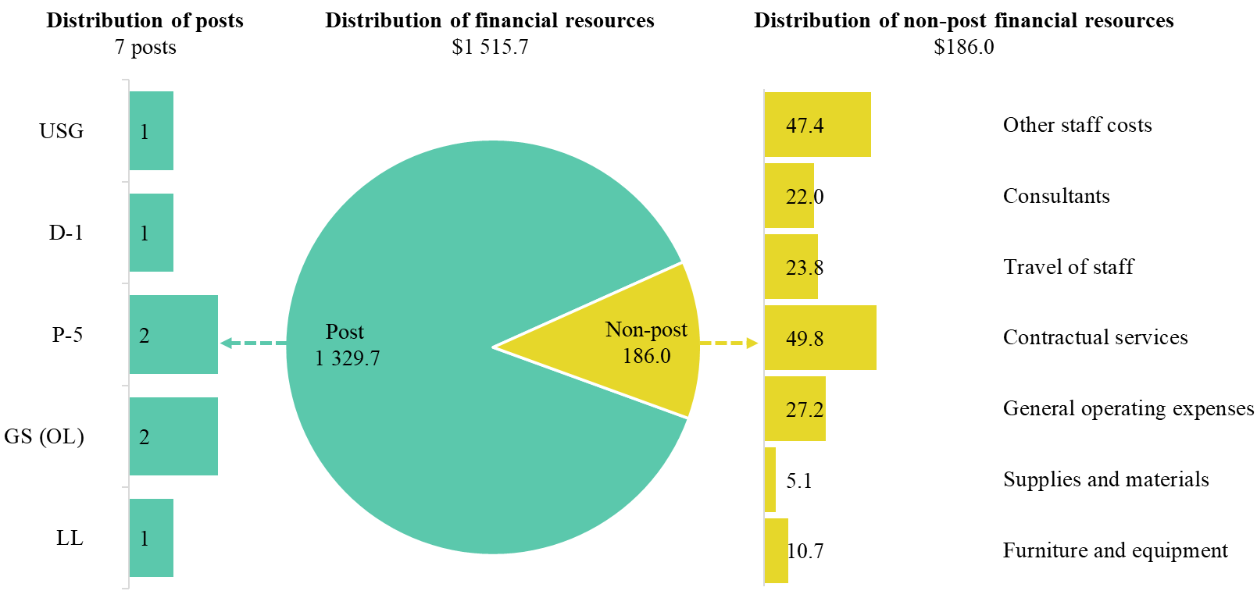

Extrabudgetary resources

15.153 Extrabudgetary resources for executive direction and management are estimated at $5,543,600 and would provide for 28 posts (1 Assistant Secretary-General, 1 D-2, 1 D-1, 3 P-5, 8 P-4, 3 P-3, 1 P-2/1, 1 National Professional Officer (NPO) and 9 Local level (LL)), as well as non-post resources. The resources would be used to assist in the overall executive direction and management of UN-Habitat, including the planning, coordination, management and assessment of the programme of work and strategic plan of the Programme. The expected increase of $2,020,100 is mainly attributable to the proposed implementation of various initiatives, such as the International Urban Cooperation programme, Sustainable Development Goals Cities, the Mayors’ Declaration of the Economic Commission for Europe Forum of Mayors 2020 and activities under the Commonwealth Healthy Cities initiative.

Programme of work

15.154 The proposed regular budget resources for 2022 amount to $10,061,100 and reflect an increase of $918,300 compared with the appropriation for 2021. The proposed increase is explained in paragraphs 15.133 and 15.134 ((b) to (e)). The distribution of resources by subprogramme is reflected in figure 15.XV.

Figure 15.XV

Distribution of proposed resources for 2022, by subprogramme

(Millions of United States dollars)

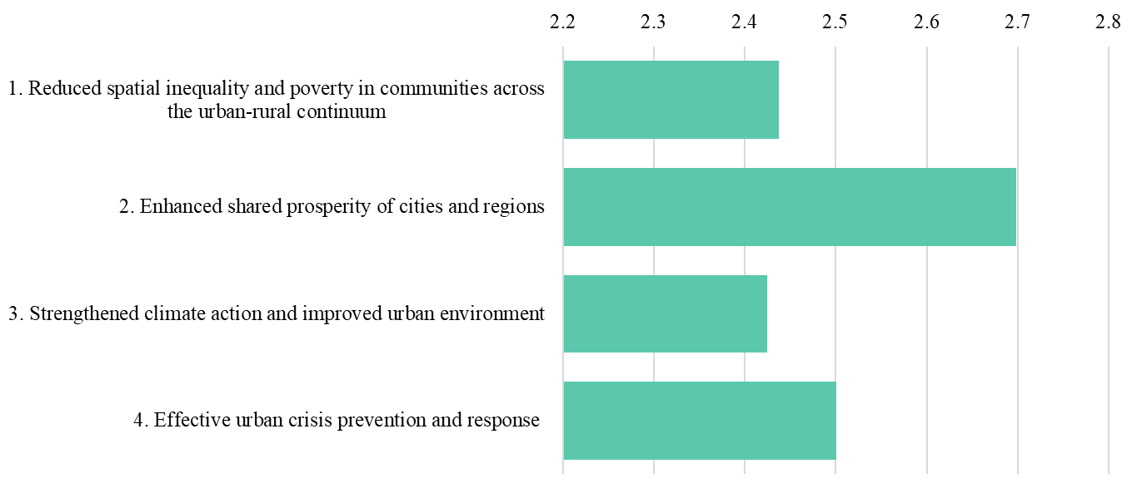

Subprogramme 1

Reduced spatial inequality and poverty in communities across the urban-rural continuum

15.155 The proposed regular budget resources for 2022 amount to $2,437,300 and reflect an increase of $188,800 compared with the appropriation for 2021. The proposed increase is explained in paragraphs 15.133 (a) and 15.134 (b). Additional details on the distribution of the proposed resources for 2022 are reflected in table 15.21 and figure 15.XVI.

Table 15.21

Subprogramme 1: evolution of financial and post resources

(Thousands of United States dollars/number of posts)

 |  |  | Changes |  |  |  |  | 2022 estimate (before recosting)
 | 2020 expenditure | 2021 appropriation | Technical adjustments | New/ expanded mandates | Other | Total | Percentage
Financial resources by main category of expenditure
Post | 2 788.3 | 2 036.3 | – | – | – | – | – | 2 036.3
Non-post | 140.1 | 212.2 | – | 145.0 | 43.8 | 188.8 | 89.0 | 401.0
Total | 2 928.4 | 2 248.5 | – | 145.0 | 43.8 | 188.8 | 8.4 | 2 437.3
Post resources by category
Professional and higher |  | 9 | – | – | – | – | – | 9
General Service and related |  | 4 | – | – | – | – | – | 4
Total |  | 13 | – | – | – | – | – | 13

Figure 15.XVI

Subprogramme 1: distribution of proposed resources for 2022 (before recosting)

(Number of posts/thousands of United States dollars)

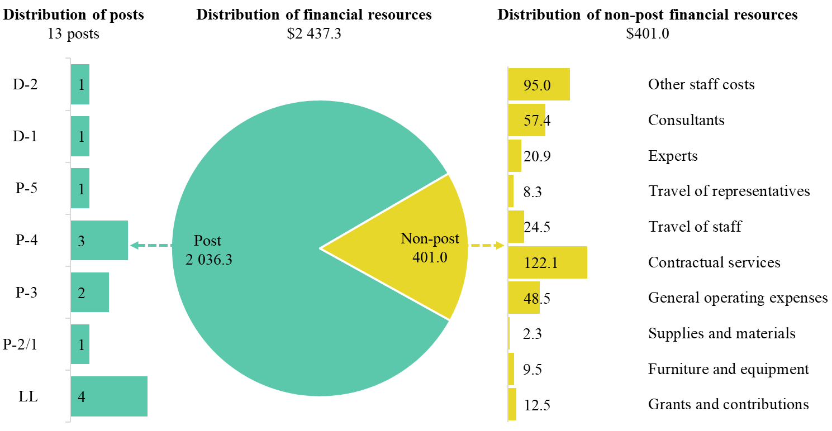

Extrabudgetary resources

15.156 Extrabudgetary resources for the subprogramme are estimated at $60,392,700 and would provide for 12 posts (1 D-1, 4 P-5, 1 P-4, 1 P-3 and 5 LL), as well as non-post resources. The resources would be used mainly for technical cooperation projects with requesting countries in the areas of urban development, digital transformation strategies, regional development and on-the-job capacity development and training for local government officials, in order to better manage inclusive urban development following the new challenges to basic service provision posed by the COVID-19 pandemic. Given the impact of the pandemic, subprogramme 1, in conjunction with other subprogrammes, will contribute to the pursuit of holistic responses to better support countries in their efforts to overcome the adversity and economic and social challenges resulting from the pandemic. Furthermore, under the subprogramme, extrabudgetary resources would also be used to promote and stimulate the engagement of the private sector in public-private partnerships that take into consideration the economic, social and environmental dimensions of sustainable urban development.
15.157 The expected decrease of $584,500 is attributable mainly to the reallocation of extrabudgetary resources across the four subprogrammes after the analysis of the resource requirements for each strategic area and of the strategic priorities of UN-Habitat, driven by the express needs of Member States. There is significant increased demand worldwide for projects that promote strengthened climate action and improved urban environment, which is the domain of subprogramme 3.

Subprogramme 2

Enhanced shared prosperity of cities and regions

15.158 The proposed regular budget resources for 2022 amount to $2,698,400 and reflect a net increase of $76,100 compared with the appropriation for 2021. The proposed increase is explained in paragraphs 15.132, 15.133 (b) and 15.134 (c). Additional details on the distribution of the proposed resources for 2022 are reflected in table 15.22 and figure 15.XVII.

Table 15.22

Subprogramme 2: evolution of financial and post resources

(Thousands of United States dollars/number of posts)

 |  |  | Changes |  |  |  |  | 2022 estimate (before recosting)
 | 2020 expenditure | 2021 appropriation | Technical adjustments | New/ expanded mandates | Other | Total | Percentage
Financial resources by main category of expenditure
Post | 1 559.0 | 2 410.0 | 98.1 | – | (172.9) | (74.8) | (3.1) | 2 335.2
Non-post | 148.8 | 212.3 | – | 151.4 | (0.5) | 150.9 | 71.1 | 363.2
Total | 1 707.8 | 2 622.3 | 98.1 | 151.4 | (173.4) | 76.1 | 2.9 | 2 698.4
Post resources by category
Professional and higher |  | 12 | – | – | (1) | (1) | (8) | 11
General Service and related |  | 5 | – | – | – | – | – | 5
Total |  | 17 | – | – | (1) | (1) | (6) | 16

Figure 15.XVII

Subprogramme 2: distribution of proposed resources for 2022 (before recosting)

(Number of posts/thousands of United States dollars)

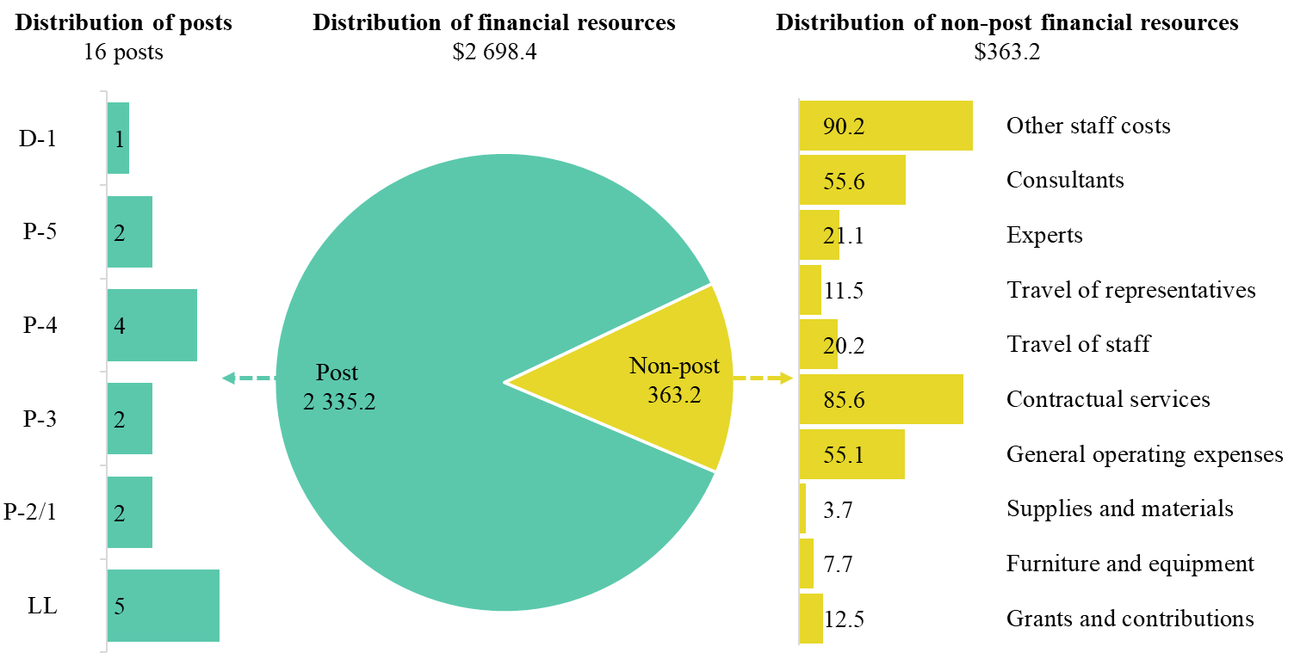

Extrabudgetary resources

15.159 Extrabudgetary resources for the subprogramme are estimated at $38,006,200 and would provide for 12 posts (2 D-1, 2 P-5, 4 P-4, 3 P-3 and 1 LL), as well as non-post resources. The resources would be used mainly to implement technical cooperation projects with requesting countries in order to develop innovative solutions to address key urban challenges and to prepare people-centred, “smart city” strategies aimed at reducing the digital divide and improving the quality of life of urban dwellers. Given the impact of the pandemic, subprogramme 2, in conjunction with other subprogrammes, mainly subprogrammes 1 and 4, will contribute to the pursuit of holistic responses to better support cities in their efforts to overcome the adversity and the economic and social challenges resulting from the pandemic. Under the subprogramme, UN-Habitat will work with cities to generate improved spatial data in real time on the local social and economic impact of COVID-19, and to channel this evidence into the formulation of strengthened national and subnational urban policies and local urban recovery interventions. In addition, under the subprogramme, UN-Habitat will continue to support cities in their efforts to strengthen own-source revenue generation and to support regions in their efforts to strengthen urban-rural linkages in order to enhance local economic recovery and increase basic infrastructure provision. Furthermore, under the subprogramme, UN-Habitat intends to use extrabudgetary resources to promote people-centred, “smart city” strategies and challenge-driven innovation in order to accelerate COVID-19 recovery and build resilience in cities.
15.160 The expected decrease of $8,525,100 is attributable mainly to the reallocation of extrabudgetary resources across the four subprogrammes after the analysis of the resource requirements for each strategic area and of the strategic priorities of UN-Habitat, driven by the express needs of Member States. There is significant increased demand worldwide for projects that promote strengthened climate action and improved urban environment, which is the domain of subprogramme 3.

Subprogramme 3

Strengthened climate action and improved urban environment

15.161 The proposed regular budget resources for 2022 amount to $2,424,700 and reflect a net increase of $75,500 compared with the appropriation for 2021. The proposed increase is explained in paragraphs 15.132, 15.133 (c) and 15.134 (d). Additional details on the distribution of the proposed resources for 2022 are reflected in table 15.23 and figure 15.XVIII.

Table 15.23

Subprogramme 3: evolution of financial and post resources

(Thousands of United States dollars/number of posts)

 |  |  | Changes |  |  |  |  | 2022 estimate (before recosting)
 | 2020 expenditure | 2021 appropriation | Technical adjustments | New/ expanded mandates | Other | Total | Percentage
Financial resources by main category of expenditure
Post | 2 116.0 | 2 136.9 | 98.1 | – | (172.9) | (74.8) | (3.5) | 2 062.1
Non-post | 211.7 | 212.3 | – | 150.5 | (0.2) | 150.3 | 70.8 | 362.6
Total | 2 327.7 | 2 349.2 | 98.1 | 150.5 | (173.1) | 75.5 | 3.2 | 2 424.7
Post resources by category
Professional and higher |  | 11 | – | – | (1) | (1) | (9) | 10
General Service and related |  | 3 | – | – | – | – | – | 3
Total |  | 14 | – | – | (1) | (1) | (7) | 13

Figure 15.XVIII

Subprogramme 3: distribution of proposed resources for 2022 (before recosting)

(Number of posts/thousands of United States dollars)

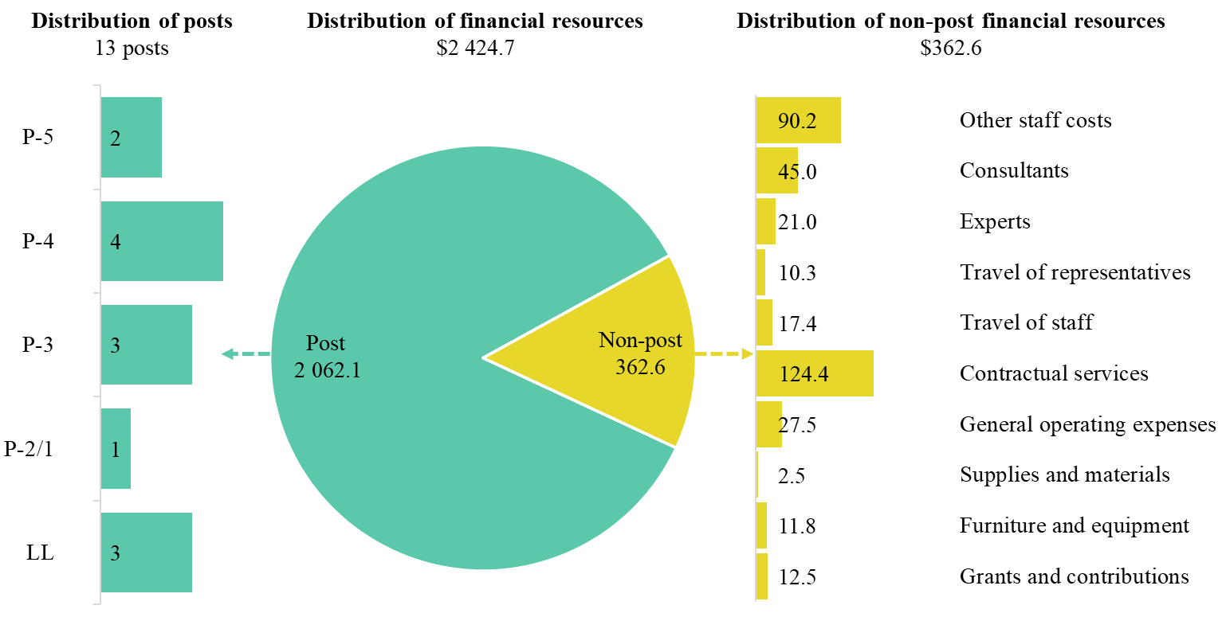

Extrabudgetary resources

15.162 Extrabudgetary resources for the subprogramme are estimated at $69,524,300 and would provide for 19 posts (1 D-1, 3 P-5, 4 P-4, 1 P-3 and 10 LL), as well as non-post resources. The resources would be used mainly to carry out technical cooperation projects with requesting countries in order to fulfil increased ambitions to combat climate change at the national and local levels and to develop climate-resilient water supply systems. Given the impact of the pandemic, subprogramme 3, in conjunction with other subprogrammes, mainly subprogramme 1, will contribute to promoting sustainable mobility and ensuring access to basic services, public space and adequate and affordable housing in the pursuit of a holistic approach to the achievement of a resilient and green recovery from the pandemic. For example, under the subprogramme, support will be expanded for low-emission development strategies which facilitate the creation of green jobs and access to green public spaces. The subprogramme will further support planning for, and the implementation of, climate resilience strategies that support health resilience, in particular through climate-resilient water and sanitation facilities, which will enhance hygiene. In addition, the subprogramme will continue to support urban climate adaptation, with an emphasis on the urban poor and on low-emission development planning and implementation. Furthermore, under the subprogramme, UN-Habitat intends to use extrabudgetary resources to develop urban climate finance tools suitable for cities in the least developed countries and small island developing States.
15.163 The expected increase of $31,961,900 is intended to address the higher demand for technical cooperation projects that promote the strengthening of climate action and improved urban environment.

Subprogramme 4

Effective urban crisis prevention and response

15.164 The proposed regular budget resources for 2022 amount to $2,500,700 and reflect a net increase of $577,900 compared with the appropriation for 2021. The proposed increase is explained in paragraphs 15.133 (d) and 15.134 (e). Additional details on the distribution of the proposed resources for 2022 are reflected in table 15.24 and figure 15.XIX.

Table 15.24

Subprogramme 4: evolution of financial and post resources

(Thousands of United States dollars/number of posts)

 |  |  | Changes |  |  |  |  | 2022 estimate (before recosting)
 | 2020 expenditure | 2021 appropriation | Technical adjustments | New/ expanded mandates | Other | Total | Percentage
Financial resources by main category of expenditure
Post | 1 457.2 | 1 711.2 | – | – | 345.8 | 345.8 | 20.2 | 2 057.0
Non-post | 207.1 | 211.6 | – | 150.1 | 82.0 | 232.1 | 109.7 | 443.7
Total | 1 664.3 | 1 922.8 | – | 150.1 | 427.8 | 577.9 | 30.1 | 2 500.7
Post resources by category
Professional and higher |  | 8 | – | – | 2 | 2 | 25 | 10
General Service and related |  | 4 | – | – | – | – | – | 4
Total |  | 12 | – | – | 2 | 2 | 17 | 14

Figure 15.XIX

Subprogramme 4: distribution of proposed resources for 2022 (before recosting)

(Number of posts/thousands of United States dollars)
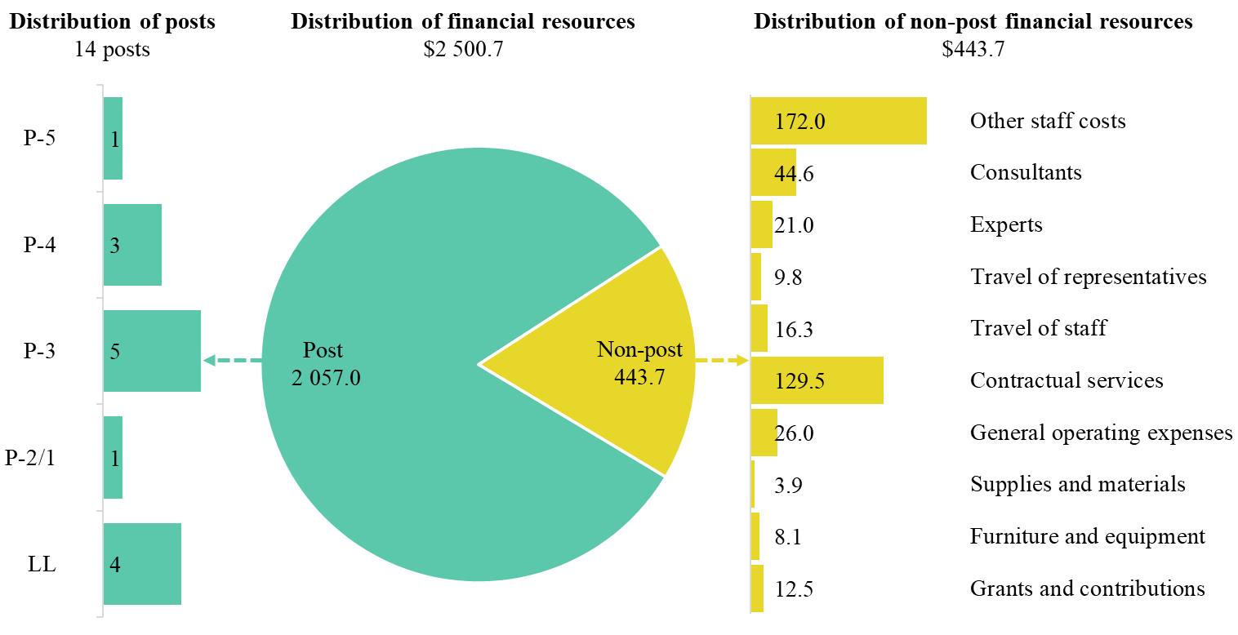

Extrabudgetary resources

15.165 Extrabudgetary resources for the subprogramme are estimated at $59,753,500 and would provide for 21 posts (2 D-2, 1 D-1, 2 P-5, 2 P-4, 1 P-3, 1 NPO and 12 LL), as well as non-post resources. The resources would be used mainly to implement technical cooperation projects with requesting countries aimed at ensuring the sustainable return of internally displaced persons through the provision of basic services and the improvement of living conditions, with a focus on vocational training and job creation. Furthermore, under the subprogramme, UN-Habitat also intends to use extrabudgetary resources to roll out resilience-building programmes and tools in order to support cities in their efforts to gather and analyse resilience data, understand risks and create realistic action plans that will potentially improve the lives of all urban populations affected by crises (natural or man-made).
15.166 The expected increase of $484,000 is attributable mainly to the increased demand for technical cooperation projects that promote effective urban crisis prevention and response.

Programme support

15.167 The proposed regular budget resources for 2022 amount to $1,122,000, which is equal to the level of the appropriation for 2021. Additional details on the distribution of the proposed resources for 2022 are reflected in table 15.25 and figure 15.XX.

Table 15.25

Programme support: evolution of financial and post resources

(Thousands of United States dollars/number of posts)

 |  |  | Changes |  |  |  |  | 2022 estimate (before recosting)
 | 2020 expenditure | 2021 appropriation | Technical adjustments | New/ expanded mandates | Other | Total | Percentage
Financial resources by main category of expenditure
Post | 1 257.8 | 1 102.9 | – | – | – | – | – | 1 102.9
Non-post | 134.8 | 19.1 | – | – | – | – | – | 19.1
Total | 1 392.6 | 1 122.0 | – | – | – | – | – | 1 122.0
Post resources by category
Professional and higher |  | 5 | – | – | – | – | – | 5
General Service and related |  | 2 | – | – | – | – | – | 2
Total |  | 7 | – | – | – | – | – | 7

Figure 15.XX

Programme support: distribution of proposed resources for 2022 (before recosting)

(Number of posts/thousands of United States dollars)

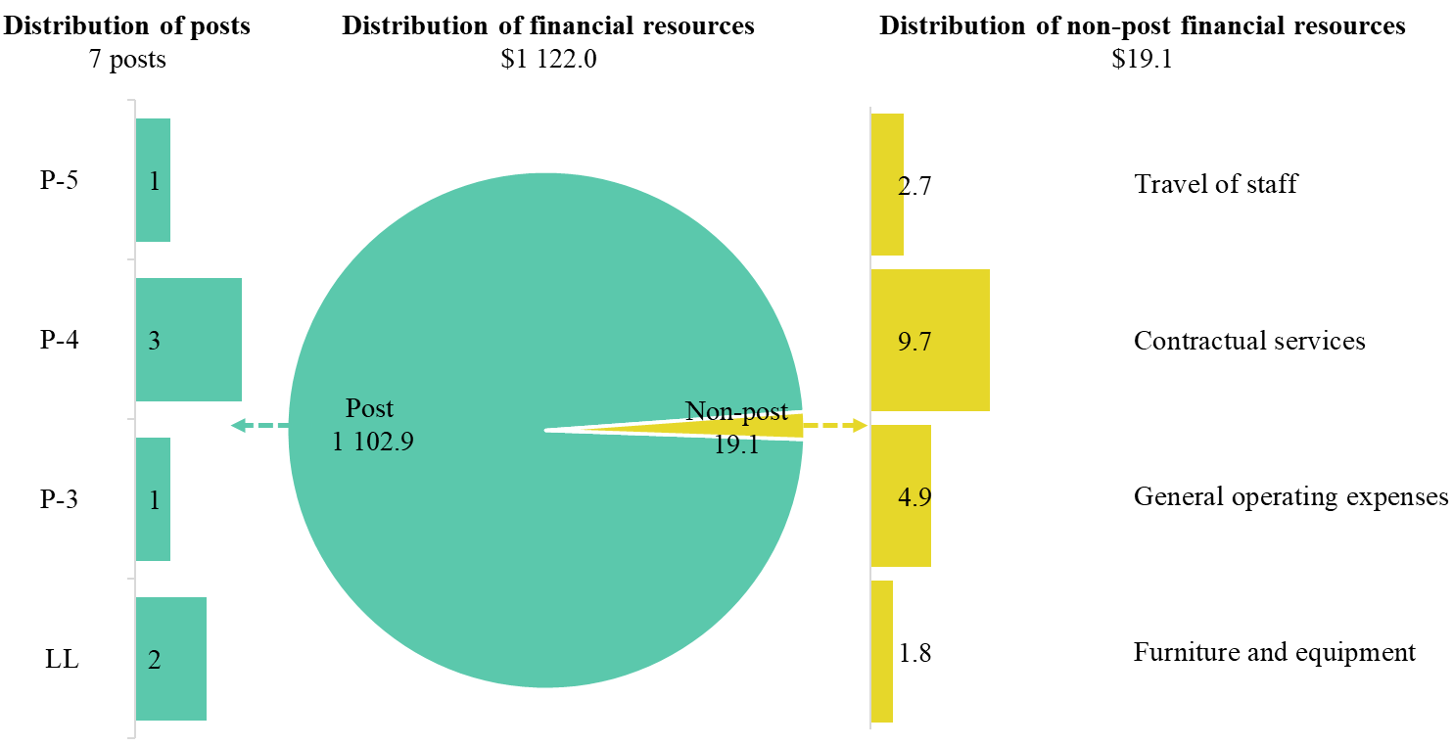

Extrabudgetary resources

15.168 Extrabudgetary resources for the subprogramme are estimated at $8,051,600 and would provide for 37 posts (1 D-1, 8 P-4, 8 P-3, 2 P-2/1, 1 NPO and 17 LL), as well as non-post resources. The resources would assist the Under-Secretary-General in discharging responsibilities in the areas of personnel, finance and general administration. The expected increase of $1,737,000 is attributable mainly to increased requirements for activities in support of programmes.

Annex I

Organizational structure and post distribution for 2022

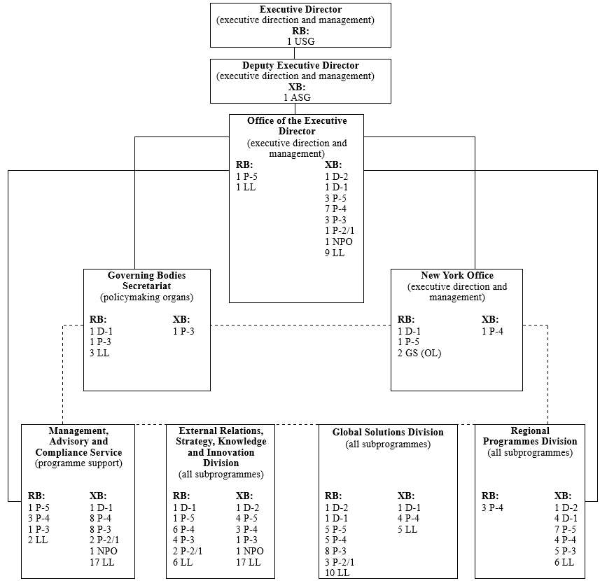

Abbreviations: USG, Under-Secretary-General; ASG, Assistant Secretary-General; GS (OL), General Service (Other level); LL, local level; NPO, National Professional Officer; RB, regular budget; XB, extrabudgetary.

Annex II

Summary of follow-up actions taken to implement relevant recommendations of the oversight bodies

Brief description of the recommendation | Action taken to implement the recommendation
Board of Auditors
A/74/5/Add.9, chap. II, para. 42
The Board recommends that UN-Habitat establish a framework and methodology for full cost recovery in accordance with General Assembly resolution 67/226 applicable in all units of the entity and inform its hubs and offices of its application. | Status: Under implementation
 | UN-Habitat acknowledges the referenced General Assembly resolution, in which United Nations organizations are requested to ensure that neither regular budget nor non-earmarked resources are used to subsidize activities under earmarked trust-fund projects. In 2020, as a first step, UN-Habitat apportioned all common service costs for earmarked projects among the relevant projects. UN-Habitat is in the process of implementing additional measures to prevent the cross-subsidization of activities from various funding sources. In 2021, UN-Habitat will evaluate options for funding field, regional and multi-country offices through cost allocations. This eventual funding arrangement will be reflected in future contribution agreements with field, regional and multi-country offices.
 | This recommendation has been partially implemented.

Annex III

Summary of proposed post changes, by component and subprogramme

Component/subprogramme | Posts | Level | Description | Reason for change
Subprogramme 2, Enhanced shared prosperity of cities and regions and subprogramme 3, Strengthened climate action and improved urban environment | (2) | P-3 | Redeployment of 2 posts of Programme Management Officer (P-3) to subprogramme 4 | Proposed in line with the consolidation of external relation functions under subprogramme 4. Even though the work on external relations applies to all subprogrammes, the proposed redeployment to subprogramme 4 is primarily attributable to the recent increase in demand for external relations support for crisis prevention and response, in part owing to the recent developments associated with the coronavirus disease (COVID-19) pandemic. This change is in line with the strategic direction endorsed by the Executive Board and is intended to maximize the effectiveness and progress towards the objectives of all the subprogrammes of UN-Habitat.
Subprogramme 4, Effective urban crisis prevention and response | 2 | P-3

A/RES/69/283 Sendai Framework for Disaster Risk Reduction 2015–2030.
As reflected in the proposed programme budget for 2020 (A/74/6 (Sect. 15)).
As reflected in the programme budget for 2021 (A/75/6/Add.1).
As reflected in the proposed programme budget for 2020 (A/74/6 (Sect. 15)).
As reflected in the programme budget for 2021 (A/75/6/Add.1).
As reflected in the proposed programme budget for 2020 (A/75/6 (Sect.15)).
As reflected in the proposed programme budget for 2021 (A/75/6 (Sect.15)).
As reflected in the proposed programme budget for 2020 (A/74/6 (Sect. 15)).
As reflected in the programme budget for 2021 (A/75/6/Add.1).

