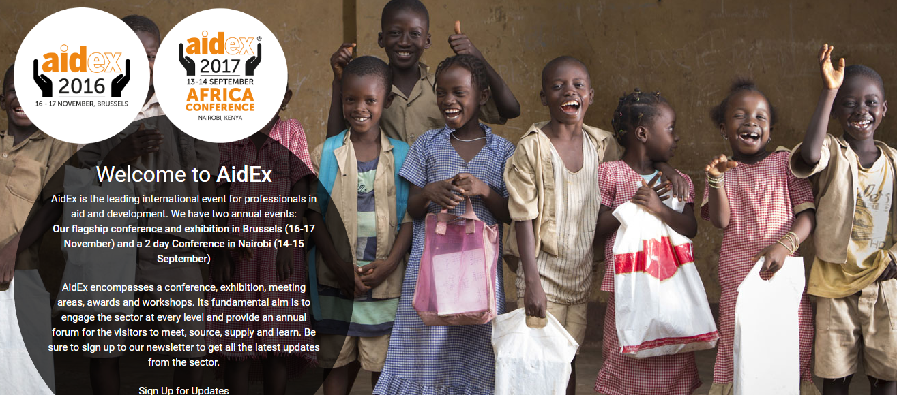
ABOUT
AidEx Africa was launched in 2014 as a satellite event focused on aid and development within Africa. It is a two-day high-profile conference attracting over 350 delegates.
The high-level audience that attends AidEx Africa includes the Government of Kenya, UN agencies, Kenyan Red Cross and leading NGOs, with input from the British High Commission and UKTI.
LOCATION
Nairobi, Kenya
DATE
13-14TH September 2017
More information
http://www.aid-expo.com/aidex-africa

