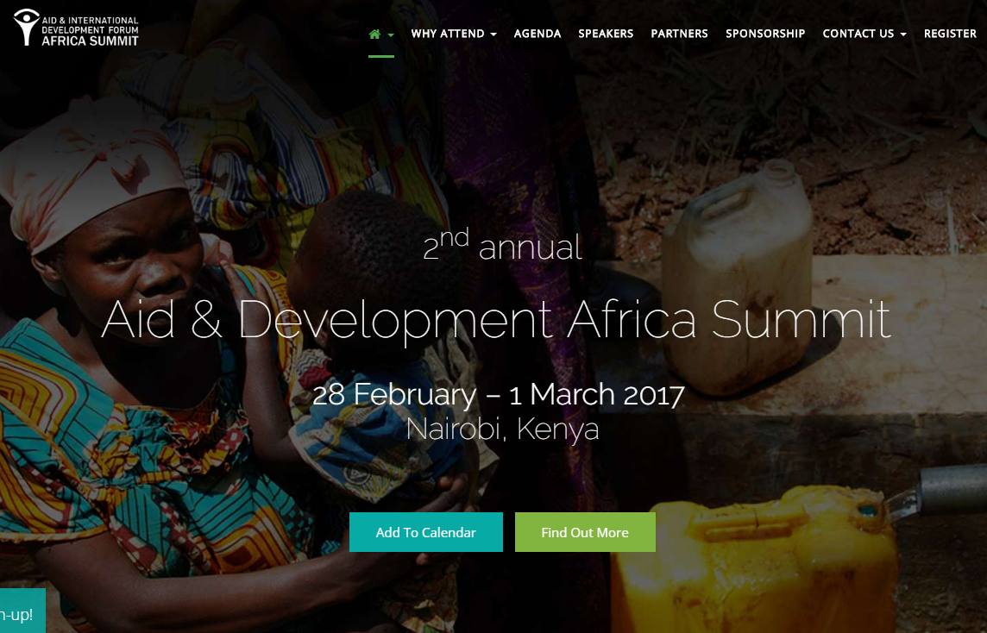
ABOUT
Aid & Development Africa Summit looks at how technological innovations and best practice can improve aid delivery and development strategy in East Africa.
Gathering 300+ senior representatives and advisors from regional governments, UN agencies, international and regional NGOs, CBOs, investors and donors, research institutes and the private sector,
The agenda has been developed in consultation with key organizations, such as WFP, IRFC, World Vision, USAID, UNICEF, World Bank, Save the Children, UN Habitat, CRS, FHI360, Oxfam, Habitat for Humanity International, IRD and will include case studies, panel discussions, workshops, and interactive roundtable sessions
LOCATION
Nairobi, Kenya
DATE
28TH February- 1ST March
More information: http://africa.aidforum.org/

