ABOUT
The summit strives to enable quicker and better response during crisis and catastrophes in a more effective, sustainable and cost-efficient way. They have developed the agenda in consultation with key organizations, such as UNOCHA, World Vision, UNOPS, USAID, Red Cross, World Bank, Aidmatrix, and CIPS.
LOCATION
WASHINGTON D.C., USA
DATE
6-7 September 2017
DONORS PRESENT:
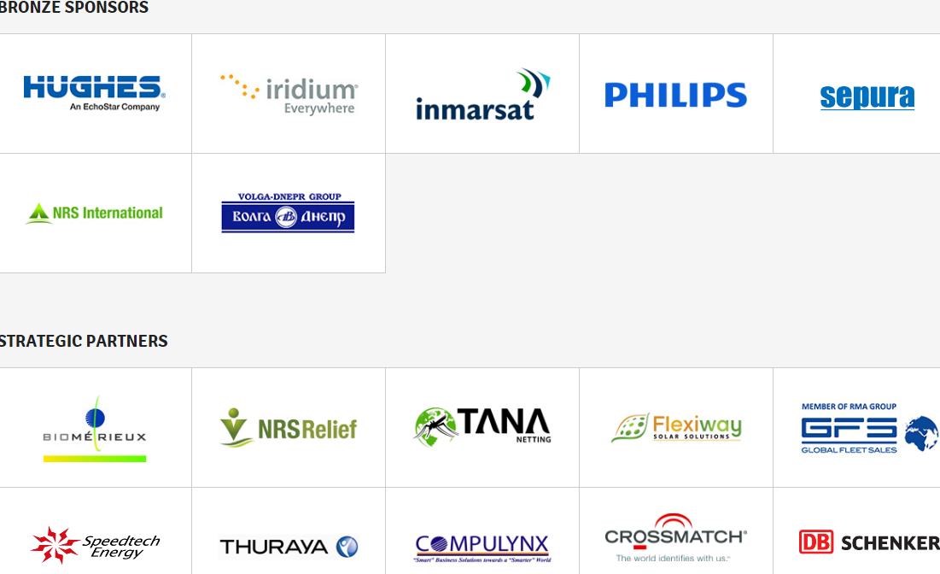
More Information
http://disaster-relief.aidforum.org/

